Jakarta, September of 12th, 2015

To: Human Resources Manager

Dear Sir/Madam

Upon hearing the information regarding a vacant position, I could not contain my excitement to be involved on the activities of your organization. I am quite convinced that the skills which I’ve obtained during this four years of college will be helpful and advantageous for your organization.

With this letter, I’ve enclosed my latest resume to provide more details regarding my qualification in hope that it will fortify your decision. I will look forward to hear from you regarding the continuation of this matter. I would welcome any opportunity to meet you in person and discus more deeply about this opportunity.

Sincerely yours,

Dwica Rina Novianti
(081808041430)

Curriculum Vitae

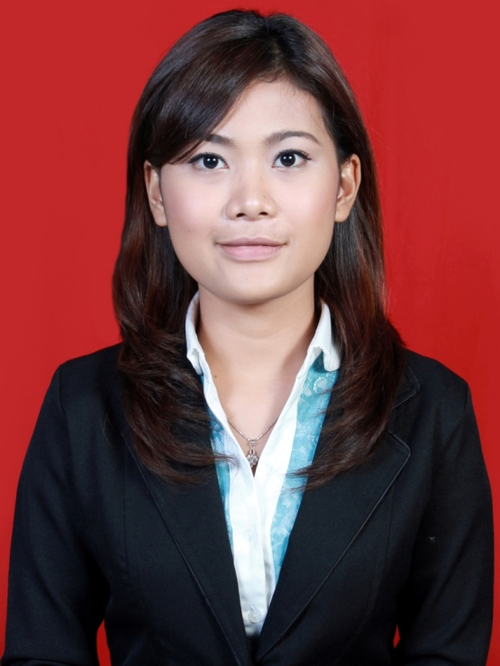

Personal Details
 | Full Name  Sex  Place, Date of Birth  Marital Status  Height, Weight  Address  Mobile Phone  E-mail | : Dwica Rina Novianti  : Female  : Jakarta, November of 11th, 1994  : Single  : 160 cm, 47 kg  : Jalan Jambu 1 Rt 003 Rw 01 No. 1  Tanjung Barat, Jagakarsa - Jakarta Selatan 12530  : 081808041430  : dwicarina@gmail.com
Educational Background
 | 1999 – 2005  2005 – 2008  2008 – 2011  2011 – 2014 | SDN 05 Pagi Pejaten Timur, Jakarta  SMPN 41, Jakarta  SMAN 38, Jakarta  Universitas Indonesia, Vokasi Komunikasi  Major Public Relations
 | 2014 – .... | Universitas Persada Indonesia YAI  Major Public Relations

Personal Skills
- Computer Literate (Microsoft Office, Adobe Photoshop, Adobe InDesign, Adobe Dreamweaver, Corel Draw, Windows Moviemaker, Macintosh Operating System).
- Internet Literate.
- Speaking in English fluently.
- Self confidence.

Organization Experiences

Event VAGABOND, Universitas Indonesia
 | Position | : Staff Divisi Acara
 | Event ONEVOCATION, Universitas Indonesia
 | Position | : Staff Divisi Dana Usaha
 | Event MABIM VOKASI, Universitas Indonesia
 | Position | : Staff Divisi Keamanan
 | Event MABIM VOKASI KOMUNIKASI, Universitas Indonesia
 | Position | : Staff Divisi Dana Usaha
 | Event MABIM PUBLIC RELATIONS, Universitas Indonesia
 | Position | : Staff Divisi Mentor
Event GREENATE, Universitas Indonesia
Position | : Staff Divisi Media Partner

Work Experiences
Working at Event Rokok Country PT Bentoel, Jakarta
Position | : Sales Promotion Girl
Working at Event Allianz Fun Walk , Jakarta
Position | : Sales Promotion Girl
Working at Event BTA 8 Group, Jakarta
Position | : Sales Promotion Girl
Working at Event Natura Vista Apartment by Premier, Jakarta
Position | : Sales Promotion Girl
Working at Cosmobeaute Indonesia at Jakarta Convention Centre
Position | : Temporary Staff at Rebook Counter
Working at Angkasa Pura II, Soekarno-Hatta International Airport
Position | : Duta Bandara 2014
Working at Angkasa Pura II, Soekarno-Hatta International Airport
Position | : Customer Service Mobile
Working at “Silent Siren Live in Jakarta 2015” Concert at Upper Room, Jakarta
Position | : Sales Promotion Girl

Jakarta, September of 12th, 2015

