Project EAA Online Forum 1 (15-16 Sept) – Indonesia

Day 1-Part 1
- Please introduce yourself to each other and please make sure you tell us your name, age and your favourite hobbies
  - Show us pictures that best depict you as a person
  - Tell us a bit about this picture and why this represents you

No. | Name | Response
1 | Hesti | My name is Hesti, 37 yo, my hobby is cooking. This photo represents who I am now, a mother who is busy with housechores everyday, looking after my 2 kids.
2 | Paula Marlen | Hi, I am Paula Marlen, 36 yo and my hobbies are baking and watching films (she responded to my Introduction Section)
3 | Prichas Devi Ayu | Name: Prichas devi ayu natalia  Age: 25 yo  Occupation: housewife  Hobby: singing in the bathroom and cooking  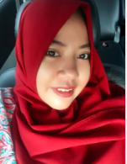
4 | Dewi | Assalamualaikum, my name is Dewi. I was working before but after I gave birth I prefer to stay home and look after first born, whose name is Aqsa who is 5 months old now. I play with Aqsa everyday and I breastfeed exclusively for a good growth and development in his future
5 | Syamsiah | Assalamualaikum. Nice to meet all of you moms. My name is Syamsiah, I am 33 yo and I am a housewife with a 5 mo baby boy. My hobbies, aside from playing with my baby, are going out and reading  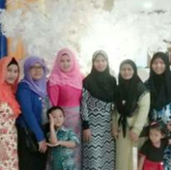  I am a disciplinarian but I love my family
6 | Rahmawati | I’m a housewife with 2 kids that make me very grateful to have the baby as a gift… my hobby is cooking..eat also
7 | Rahma Nur Aulia | Assalamualaikum  My name lia  I’m a housewife of 2 kids  The first one is a boy 3 years old his name is fahri..the second one is a girl her name is anindya  My hobby is travelling
8 | Anisa Dwina | Hello, my name is annisa. Hobby is traveling, especially just have a baby so I’m really happy traveling while drive the baby, and proud to become a mother hihihihi I’m 33 years old
2 | Paula Marlen | Hallo,  My name is Paula Malein, 36 years old,. My hobby is making cake and watching, I’m a mother of two boys, the first one is 4 years old, the second is 3 month years old  This picture showed that I’m fun and easy going

- Now that we know you better, we would like to know your family too
  - Introduce us to each member of your family with an image – please upload one image per person and describe them
  - Show us an image of all of you together sharing a happy moment – describe this image to us
  - Show us how you live by uploading images of parts of the home or work that you are most proud of. Please explain why
No. | Name | Response
3 | Prichas Devi Ayu | This is a photo of us as family when we were out at the mall to refresh our boredom. This one is me with my family and cousins  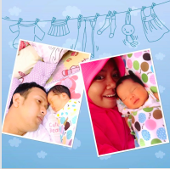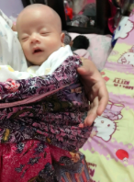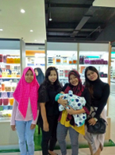3
1 | Hesti | My husband always helps and loves us, we eat out together once in a while on the weekend. My daily activities revolve around caring for the baby. This one is the eldest Ainun who turned 12 yo on September 12. She is stil jealous of her little brother but she loves him very much…Thanks Allah for this little family of ours
5 | Syamsiah | My newest family member, my hero Vier, a super active baby who loves to take photo.  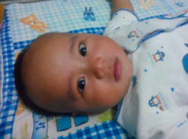  My life partner, though he is very quiet he really cares about his baby. He is willing to sacrifice for this family and that is how my beloved husband is  The most precious moment spent with the extended family, especially during the Eid al- Ftr, together with brothers and sisters and nieces and nephews, we gathered at grandma’s house  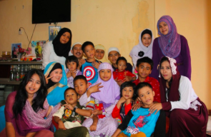  Being a mom is an irreplaceable profession. We always enjoy our moments together though we only spend it to just get together and chat  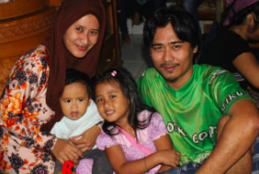  the bubbly and curious big sister  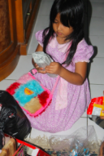
2 | Paula Marlen | This is my husband he is a private employees beside musical hobby both of us love making cake.  My husband really helpful in house affairs including take care of the children and together in the kitchen.  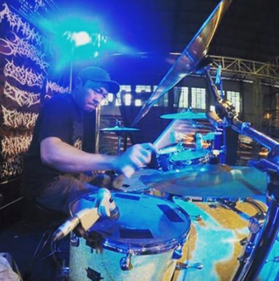  This is my first hero, good humored, lively, and approaching her five years old, she is super want to know everything around her.  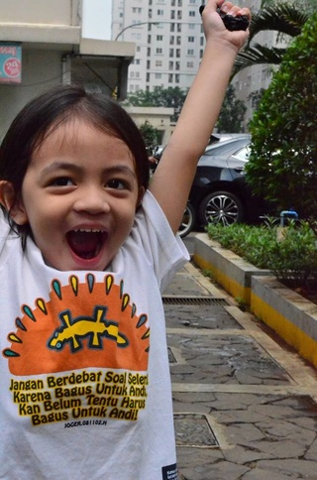  My second hero that was funny now is 3 month old  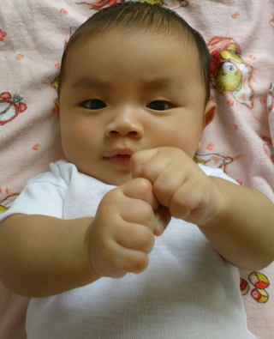  This is us when enjoying favorite family moment …lazy around in bed
6 | Rahmawati | Hai every one,,,,my husband is Muhammad hanif 27 years old work in IT field. His hobby is cycling around UI ( university of Indonesia ) lake  My first kid syaza, this beautiful have a hobby bully her little brother, while syam the little one because he only 1 month old, his hobby still sleeping…
7 | Rahma Nur Aulia | Halo let me introduce you this is my family with parent from husband  The kids called it grandma and datuk ( datuk = grandpa )  In this moment abang ( elder son ) is having his 3rd birthday  My husband is 30 years old an entrepreneur  The big one his name is Muhammad umar al fakhri he is 3 year old usually called abang fakhri...  Abang now already active in pre school ..abang is really love her sister, if she cried he run take the milk or pacifier so her sister calm..but sometimes he jealous because his mother always pickaback her.  My second kids name is aysha anindya khaliqa her age is 5 month old usually called dede ( dede = younger son ) anindy  Now dede so active back and forth lying flat on stomach ...like to bables an yellings  With my own life that really troublesome, exhausting and emotional, I’m really happy taking care the baby because I’m doing it by myself
8 | Anisa Dwina | This is the first photo of my little family. This isa moment where I very proud become a mother. I already imagine how is feel to raise a beautiful daughter like Yumnaa  I’m the second son of the three sibling. I’m really enjoying my role as a mother for my first daughter. I’m planning to give the exclusive breast mik even until she 2 years old. Even at first is quiet hard to make her take my breast milk. Thank god Alhamdulillah I have an amazing husband that really understanding, so there is many thing we do together..  Our daughter name is Yumnaa, last week we already done aqiqah ( Islamic tradition of the sacrifice of an animal on the occasion of child birth )  There many thing that impress me and made me happy in this little family the moment of taking care the kid also I enjoy it with full of dramas. Support was also given by the faily and husband so I’m always pumped to become a mother even with minimize experience.

- Lets move the focus to your new born child – can you please introduce us to them too – Show us their personalities through images/videos
  - Tell us a few things that you love about your kids – Feel free to write as much as you can!
  - How many months has it been since you gave birth?
    - Tell us about the birth of your child - what was this moment like? How did you feel during and after this experience? (Physically and emotionally)
 | Name | Response
3 | Prichas Devi Ayu | a. My child is a blessing from Allah dan I really love her. I was pregnant for 9 months and I carried her everywhere with me, that is what also makes me love her very much  b. 2 months  I had a cesarean section  Physically I was weak and emotionally I was scared but when I saw her, all those feelings disappeared
1 | Hesti | a. My second born is the most beautiful blessing from Allah SWT given to my husband and me. He was a given replacement of our first born who left us when he was 4 mo in 2009  b. 5 months  My son was born at week 38, the process was intense for me because my water broke without any signs of dilation at all. So I had to do a cesarean section. He only weighed 2,400 gr, tiny for a baby boy. Alhamdulillah in the first month he gained 4 kg. He is now 7 kg at the age of 5 months
5 | Syamsiah | Vier is our little hero. He completes the happiness of our family. Ever since he was stil in my tummy, Alhamdulillah, my little hero had already showed signs of an active child so the birthing process didn’t take long, it only took 3 hours. I had to push hard because he was quite big, 3.4 kg. He is turning 5 months old on this coming 25th. My Vier has started crawling and exploring everything around him  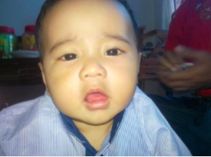
7 | Rahma Nur Aulia | My second son is aysha anindya khalika  weight 2.9 kg and 46 cm long  it really awaited for because my mother grandchild there are 10 and all of them is a boy  dede birth is normal even her position is sungsang ( sungsang = breech )  the butt is get out first  but alhamdullilah born safe with delay in cutting the umbilical cord method  now she already back and forth lying flat on stomach  expert swimmer  always cheerful
4 | Dewi | My kid name is Aqsa Sutan Amadeo Putra… Aqsa is my first baby he really lively and cheerful, especially he will entering 5 month, there so many of his cleverness from rolling until yelling  Aqsa born Caesar with 2.850 kg weight and 50 cm long  In family aqsa been awaited because he is the first grandchild of apy and amy ( apy and amy = grandpa and grandma ) me and husband really love him so much because he is very funny and already show his cleverness… just pray him always stay healthy, amiin..
6 | Rahmawati | Love to the children is the most important, he just 1 month old made me want to cuddle it and his brother that already 2,5 years old often jealous and accompany me when I’m breastfeeding his little brother .  I gave birth normally, in Aulia Jagakarsa Hospital, waiting when opening birth is a moment that made us feels the perfection as a woman, even it hurt a thousand times but after see the babies we really happy, cannot be expressed with words. Just amazing!
2 | Paula Marlen | Edgar, the owner of my favorite sweet smile is my second kid  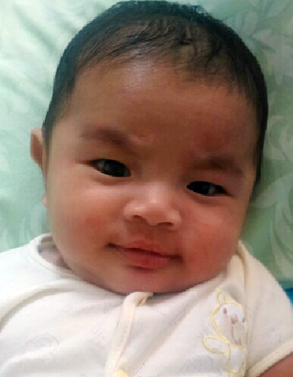  at 3,5 month, my hero is one of many gift from god, that all of the family really grateful for it . give birth normally to edgar with 3,1 kg weight and 50 cm long, is an emotionally moment specially for me, because born in the hometown and the process is helped by a midwife that also my family in batam. And the most memorable I feel being helped during the birth process, especially from the time that only need about 1 hours, from the start of first contraction until give birth  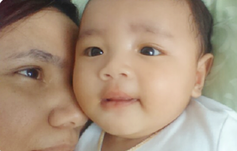
8 | Anisa Dwina | My daughter name is Yumnaa. This little child born by Caesar operation in Sunday morning without nausea however briefly I have a problem with amniotic fluid. But that process just disappear after her first cry that break the operation room that time.  Yumnaa become a belle in our family, our other family members care to her. Until her birth present is full not fit again in her chest.  Yumnaa already done her first syringe which is BCG syringe. Her weight is over than 1 kilos and 3 ounce in her age heading 2 month  Yumnaa already able to see stuff around her, it looks like she understand  That is what make other people adore and more love her  She also didn’t cry as many as other baby when she just born  I really love my role as a mother and will keep to do it with a happy feeling

- What kind of a relationship do you share with your kids?
  - Can you please show us some of the parenting references you use to guide during this period of upbringing? – Websites, magazines, doctors words or even your own mother’s words

No. | Name | Response
1 | Hesti | I have a close bond with my children because I raise them without the help of any maids. It is just my husband and I. My close extended family helps once in a while. In terms of parenting references, my husband and I have our own way, once in a while we look for information from doctors, parents or websites.
2 | Paula Marlen | My relationship with my child is very close, that is because I take care of them myself. There are some things that I learn from my parents, about how to rasie a child but, the rest is lots of reading magazines and the internet and am also relying on my feelings as a mom
3 | Prichas Devi Ayu | My relation with my child is like a stamp that adhered to an envelope, un-detachable...  Hehehe  I take care of everything myself. When my child is sick or when she vomits, I prefer to look for information in Google or ask my parents
5 | Syamsiah | Ofcourse my relation with him is unbreakable. We are like friends who will always be together whenever wherever hehehe…  I awalys seek information about my children’s growth and development, aside from parents, I also look for information on the internet, only from trustworthy sources such as pediatrician
8 | Anisa Dwina | The relationship between kids and a mother is very close, and that also a mother dream to always close with her kids, because with those bond it will make the kid grow confidence, safe and comfortable.  The information source about kids, where I search it or I get it, certainly before I practiced it , I read it and understand it which one I thinks is good and bad . certainly a mother always try the best for her kids
7 | Rahma Nur Aulia | My relationship with the kids is very close  For the kids growth I always discussed with my husband.. asking with my parent, and by internet  Asking with my pediatrician
4 | Dewi | My relationship with aqsa my baby is definitely very close. My husband help me in taking care the kids. Sometimes I asked my parent opinion how to take care a kid when she get a flu / post immunization. But I also always consulted to doctor if the baby is not well. For information about kids growth, I always search it through the internet and sharing with a few experienced friends .
6 | Rahmawati | Definitely my relationship with my kids is really close, because our togetherness every day we see him grow and smile, he cried, during breastfeeding that is a bond that cannot be broken, for information I often asked to y mother, my sister abaout their experience when taking care the kids, with husband searching for information through website, internet, forum in media social, also from pediatrician that helped when I give birth.

Day 1-Part 2
- Can you please describe your current Lifestage in a bit more detail – what name would you give this Lifestage?
  - What are the various changes you are noticing in your body? Please tell us the physical, mental and social aspects
  - Which are most critical needs in your life? Tell us stories that support your needs at this stage?
MODERATOR – Please ensure we understand key changes in this Lifestage
  - How is this phase of your life different to 2-3 months ago?
  - How will you be different 2-3 months from now? How will your needs and worries change?

No. | Name | Response
1 | Hesti | A super busy delightful life  a. It has been almost 5 months since my baby was born. Ofcourse my body is not as slim anymore. I get tired easily maybe because I do all of my housechores myself, lack of sleep, not enough rest, mentally all these changes affect my daily life. Sometimes I feel anxious and cautious when my baby is fuss for no reasons. My older child feels jealous if I pay more attention to his little brother  b.What I need right now is the support from the people that I love to raise my two children and that I already am getting from my husband and my parents.  c. Now I feel happier and I enjoy it better compared to 2-3 months ago. Because my baby is growing, he is becoming more active and cute though sometimes, I need to be extra careful to protect him  d.2-3 months ahead, ofcourse I am going to need more physical and mental strength to take care of my children and this little family of mine
2 | Paula Marlen | Stages of Life Learning  a. My life changed from having to only caref or one child to having to care for 2 children. Often times I feel mentally and physically tired, but it is also fun. I socialize less with my friends because all of my time is spent looking after the children  b. What I need now is to manage my time well between the 2 childres, and I get all the support I need from my husband. My husband happily helps to look after the children when I need to rest  c. Ofcourse it is different, now that I have 2 kids I have to automatically split my time between the two and I have to pay enough attention to my first child so he/she doesn’t get jealous of the little one. As a result, I have less time for myself  d. The next 2-3 months will be more hectic, I am going to need more physical and mental readiness. I am worried I can’t devide my attention and time fairly but, my family really supports me
5 | Syamsiah | This lifestage is a learning stage  a. Life is constantly changing like a spinning wheel. From having only 1 child to having 2 kids now for sure, it drains y energy and emotion. Physically I for sure easily get tired but mentally I have to stay as strong as steel for the sake of my children’s growth and development. After the birth of my second child I have grown to like socializing with my nieghbrs and friends so to share information about children ofcourse  b. What I need the most right now is health. So to get a healthy life together with my family, I always make sure we eat nutritious food, life hygienically and ofcourse exercise regularly  c. 2-3 month ago I still had time to help the big sister with her homework or even just to play with her. Now I have to pay more attention to the little brother because he has started to crawl  d. for the next 2-3 months, I really have to be prepared because my kids are growing, especially the little brother. He will be introduced to solid food to complement breastmilk, it will be my task to manage the menu then. What worries me is not knowing whether he will be a difficult eater or not
3 | Prichas Devi Ayu | a.change of life is a certain, having a change from physical form, emotion definitely change . even physical can be confirmed easier to get tired but mentally still have to be a steel for the kids grow as they progress. With the born of my kids I become excited to get an information in magazine article, Google etc. and sometimes we share in media social to a friends about our kids growth .  b. the only important needs to my right now is health, for have a healthy life me and family always control dietary habit with nutritious foods, clean life and of course exercise routine  c. in a period where I have plenty of time to take care my kids and watching her growth from 0 month  d. in a few month ahead I have to really prepared because that time my kids already grow into a higher stage. Especially it is my first kid and he will get more attention. He will be introduced to breast milk companion food, that is a homework for me in mixing his food menus later. So sometimes that made me worries is whether my baby is like it or not
8 | Anisa Dwina | a. definitely there is a lot of change especially in the body, or stomach precisely, before it so slim now become more fat, that cannot be discarded or undo perfectly hehehe, maybe with a process it can  b. the most important needs is nutrition specially to a mother that give breastfeeding  c. this 2-3 month my life change dratisticaly from dietary habit and sleep pattern, but still fun because take care and accompany the baby  d. in regard of the C question. With so many kind of technology and method. What happens to in the past few month will be back better again if diligently do the method that can change our self
7 | Rahma Nur Aulia | A. the change in my body is very drastically rise up… when I’m married my weight is 55 kg and after first pregnancy it up to 70, and now postpartum my weight become 85 huhuhu  The change after have 2 kids is realy exhausting, because I have to do it all alone. Even physically easily getting tired but mentally have to be a steel for the kids growth as progresses. I like to socialize through internet or communication with neighbors  B. the needs that I need is husband support… because everything that I did is very exhausting, after husband give affection more love everything gone.. my primary, secondary and tertiary needs that balanced  C. 2-3 month ago of course I feel happy, because the baby is smart already.. can joke, can lying flat on stomach. And very active  D. for the next month ahead I have to prepared well because the baby start to eat.. her brother already active at his school
6 | Rahmawati | Study to educate the kid become sholehah ( sholehah = obedient, kind etc )  Change in the body is a certain especially the gap between first and the second is not that far, body less attractive, fat and hard to control dietary habits because have to fulfilled nutrition for the kids, taking care of kids that still small is exhausting but because we do it with sincere and love made me happy and enjoy doesn’t feel tired or always happy, entertain myself through social media and internet can be one of entertainment when the kids fall asleep or i want the kids soon get a strong religion education so will have a strong foundation when they grown up  For the past 3 month is an exhausting period still in pregnancy but happy to know the development of embryo inside, that stay healthy and agile. And 3 month ahead is period of happy times when i looked the kid grow become more fat and lively
 | Dewi | a. entering 5 month postpartum of aqsa, at first I worried about the change of weight that will rise drastically, but what happen is a reverse of it, from the beginning of pregnancy my weight still stabilize. Now over the my activity taking care the kid and the house alone, slowly my weight dropped but the same with my kid that his weight increase almost into 8 kg in her age who just 5 month, im really happy because my kid have a good nutrition food supply from anything that I eat, because accidently my kid only consume my breast milk.  b. the needs that important to me is by given a great health by Allah SWT, because if im’m healthy then my kid also feels the same and that is truly a magnificent gift to see the baby always healthy..  c. for 2-3 month ahead I really need to prepare a substitution food for breast milk and more detail in choosing food ingredient that have good nutrition.

- Can you please think about the period just after birth….
  - How did you feel?
    - Physically
    - Mentally
    - Emotionally
How long did these feelings last post birth?
  - What are the kinds of things that you are allowed to do? Why?
  - What were you not allowed to do? Why?
  - What worries did you have after birth in regards to your own self?
What did you try to do resolve this?
No. | Name | Response
1 | Hesti | a Physically I am fatter ofcourse  ii. Mentally, sometimes I feel cautious when I am watching over my children  iii. Emotionally, sometimes I have no control over it maybe because it is tiring to do all these housechores. This feeling lasted for 3 months after birth  b.What I have to do after birth is ofcourse to watch the type of food that I eat so to lactate good breastmilk  c.What is not allowed to do is to lift and carry heavy objects because I had to be careful with the stiches since I had a cesarean section.  The worries that I have after birth are worrying that I am lactating enough, how do I take a proper care of my baby, I had baby blues, I was afraid that my baby had jaundice, sleep deprivation and lack of proper rest that could affect the quality of my breastmilk  To overcome all these I ask my closest family to accompany me at home so I don’t feel lonely
2 | Paula Marlen | a. i. Physically: I am still fat  ii. Mentally: There are times when I feel tired because I ttake care of 2 childrens without helpers, but I try to be happy and try to enjoy my life.  iii. Emotionally: Sometimes I get highly emotional because I feel tired but my first child demands more of my attention and does everything he can to get it  These feelings lasted for the first 2 months after birth, after that things got better because I had grown to get used to it.  b. I consume nutritious food to stimulate lactation for my second child.  c. What I am not allowed to do is to be with my second child more that I am with the first child, this is o avoid jealousy  d. The changes in my body shape, I am worried it may not ever be the same as how it used to be and also, not lactating enough for my second child.
3 | Prichas Devi Ayu | (She sent this to my Inbox)  Physically  i. I am still fat  ii. Mentally I still feel cautious, having to take care of my baby without any help and having to deal with everything myself  iii. Emotionally: Soemtimes I am highly emotional because I am sleep deprived having to stay up all night  b. I eat vegetable, fruits, meat, egg and fish for good quality breastmilk  c. What I am not allowed to do is to lift heavy objects, I am still allowed to pick up the baby though  D. I am scared when my baby cries and I can’t be stressed. So to lactate well I need to just enjoy this  To resolve this I watch TV, read articles and I shop online
5 | Syamsiah | a. Physically I am not fat but my tummy is not getting smaller hehehe...  Mentally I have to withstand impact like steel  Emotionally I need to have an abundant stock of patience  b. Eat more green vegetables and milk to increase lactation  c. After I gave birth, what I had to avoid is stress because stress affects the baby  d. I am worried if I fall sick, no one will look after my family  To get all these I have to maintain my health, watch what I eat and always pray
7 | Rahma Nur Aulia | I phisicaly the body still wider  ii mentally worries because the brother start to jealous with his sister  the baby also start to active  iii emotionally sometimes like to angry because exhausted taking care everything alone  B. nutrition foods  C. avoiding stress because it affected to the kids  D. worried that my weight is not back again like it used to be  To achieved all of that I have to take care of my health so could take care both of my baby and take care of my husband
6 | Rahmawati | The body certainly hasn’t back like it used to be,  Mentally still feel hurt because of stitches postpartum and the brother still looking for affection.  Easily get tired because lack of sleep and rest, made me feel sleepy that made a headache  Need nutrition foods and husband attention  Afraid easily getting angry and stress  And for all of that I always communicate with my husband when he able take turn to help keep the kids and taking care of them
4 | Dewi | i. physically Alhamdulillah until today still stabilize  ii. mentally still afraid of taking care the baby alone without a helper  iii. emotionally sometimes I liked to cried when see the baby, when im sick but the baby stay healthy then I’m happy again  a. eat foods that have a good nutrition supply  b. because of Caesar birth , I’m forbid to carry a heavy object and cannot become stress because it affected the production of breast milk.  c. what I’m worried is if my health dropped then my baby also feels the same ( sick)
 | Anisa Dwina | Bi. Physically of there is a different which is grown more become fat, a stomach that change it form and haven’t back like it used to be because the Caesar operation, even I do thing that can help a little. To return the condition.  ii. mentally I feel many thing postpartum, there many thing I know right know, before of it I don’t know a thing, it feels like I’m getting stronger as a women and enjoyed my role as a mother  iii. mentally a little bit change like often to worried about something, like parent word that permitted to do something but not for me, more sensitive about thing that connected with the baby, sometimes cried if the baby didn’t stop crying. And im confused what I have to do, but I enjoy every process  until the baby approaching 2 month old this kind of feeling still exist and sometimes appeared  .  b. what allowed postpartum is to control food supply not only enough fibers but also not affected badly for baby health, do light things and not consume so much time as a substitute for light exercise  C. what not allowed postpartum is lift heavy object because it risked the stitches, gone to long without the baby, and most important cannot stress for the breast milk production an avoiding from baby blues syndrome .  d. worried the breast milk is not enough for the baby, stress because could ended up to baby blues syndrome .  read a lot of review to many thing that connected with baby world, never shy to ask with experienced people, learning a thing with positive thingking so the result will fast respone. Maintain communication with husband as a friend to share critic and advice

