CURRICULUM VITAE

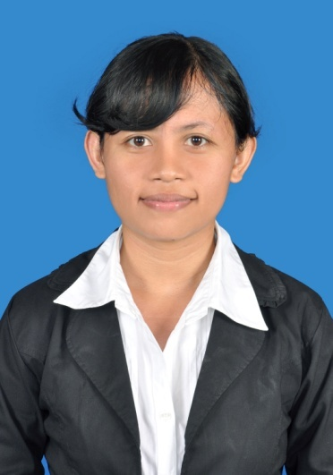 | Name  Place, Date Of Birth  Gender  Marital Status  Religion  Address  Phone  Email | :  :  :  :  :  :  :  : | Andrias Pratiwi  Kulon Progo, May 20th 1989  Female  Single  Christian  Parakan RT 54 RW 26, Sidomulyo, Pengasih, Kulon Progo, D I Yogyakarta  085643922463 / 087839440014  tiwiiast@gmail.com

EDUCATION
Last Education Description
Level Of Education |  | : | Bachelor Degree (Strata 1)
School Name, City |  | : | Sanata Dharma University, Yogyakarta
Majority |  | : | Informatics Engineering Study Program, Faculty of Science and Technology
From - Until |  | : | August 2007 – July 2014
GPA |  | : | 3.46
Title Of Thesis |  | : | Web-Based Hotel Information System Applying The Transaction Management
Previous Education Description
Level Of Education |  | : | Senior High School
School Name, City |  | : | State Senior High School 1 Wates, Kulon Progo
Majority |  | : | Science
From - Until |  | : | 2004 – 2007

WORK EXPERIENCE
[1]
From - Until | : | July 2016 – November 2016
Company Name | : | PT AQ Business Consulting Indonesia
Job Title | : | Programmer
Main Responsibilities | : | - Write and fix bug programs (mobile application: java-programming, android studio)  - Code front-end web development. (CSS, wordpress, cake-php, java-script, php)  - Test the program  - Analyze and design for mobile application
Project | : | Otomart, jalan2kejepang.com, pilihkartu.com, ayokuliah.id, android launcher for all web products
[2]
From - Until | : | July 2015 – July 2016
Company Name | : | PT Durio Indigo
Job Title | : | Programmer (Android Developer)
Main Responsibilities | : | - Write, analyze, review, and rewrite programs (use: java programming, android studio)  - Test the program  - Write API (use : php language)
Project Result (Mobile Application) | : | Dentes , RS Madani, do.Rent
[3]
From - Until | : | January 2014 – September 2014
Company Name | : | DSSystem
Job Title | : | Programmer (Internship)
Main Responsibilities | : | - Confirms project requirements by reviewing program objective, input data, and output requirements with analyst, supervisor, and client.  - Write, analyze, review, and rewrite programs (use: java programming and MySQL)  - Test the program  - Training users
Project Result | : | Hotel Information System
[4]
From - Until | : | June 2010 – August 2010
Company Name | : | PT. Diginet Media
Job Title | : | Internship/Practical Work
Main Responsibilities | : | - Define business objectives  - Design database structure for data warehouse  - Develop data architecture, data modeling, and ETL (Extract Transform Load) process.

SKILLS
Language Skills
Language | Spoken Level |  |  |  |  |  | Writer Level
 | 0 | 1 | 2 | 3 | 4 | 5 |  | 0 | 1 | 2 | 3 | 4 | 5
English
Indonesian
Technical Skills
Skills | Proficiency Level
 | 0 |  | 1 |  | 2 |  | 3 |  |  | 4 |  | 5
Operating System
Windows
Linux
Programming
VB.NET
C++
JAVA SE
JAVA Android
JAVA JSP
PHP
JAVA SCRIPT
Framework
ZK
Cake-PHP
Wordpress
Database
MySQL
Level Description: 0=None, 1=Beginner, 2 = Basic, 3 = Intermediate, 4 = Advance, 5 = Expert

ORGANITATION AND COMMITE EXPERIENCE
Year | Organization | Position
2010 | Indonesia Humanity Action/ Gerakan Kemanusiaan Indonesia(GKI) | Member
2009 | Initiation of Science and Technology Faculty/ Pekan Inisiasi Fakultas Sains dan Teknologi(PINNISI) | Coordinator of Group Dynamics
2009 | Personality Development Training, Sanata Dharma Universty/ Pelatihan Pengembangan Kepribadian Mahasiswa(PPKM) | Assistant trainer
2009 | Open House of Science and Technology Faculty | Member
2008 - 2009 | Informatics Engineering Students Community/ Himpunan Mahasiswa Jurusan Teknik Informatika(HMJTI) | Coordinator of Database Study Club

I herewith confirm that all my above statements are true and fully responsible for all the consequences.
Sincerely yours,
(Andrias Pratiwi)

