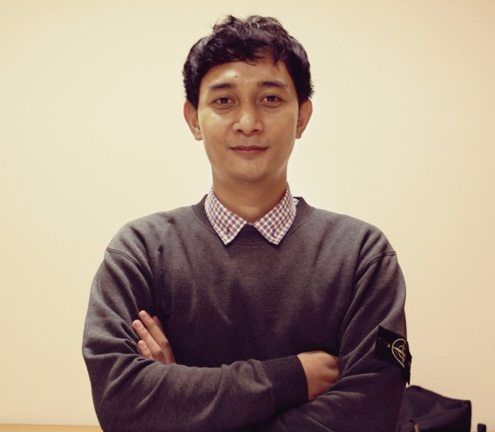
INDRA KUSUMA NUSANTARA
Personal Email: comeonyouindra@gmail.com
Phone: 083890001901
Portfolio:
Weebly: www.indramf.weebly.com
Werdsmith: http://werdsmith.com/indramf
Social Media:
Twitter: @weekendcasualco
Instagram: @weekend.connoisseur
Facebook: Weekend Connoisseur
LinkedIn: Indra Kusuma Nusantara
Address:
Jln. Pisangan Baru Timur III no 20 RT/RW 002/015 Matraman, Jakarta Timur. 13110

Objective
Helping companies and brands get their message across in clear, communicative and creative.
Develop ideas/solution and ensuring message consistency across mediums while keeping everything aligned with corporate/brand guidelines
Key statements: • Conceptualize and execute writer strategic • Market analysis through SWOT • Experience in City Branding • Manage and motivate the creative team • Good organizational skill and team player • Possess good presentation skill • Good verbal and written communication skill • Quick learner and communicative
I enjoy making new professional acquaintances. Reach me to discuss about strategy, writing, social media, gadget, and culture of football casual (against modern football)

Experience
Copywriter at Rhema Communications Branding Agency
(October 2011 - March 2012 )
- Official Website: www.rhemacomm.com
- Job Desk: Creating All content for Company Profile and Branding Packaging
- Client : Bam Decorient Indonesia http://www.baminternational.com
Company Profile x-block

Copywriter at MaxxcomAD (Omni Dynamic) Advertising Agency
(March 2012 - January 2013)
- Job Desk: Creating all Concept TVC, Print Ads and Radio Ads
- Client :
Carvil
Youtube TVC link: Freestyle "Futsal" Ipank Freestyler Indonesian https://youtu.be/atROexS2XUY TVC Varian Sepatu Futsal Carvil
- Nuriskin Ultimate
YouTube TVC link: http://youtu.be/8lsRrzqihAc TVC Nuriskin Ultimate "Yuni Shara"

Digital Copywriter at PT. Best Buy Home Shopping Indonesia Retail
(July 2013 - February 2015)
- Address: DKI Jakarta, East Jakarta (Indonesia) Office Phone: 021 29499999 Official Website: www.bbuy.co.id
- Job desk: All concept creative include strategic plan, Social Media Specialist, Creative content for all product and Re-branding Product

Head of Advertising at EMC2 Digital Agency (February 2015 – September 2015)
- Contact: Office Phone: 021-56957022 Official Website: www.emc-square.com
- Job desk: Supervise Social Media, Google Ads, Strategic Digital Campaign and Activation
- Client:
- Carvil Fan Page
https://www.facebook.com/pakecarvil (Supervise Social Media and Concept the activation)
- Sahabat Prega Movie
Bank Artha Graha http://sahabatprega.com/moviefest/ Film karya anak
- Freshkon Indonesia
http://www.freshkon.com/country/indonesia/index.htm (Create Facebook Ads and Google Ads)
- Soltius SAP Indonesia
Soltius http://www.soltius.co.id (Creating GDN and Google Ads)

Digital Strategist at PT. Englory Intertech (Caping Apps) (September 2015 – Current)
- Job Desk: Supervise all Social Media Strategic, Creating Brand identity, Supervise Design Concept, AdWords, & Video Concept.
- Website: www.caping.co.id
- Facebook: www.facebook/capingapp.com
- Instagram: @caping.app

Education
Elementary School
- SDN 3 Tanjung Karang (November 1994 - November 2000)
Junior High School
- SLTPN 2 Mataram (November 2000 - November 2003)
Senior High School (Social)
- SMUN 2 Mataram (March 2003 - April 2006)
University (Communication) - February 2006 - October 2011
- UPN "V" Yogyakarta Thesis topic: Perancangan City Branding Lombok - Sumbawa 2012

Project
- Djarum Black Tea
Case Study : https://youtu.be/5eV_pUBAYzU Case Study Djarum Black Tea
- Radio Ads Sweet version
Dubbing by Bob Santoso https://youtu.be/b1bylZUJ4pU Radio Ads Dies Natalies UNY 2011
- Radio Ads Telephone Version
Dubbing by Bob Santoso and Lenny Gunawan https://youtu.be/PlbsnX3IvDY Radio ads for Dies Natalies UNY 2011

- Organizational Skills
Project Management, Team Building and Collaborations.
- Professional Competencies
- Brand Development, Social Media Strategic, Google Ads, Scriptwriter, Corporate identities, Company profiles, Blogging,
- Computer Skills
Microsoft words, Excel, Power Point and Corel Draw
- Other skills
Playing Football and Surfing

