CURRICULUM VITAE

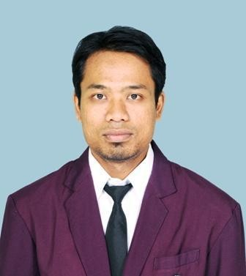Name : Ade Irwansyah
Perum Citra Kebun Mas Blok P1/40 Kec Majalaya, Karawang 41361 Phone : 0856 156 5210
Email : 354.ade@gmail.com

Profile

I has been working at PT ALMARON PERKASA. I have capability to learn fast, proven ability to work independently and as a teamwork with under pressure. I am seeking a challenging position that will give me the opportunity to develop my career, education level, working experience and knowledge. My expectation salary is 5 million rupiah.

Personal Information

Date of Birth : Jakarta, September 18th
,

1983

Marital Status : Married Hobbies : Music & Sport

Formal Education

2005 – 2010 STMIK KHARISMA KARAWANG
Bachelor Degree in Teknik Informatika 1998 – 2001 SMUN 101 Jakarta

Work Experience

April 2014 – present PT. ALMARON PERKASA
Drafter

Job Description :
Making 2d drawing, making shop drawing and as built drawing.

August 2013 – Jan 2014 PT. METROPOLIS PROPERTINDO UTAMA
Drafter

Job Description :
Making 2d and 3d drawing, checking drawing for project, control material on site, supervise and checking the qty or volume material.

Nov 2011 – July 2013 PT. KIDO JAYA
Staff Merchandiser

Job Description :
Control the production,control and follow up sample production, update comment and translate sample request, control raw material, checking PO, register PO and update, checking and update worksheet schedule, making worksheet, stylesheet and sample request.

Nov 2010 – Nov 2011 PT. KIDO JAYA
Staff Administration

Job Description :
To filling and update data sample department, communication with foreign employees , follow up and translate sample request to pattern maker and sewing worker, make PO embroidery and report.

Oct 2002 – Oct 2003 PT. Hung-A
Helper

Job Description :
To maintain the material supply for worker at Production department and update data production.

July 2001 – July 2002 PT. Astra Isuzu Casting Company
Warehouse Operator (PPC)

Job Description :
Update data raw material and checking the material, receiving material, arrange material position,to handle steel scrap and pig iron.

Course

Internet Literate.2000 – 2001 Lembaga Bahasa LIA Jakarta
Intermediate IV

