Curriculum Vitae

Personal information

Surname(s) / First name(s) |  | Rio Putro Utomo
Address(es) |  | Jl. Telagasari No.19A, Rumbai – Pekanbaru 28265
Telephone(s) |  | Mobile: 081222302697 | Phone: -
Fax(es) |  | -
E-mail(s) |  | rioputroutomo@gmail.com
Nationality (-ies) |  | Indonesian
Place and Date of birth |  | Boyolali, June 16th 1992
Gender  Religion  Height (cm) / Weight (kg) |  | Male  Moeslim  172 / 62

Work Experience and Training

Dates |  | November 4th 2013- February 3th 2014
Occupation or position held |  | Electrician and Mechanical
Main activities and responsibilities |  | Maintenance and repairing
Name and address of employer |  | PT. Creative Technology & Machinery
Type of business or sector |  | Technical

Education

Dates |  | 2011 - 2014
Title of qualification awarded |  | Diploma Degree
Principal subjects/Occupational skills covere |  | Mechatronic Engineering
GPA |  | 2.80 (scale 4)
Title of final project |  | Seruling Rekorder Otomatis
Principal subjects/Occupational skills covered |  | Milling, Turning, Bench Work, PLC, Pneumatic & Hydrolic
Name and type of organisation providing organisation and training |  | Department Mechatronic Engineering – Polytechnics Caltex Riau, Pekanbaru, Riau  UKMI (Rohis)  UKM Robot

Personal skills and competences

Mother tongue |  | Indonesian

Other language(s)
English |  | Understanding |  | Speaking |  | Writing
 |  | Listening | Reading | Spoken interaction | Spoken production
 |  | good | good | good | good | good

Social skills and competences |  | Team Work: I have been involved in PT. Creative Technology & Machinery. I learnt about how become a leader and also a member of group.
Organisational skills and competences |  | - Member of Moeslim Student’s Association  - Member of Mechatronic Engineering Student’s Association  - Member of Robotic student’s organization
Technical skills and competences |  | - Operating Milling machine, Turning machine, basic Welding, Bench Work. AutoCAD, CAM, SolidWork, PLC
Computer skills and competences |  | - Computer Literate Base on Windows Operating System  - Basic Programming with CodeVision AVR , Microsoft Visual Basic.  - Microcontroller and Interface.  - PLC Programming in Industrial Process.  - Installation of electrical machinery.  - Simulation of Pneumatic and Hidraulic with FluidSim.
Artistic skills and competences |  | - Technical Drawing with Auto Cad, Solidworks  - PCB Layout drawing with Express PCB, EAGLE layout editor
Attitudes |  | I am able to work independently or as part of team, strong team work, high responsibilities, honest, high motivation and eager to learn
Prestation  Academic |  | Certificate of Matriculation (October 2011)  Certificate of Internship Program as Electrician and Mechanical at PT. Creative Technology & Machinery (CHESO)

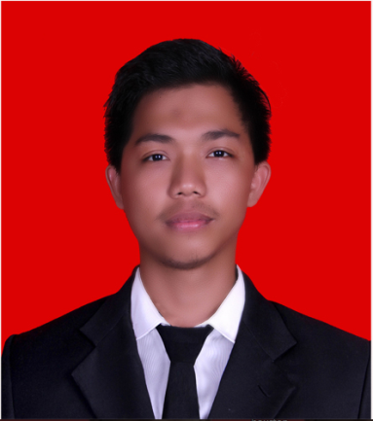

RIO PUTRO UTOMO
Diploma degree Polytechnic Caltex Riau
Mechatronic engineering Department
E-mail: rioputroutomo@gmail.com

