March, 2015

Dear Human Resources,
Please consider me as an applicant that your company has available.
I have completed my Bachelor Degree majoring in Human Resource Management from Sekolah Tinggi Ilmu Ekonomi Koperasi Malang in September 2014.
With my passion to work in your company, knowledge, and also my ability to adapt and work as a team, I believe that I could be very useful for your company.
I would appreciate to come in for an interview and talk further about my qualifications. I’m looking forward to hearing from you in the near future. A copy of my resume is attached. Thank you for your time and consideration.

Sincerely,

Karina Nerissa

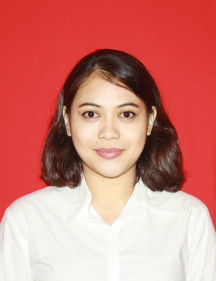
Curriculum Vitae

Personal Identities
Name : Karina Nerissa
Gender : Female
Marital Status : Single
Place of Birth : Surabaya
Date of Birth : January 24th, 1989
Address : Jl. Ikan Kerapu (Aspol Kolombo) 2 Surabaya
Phone / Mobile : 087854435324
e-mail address : contactkarina@yahoo.com / misskarinanerissa@gmail.com

Formal Education
2010 – 2014 S1 in Human Resource Management - STIEKOP Malang
2006 – 2008 D1 in System Administrator - PCP UNAIR Surabaya
2003 – 2006 SMA Trimurti Surabaya
2001 – 2003 SLTPN 2 Surabaya
1995 – 2001 SDN Perak Barat 1 Surabaya

Personal Skills
English (good written and oral skills)
Computer (MS. Word, MS. Excel, MS. Power Point)

Working Experiences
May 2012 – March 2013 Administrator in Acer Point NAM

“I hereby declare that all information above is true to the best of my knowledge.”

March, 2015

Karina Nerissa

