CURRICULUM VITAE

PERSONAL DETAILS

Name | : | Fuji Muliawati | 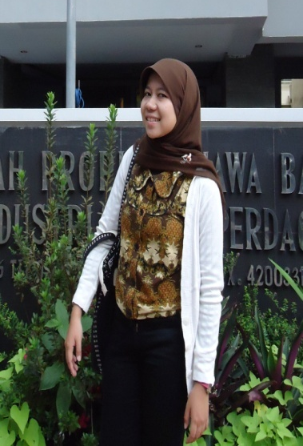
Gender | : | Female
Place and Date of Birth | : | Bogor, 13 September 1989
Religion | : | Islam
Adress 1 | : | Puri Nirwana 1 Blok T No. 30  Cibinong, Bogor
Adress 2 | : | Jl. Pejuangan gg. Mawar 2 Kebon Jeruk, Jakarta Barat
Phone Number | : | HP 085283751213
E-mail | : | fujishiro_yamatha@yahoo.com  violinstya@gmail.com
Facebook  Pinterest | : | @fujimuliawati  @foeddjii
Hoby | : | Reading books, Writing
Siblings | : | The 3rd daughter of 3 siblings
Height and Weight | : | 150 cm/ 44 kg

EDUCATIONAL BACKGROUND

1994 – 1995 | : | TK Puri Nirwana
1995 – 2001 | : | SD Negeri Ciriung IV Cibinong
2001 – 2004 | : | SMP Negeri 1 Cibinong
2004 – 2007 | : | SMA Negeri 1 Cibinong
2007 – 2012 | : | Universitas Pendidikan Indonesia Bandung, majored in English Literature (TOEFL-ITP: 530)  GPA 3,24

EXPERIENCES

Company | Position | Period | Year
iMoney Indonesia | Freelance Writer | 2 Months | Dec 2013 - now
Rajawali Citra Televisi Indonesia | Creative Promo | 3 years | Nov 2012- now
Portal.paseban.com | Freelance Writer | 8 months | 2011-2012
Department of Industry and Commerce, West Java Province | Export Section of Industry and Mining Products on Foreign Commerce | 2 months | 2011
PRIMAGAMA Antapani, Bandung | Part Time Teacher | 3 months | 2010
Coffeology Cafe, Bandung | Apperenticeship as a waitress | 2 weeks | 2010

COURSES

Courses | Period | Year
Mandarin Course at UPT Bahasa ITB, Bandung | 3 months | 2008
English Course at BBC English Training Specialist | 2 years | 2002-2004

SKILLS

Skills
- Ms. Office Literate (Word, Excel, Powerpoint)
- Internet Literate

