CURICULUM VITAE

- PERSONAL DATA

Full Name | : | Arinda Ayu Puspitasari |  |  |  | 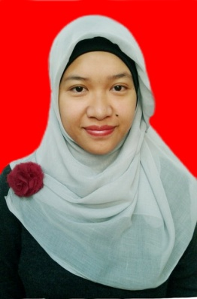
Address | : | Ranu Grati III / 61 RT. 05 RW. 01 Sawojajar  City : Malang Postal Code : 65139
Place, Date of Birth | : | Malang, May 21st 1991
Age | : | 24
Gender | : | Female
Tel (mobile / other) | : | 085655539063
E-mail | : | arindayu91@gmail.com
Interests / hobbies | : | Choir, Crafting, Drawing
Height (cm) | : | 162 cm | Weight (kg) | : | 60 kg
Shoe size | : | 40 cm

- EDUCATIONAL BACKGROUND

Date attended | Institution
1997 | Taman Indria III, Kindergarten, Malang
2003 | Purwantoro I, Elementary Schoo, Malang
2006 | Junior High School 5 / SMPN 5, Malang
2009 | Senior High School 1 / SMAN 1, Malang
2010 - now | Brawijaya University, Malang (GPA : 3,37)

- WORKING EXPERIENCE

Date attended | Company / Institution  (provide contact details of your direct managers / supervisors) | Brief description of duties / responsibilities
19th September 2013 – 28th February 2014 | PTIIK, Brawijaya University | As a lecturer assistant for Software Engineering lecture subject, my duty was to help the lecturer teach the students to build a software project

- ACHIEVEMENT and AWARDS

Date awarded | Brief Remarks
Desember 9th, 2013 | Gold C Medal for Folklore Category on A Voyage of Song, 10th Anniversary International Choral Festival, Bangkok, Thailand
Desember 9th, 2013 | Silver B Medal for Mixed Voices Choir (Open) Category on A Voyage of Song, 10th Anniversary International Choral Festival, Bangkok, Thailand
July 10th, 2012 | Silver Medal fo E Category (Folklore) on Festival Paduan Suara Institut Teknologi Bandung (FPS ITB) XXIII 2012, Bandung
July 10th, 2012 | Bronze Medal for D Category (University/Public) on Festival Paduan Suara Institut Teknologi Bandung (FPS ITB) XXIII 2012, Bandung
July 4th, 2011 | Silver Medal for Folklore Category on The 1st Bandung International Choir Competition, Bandung

- ORGANIZATIONAL EXPERIENCE

Date attended | Organization | Position | Brief Remarks
24-25th February 2012 | 2nd BaSIC Science International Conference (BaSIC) 2012 | Committee | 2nd BaSIC Science International Conference (BaSIC) 2012 is a conference that had been held by Faculty of Science Brawijaya University. The committee of this conference were the lecturer and the selected student. I had been chosen as student committee for this conference. My duties in this conference were maintaining the administration and as a moderator.
January 2011 – December 2012 | Student Choir of Faculty of Science “Cientifico Choir”, Brawijaya University | Secretary | Cientifico Choir is a student choir of Faculty of Science that has followed many choir competition from regional, national, and also international level. I had been chosen as secretary that responsible for the organization administration.
January 2010 – December 2011 | HIMAMASTER (Himpunan Mahasiswa Matematika Statistika dan Ilmu Komputer) of Faculty of Science, Brawijaya University | Secretary of Research and Development Division | Research and Development Division is one of division in HIMAMASTER that responsible in the student academic sector. I had been chosen as secretary that responsible for the division administration.

