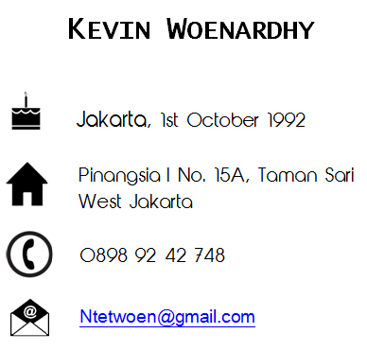
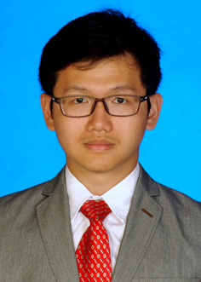

Job Experience

2014 Advanced Biotechnology for Plants Laboratory Assistant
My team and I were responsible to teach and assist students in advcanced biotechnology for plants laboratory experiments. My duties were making genetic transformation, preparing media and plant culture, isolate DNA and RNA from plants, and making data backups for the students’ experiments.

2013 Plant Tissue Culture Laboratory Assistant
My team and I were responsible to teach and assist students in advanced plant tissue culture laboratory experiments. My duties were multiplicating plants using plant tissue culture techniques, preparing media and plant culture and making data backups for the students’ experiments.

2012 Internship student as research and development at SEAMEO BIOTROP
I was responsible to figure out what was the best way to initiate the growth of Musa acuminata AAA or Cavendish banana using plant tissue culture methods.
Organizational Experience

2013 Atma Jaya Catholic University of Indonesia
- Chairman of Nature and Environtment Explorers’ Association Everest
- Committee of Rafting ‘Hydrophile’ as secretary and treasurer

2012 Atma Jaya Catholic University of Indonesia
- Chief of Operasi Bersih Sekitar Pantai (Obras) ‘CLOSE’
- Chief of Everest Basic Training and Education VIII
- Committee of Food Festival ‘Extasea’ as field coordinator
- Committee of Outbound 2012 ‘Olympic’ as security coordinator
- Committee of International Seminar on Advances in Molecular Genetics and Biotechnology for Public Education ‘BIO-EDU’ as staff
- Member of Nature and Environtment Explorers’ Association Everest

2011 Atma Jaya Catholic University of Indonesia
- Committee of Fun Hiking Everest as logistic and equipment coordinator
- Committee of Everest Basic Training and Education VII as evaluator coordinator
- Committee of Futsal League ‘MYT Challange’ as publication and documentation coordinator
- Committee of New Students Guidance ‘Paragon’ as security coordinator
- Mentor of New Students Festival committee ‘EARTH’
- Committee of Futsal Championship for Biology Students ‘Goblet of Biotech’ as staff
Educational Background

2010 – 2014 Atma Jaya Catholic University of Indonesia, Jakarta
Bachelor of Science from Faculty of Biotechnology
GPA : 3.19
Thesis : The Efficacy of Pithecellobium jiringa Biomolecule and Bioactive Fractions as Anti-obesity Agents Using 3T3-L1 Preadipocyte Model

2007-2010 Ricci I Catholic Senior High School

