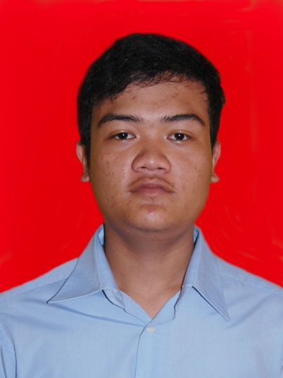
Wisnu Hadi Pamungkas

Wisnu.pa@students.amikom.ac.id
+62 822 4229 9899

OBJECTIVE  Loremipsumdolor sitamet, consecteturadipisicingelit, sed do eiusmodtemporincididuntutlabore et dolore magna aliqua. Utenim ad minim veniam, quisnostrud exercitation ullamcolaboris nisi utaliquip  EDUCATION OR QUALIFICATION  PROFESSIONAL EXPERIENCE OR TRANING  2014 – Present : Freelance technician of POINT-NET Sidareja, Cilacap  2013 – 2014 : Developer of NDESO Network (RT/RW Net) Sidareja, Cilacap  2010 – Present : Freelance technician of Adhyaksa Sarana Computer, Cilacap | AREA OF EXPERTIES  - Hardware & Software Troubleshouting  - Hardware & Software Instalation  - Basic Network Maintenance  - Basic Database Programing  - Photoshop image editing  PERSONEL SKILL  - Highly motivated  - Excellent imagination  - Attention to detail  PERSONEL DETAIL  DOB : Cilacap, 20 Maret 1992  Nationality : Indonesia  Languages : Indonesia, English  Marital Status : Single  Interests : Gaming, Traveling  Address : Jl Kaswari No 77, Mancasan Lor, Condong catur, Depok, Sleman, Yogyakarta

