CURRICULUM VITAE
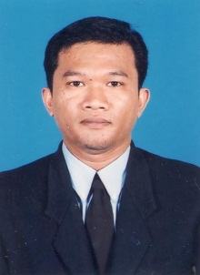
Putra Rio Kriswanto.
Address 1 : Perum. Purwomartani Baru Blok D-31 Rt/Rw 13/03.Purwomartani, Kalasan, Yogyakarta, 55571.
Address 2 : Jl. CInere Raya 9 Pintu 5 Cinere, Limo, Depok, West Java.
Handphone : 0856-42280944
Email : putrario2003@yahoo.com
Born 19 May 1977 at Pekanbaru, 37 years old, Married.

EDUCATIONS
1995 – 2000 College (Diploma 3).
Informatics Management Department - AMIK "AMIKOM" Jogyakarta.

1992 – 1995 High School.
SMUN 1 Purwakarta, West Java.

SKILL
IT – Computer Programming with Borland Delphi, Web design with Dreamweaver,Wordpress, CMS, Mysql, HTML, Troubleshooting, Maintenance, LAN.
Art Hand Drawing.

JOB EXPERIENCE
2009 until Now Enduro Center Yogyakarta
Self Employer as a programmer.

2006 until June 2009 PT. Jatelindo Perkasa Abadi.
August 2006 until December 2008 As a IT Technical Support Staff for Customer Billing Processing Application at PT. PLN (Persero) Yogyakarta.
01 January 2009 until 08 June 2009 As a Database Administrator (DBA) for Payment Point Online Bank (PPOB) server at PT. PLN (Persero) Central Java & Yogyakarta Region.

2003 until 2005 PT. Altekindo Jejaring Nusantara Solusindo.
As a IT Technical Support Staff for the System Online Payment Point (SOPP) Service at PT. PLN (Persero) Klaten, Central Java.

I HAD MAKE MANY DESKTOP PROGRAM APPLICATIONS
1. System Information for Laundry Service.
2. System Information for General Clinic at Yogyakarta.
3. System Information for Bakery & Cake Factory.
4. System Information for Sleeping Bed Factory.

LANGUAGE SKILL
English Writting and Speaking.

