Adya Nugraha Fattah
Bogor, 22 Oktober 1992
Puspasari Citeureup RT 02/03 Bogor, Jawa Barat
Mobile: 085716206071
Email: adya.nugraha@gmail.com

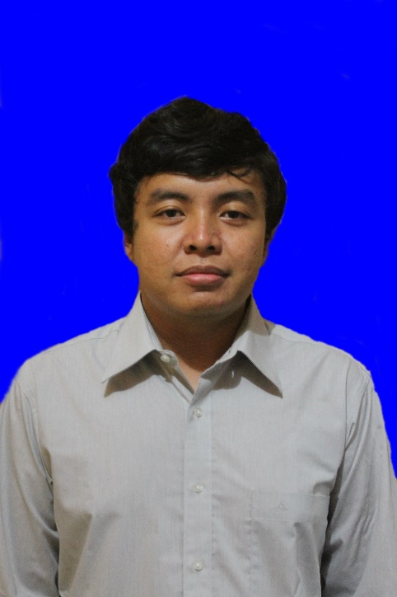

Formal Education

2010-2016 : History Majors. Universitas Indonesia. GPA (3.16)

2007-2010 : SMAN 2 Cibinong

2004-2007 : SMP Puspanegara

Key Skill Gained
- Analytical thinking
- Problem solving
- Data research & analysis
- Writing & editing

Organizational Experiences Highlights
- 2011 :History Camp. Chief of logistic Division
- 2012 :PSA/Mabim UI. Deputy Chief of Logistic Division
- 2013 :Pemira SKS UI 2013. Chief of logistic Division

Additional Skills
- Fluent in English (Oral and written)
- Able to work in team or independently
- Good written and verbal communication skill
- Good interpersonal skill
- Proefficient in Ms. Office/computer literate
- Translating

I am a fresh graduate from University of Indonesia, History Majors. I have several organizational experiences both at Majors or Faculty level, as a staff, a chief deputy, as well as a chief of a team. All of that experiences make me understand how to work in a team, as a team, or to be a leader of a team. My organizational experience also improve my interpersonal skill and problem solving ability. On the other hand, I learn a lot about writing history from my study at History Major. I understand how to verified a historical source such as documents, newspapers, books, statements, interviews, etc. All of that needs a good analytical thinking and good objective thinking.

I would like to utilize my analytical skill and problem solving skill on practical and fast paced environment world. Also, I would like to work with fellow professionals to further improve my skill and knowledge.

