FINAL TASK REPORT
SCHOOL YEAR 2013/2014
GRAPHIC DESIGN BASED ON COREL DRAW X3
IN HERO DIGITAL PRINTING
Purposed to Fulfill English Assigment of Writing Report and Presenting Report
Arranged By :
Septy Eka Basrina
30 / XII MM2

State Vocational School 6 Surakarta
38 LU Adisucipto Street Surakarta, 57142
Phone/Fax : (0271) 726036
Website : www.smkn6solo.com e-mail : info@smkn6solo.com
ratification

This report has been examined by the board of State Vocational High School Number 6 Surakarta and declared to have fullfiled The English Curiculum.
Arranged :
Day :
Date :

Guardian of Class XI MM2 Consultant

Dwi Fista Setyo Putri Dra. Noveani Warigaliati
NIP : 19830905 2010012 021 NIP : 19641114 199303 2 001

Hend of Department

Darsono SE, MM
NIP : 19740702 199802 1 001
PREFACE

Assalamualaikum Wr, Wb.
Alhamdulilah, the writer thanks to Allah SWT, because He always gives chance so the writer can finish this final task report. This report is written to fulfill English Assignment of Writing Report and Presenting Report.
By this report, I would like to thank to :
- Dra. Sri Supartini ,as a principal of SMKN 6 Surakarta.
- Mr. Irwansyah as Leadership of HERO DIGITAL PRINTING who has given license for author to Prakerin at HERO DIGITAL PRINTING for two months.
- Mr. Azzam Albarra and Mrs. Vidi Wulandari as working partner and as well as our mentors in HERO DIGITAL PRINTING.
- Darsono SE, MM as Chief of the Multimedia Program.
- Dra. Noveani Warigaliati, as a consellor teacher.
- Mrs. Dwi Vista Setyoputri as guardian of class XII MM 2.
- My Parents, friends, classmate, and all who help on both of competence exam or final task report.

The Writer believes that this report is still far away from perfect, so the writer accepts suggestions and constructive criticism from all readers. Finally, the Writer hopes that this report can be useful for all.
Wassalamualaikum Wr, Wb.

Surakarta, 11 November 2013

Writer
TABLE OF CONTENT

TITLE ................................................................................. 1
RATIFICATION .................................................................... 2
PREFACE ............................................................................. 3
TABLE OF CONTENT ............................................................ 4
- CHAPTER I. INTRODUCTION
  - Background ....................................................... 5
  - Objection .......................................................... 5
- CHAPTER II. PRODUCTION PROCESS
  - Setting ............................................................... 6
  - Material and Equiptment ....................................... 6
  - Theoritical Preview .............................................. 6
  - Scheme of Work ................................................. 7
  - Motion of Work .................................................. 7
  - Results ............................................................ 10
  - Materials Cost Counting and Selling Product ............... 10
- CHAPTER III. FINDING
  - Feasibility ......................................................... 11
  - Benefits ............................................................ 11
  - Improvement (Continued Actions) ............................ 12
- CHAPTER IV. CLOSING fcdfcd
  - Conclusion ........................................................ 13
  - Suggestions ...................................................... 13

REFERENCES ....................................................................... 15
APPENDIX ............................................................................ 15

CHAPTER I
INTRODUCTION

  - BACKGROUND
Nowadays, technology and information develop rapidly and have become a need for every part because technology and information can use as media to increase economy and communication. Development of technology and competition that is going to be more difficult makes human resources has to increase the quality of their skill.
Therefore, schools and other educational institutions have an important role, especially to produce human resources who have to face a high level of development and competition will become more difficult. So, it takes learning methods appropriate to the workplace.
So, as we know that Job Training is a learning process that is carried out of school that is proposed to increase student’s quality of competition and experience at work place, in this report I will discuss how to design using Corel Draw X3 , why use corel draw x3 ? because in my opinion , Corel Draw X3 easier to use , as well as in my prakerin , design activities using Corel , one X3 . I hope this report will be the future for you guys who want to do prakerin .

  - OBJECTIVE
In each activity would have any particular destination in which you want to accomplish. as an experienced on the run on the job training. this goal is also not for her alone but also for school and institutions work. Objectives that include :
- Produce a highly qualified workface, which is labor that has a lever of knowledge, skills work etnic according to the demands of jobs.
- Strengthening the SMK and match between the SMK and world of work.
- Improve the effectiveness and eficiency of the process of quality education and job training.
- Give recognition and appreciation of the work experience as part of the educational process.

CHAPTER II
PRODUCTION PROCESS

2.1 SETTING
As of time and place of Practice On The Job Training they are :
Date : Juni 1st up to August 31st , 2013
Place : Hero Digital Printing
Address : Ir. Sutami Street Number 54, Jebres
Working Hours : Monday – Saturday, at 08.00 am – 05.00 pm

2.2 MATERIAL AND EQUIPTMENT
the material and equiptment are used for helping On The Job Training :
- Computer
- Printing Machine
- Order
- MMT Material
- Scissors
- Cuter

2.3 THEORITICAL PREVIEW
Corel Draw is a vector graphics editor created by Corel, a software company headquartered in Ottawa, Canada. Corel Draw is a vector graphics editor created by Corel, a software company headquartered in Ottawa, Canada. Many different types and versions of Corel Draw, Corel from year to year is always updated, otherwise a lot anyway component - the component that was developed and put into each package Corel program in any version, but Corel itself already has the basic rules and regulations for each new product , among which the release version of CorelDraw Graphics Suite to include multiple programs or applications support it. In the Corel Graphics Suite X3 are miraculous supporting applications, such as Corel Photo-Paint (for bitmap editing), CorelShow (to make the on-screen presentation), CorelChart, CorelMove, Mosaic and CorelTrace.

2.4 SCHEME OF WORK

CUSTOMER

ORDERING

EMPLOYEE 1 EMPLOYEE 2 (THE WRITER)

PRODUCTION

CUSTOMER

YES NO

FINISHING

2.5 MOTION OF WORK
How to make MMT in Corel Draw X3 are as follows :
- First, open the Corel Draw X3 and select “New”.
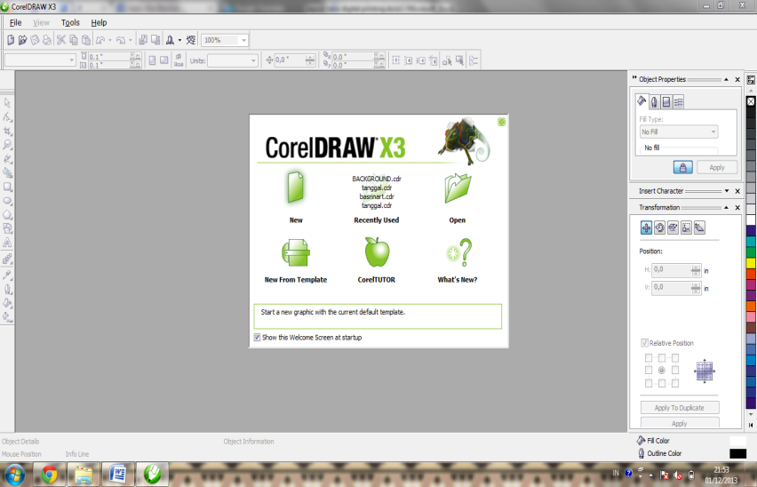

- Then, set the paper size to the design that will be created and also set the measurement scale.
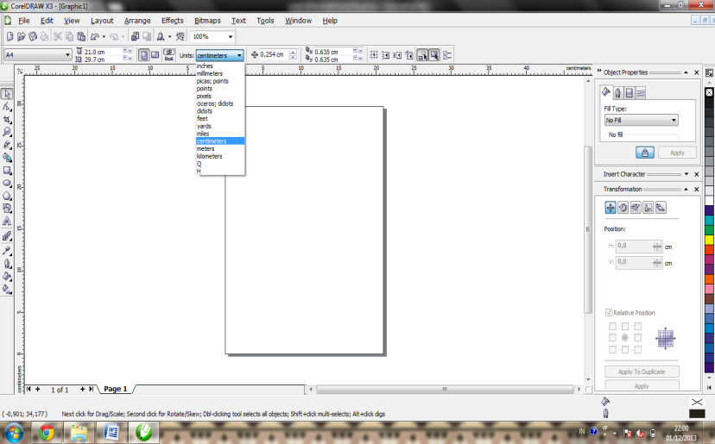
- Then, create a frame object to start making design MMT, such as the design of this rectangle, and set the size to be in the design.

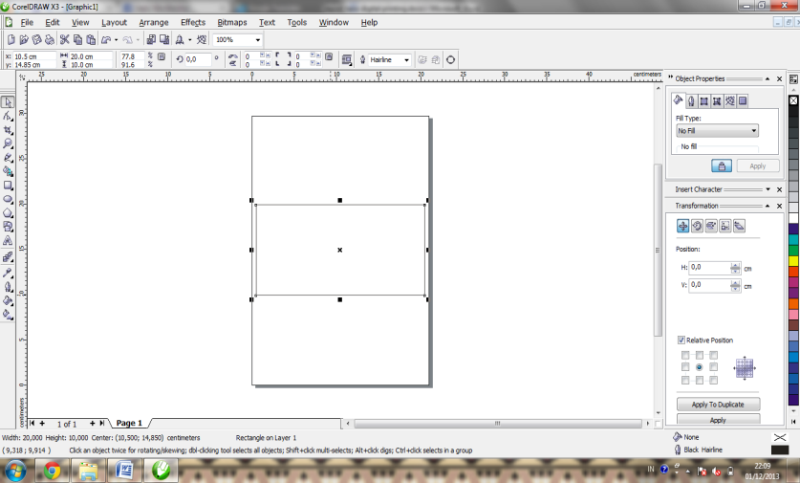

- Then, create a design that is desired by the customer, as much as possible do not need to create a design that is difficult to spend a long time, but make a simple design but still pleasing to the eye and in accordance with customer wishes.
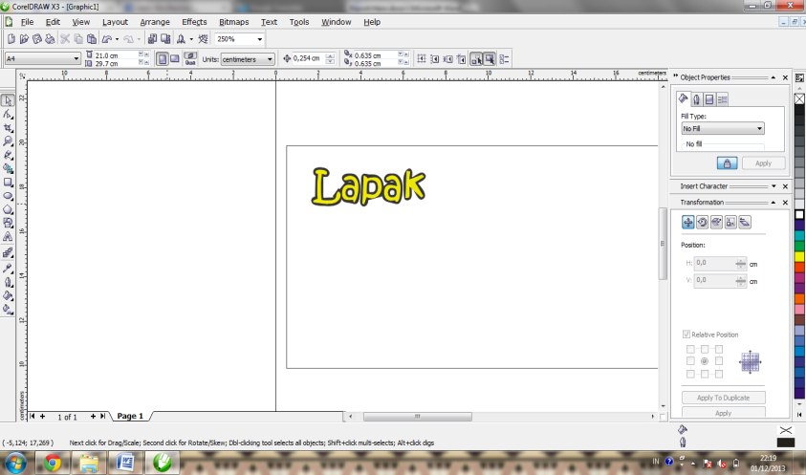

- After that, still continue to make the design until the design has been made in accordance with customer wishes.

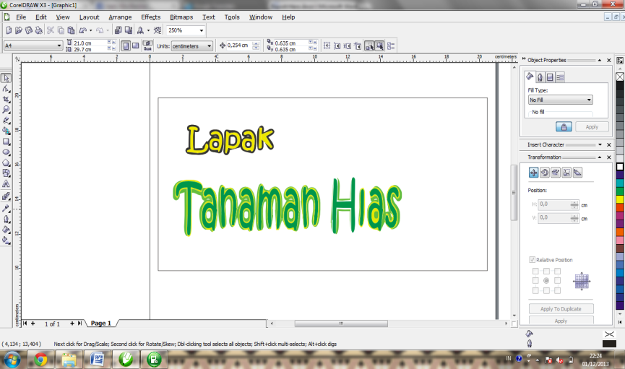

- Finally, MMT with ornamental design background or images that can beautify MMT supporters. and then the design has been completed.

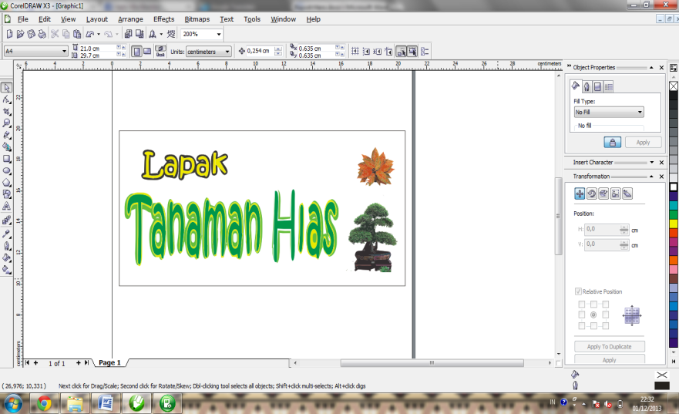

2.6 RESULTS
After the design is completed, then re-checking done by customers who booked in order to minimize mistakes, so that the customer will feel satisfied. Once the design is approved by the customer, the design will be printed mmt and the results obtained are more beautiful.

2.7 MATERIALS COST COUNTING AND SELLING PRODUCT
Counting the cost of materials and the sale of products is as follows :
- The cost of printing materials and MMT/meter : Rp 11.000,00
- MMT sales price / meter : Rp 17.000,00
- Gain on sale of MMT / meter : Rp 6.000,00

CHAPTER III
FINDING
3.1 FEASIBILITY
In a Job of course there are factors supporting and inhibiting factors, not least with other people also felt the author of two things.
- Supporting Factors
Supporting Factors are circumstances that make the writer comfortable when the writer working.
- The office atmosphere is quiet easy writer to work.
- Most customers do not want a lot of odd or complex designs.
- Tasks are divided according to their own field, so that the work becomes easier and faster completion.

- Inhibiting Factors
Inhibiting factors are circumstances that make the author uncomfortable when the author worked.
- The workplace is close to the highway so the atmosphere becomes noisy.
- There is no air conditioning in the room so it was hot work
- Often times there, hard work delayed - delay, so that when the costumer will come to take, which ordered unfinished.
3.2 BENEFIT
For trainees :
On the Job training activities can add insight about how the working world, here we can know the truth as to what the state of the working world, so that someday we can know that the world of work is very much different from when we were still at school bench. Filled with tougher competition course.
Get the knowledge :
In the world of work, the atmosphere feels more competition, if you've never felt the work would seem that the world would be so cruel, but when it is carrying out the On the Job Training, may someday be better prepared for the world of work.
3.3 IMPROVEMENT
For School :
- The practice period should be extended field work, not only for two months, so that students can further deepen the knowledge about the world of work.
- School should maintain good relations with the institutions that have been used for student field practice activities, so that no confusion later juniors looking for a place to be used for On The Job Training.
- A review or supervision of students should be tightened when students were conducting field work practice, so that when the activity has ended, there is a risk that may not be detrimental to the school and students.

For Instance Part :
- Consumer confidence in the company should be preferred, so that later the company obtained the increase in quality and a good image for customer satisfaction.
- Improve financial management so that companies do not always experience a great loss.
- Not delay the work that may be soon solved.
- Always maintain harmony among employees in order to carry out the work becomes energetically.
- Always work together in order to clean the work space into a comfortable atmosphere.

CHAPTER IV
CLOSING
4.1 CONCLUSION
From explanation and observation the writer while doing dual vocational training at cooperative, the writer conclude that:
- Hero Digital Printing has good organization structure that reflects function separation and position description that distinct so it helps all function in implement the tasks and each responsibility.
- Administration financial department must be careful and high concentration at work to avoid mistake of making financial statement.
- World of work/ industry does not only need human resource that has best score in theory, and also human resource that has high skill in practice.
- Dual vocational training gives positive impact and forms student’s mental, attitude to be more creative and innovative.
- Dual vocational training increases insight and experience in real work of world.
- Best service for consumers is the number one thing on an industrial design.
- Dual vocational training test could increase the feeling of believing in your self in world of work.

4.2 SUGGESTION
Suggestion to School
- Compromise and relation that has done with instance part still awake and more increased.
- Consultation about school competency standard by mentors from school with mentors at prakerin place.

Suggestion to Instance Part
- Do increase of a rule that written or unwritten.
- Do promotions in order to increase sales so can get maximal profit.
- Do increase discipline of management and employees.
- Further improve the financial management arrangements that are not chaotic.
- More solid cooperation between employees.
- Discuss problems that occur in the company by way of discussion.
- Further improve and maintain customer confidence.

REFERENCE
http://dianablog.blogspot.com/reportdualvocational
Krisnani,Yiyis, et al. 2013. English for Vocational Schools, Book III. Yogyakarta: LP2IP.
APPENDIX

