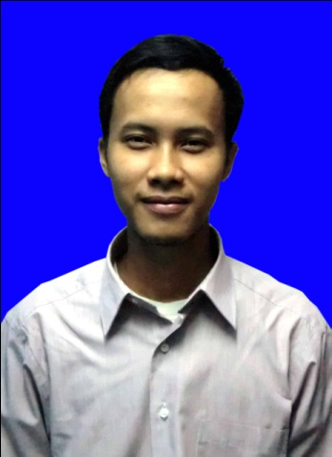

AAN ANGWAR

Jl. H. Baping Susukan - Ciracas
Phone: (HP) 0838 0741 2154, 0897 1561 072
Email : aan.angwar@gmail.com / aan_chykal804@yahoo.com
____________________________________________________________________________________________________

O B J E C T I V E
Looking for a creative and challenging position in other company that enables me to
gain valuable commercial experience and improve the skills.

____________________________________________________________________________________________________

I D E N T I T Y
Place & Date of birth : Cirebon, April 08th, 1990 Sex/ Gender : Male
Marital Status : Single Religion : Islam
Citizen : Indonesian KTP Number : 3175090804900007

____________________________________________________________________________________________________

E D U C A T I O N
- College BINA SARANA INFORMATIKA, Jakarta, Indonesia. Majoring: Management of informatics, Graduation year 2013.
- College NUSA MANDIRI, Jakarta, Indonesia. Majoring: Information System, still in course.

____________________________________________________________________________________________________

S K I L L S
- Database
Oracle, Mysql, MS Access
- Programming
HTML, PHP, CSS, Visual Basic, JavaScript, Java, Jquery.
- Software & Design Tools
EditPlus, Dreamweaver, Photoshop, CorelDraw, AutoCad.

W O R K I N G E X P E R I E N C E S

Pharmacy, PT. Harsen, Jakarta, 2007 - 2014

QC (January 2007 - February 2010)
- Check the product and make a report In Proces control in the laboratory.
- Make a report of the short and long-term products stability.
- Create reports of the retained incoming product samples.
- Control main production and supporting materials.
- Input and maintaining stocks data in the system.

Registration Officer (March 2010 – December 2013)
- List new products and prolong the distribution license’s number to National Agency for Drug and Food Control (BPOM).
- Makes the data for registration to the National Agency for Drug and Food Control (BPOM).
- Create new products packaging design.

Staff QA (January 2014 – September 2014)
- Review the ongoing Batch Record.
- Check the ongoing production report and register one.
- Make reports on the batch production of hormones and tracking date.

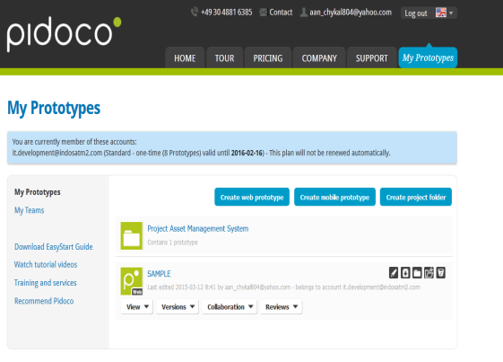
Information and Technology Consultant, PT. Gratia Tekhnologi Internusa, Jakarta, February 2015 – Present.
Client : PT. Indosat Mega Media (IM2)
Position : Junior Programmer
Project Title : Supporting Project Asset Monitoring System (AMS) Ver.2.0
Project Date : January 2015 - March 2015
Software : Oracle, PHP, HTML, CSS, Javascript, Pidoco
Description : Design Mockup Application for Asset Monitoring System (AMS) with software pidoco application.

____________________________________________________________________________________________________

R E F E R E N C E S

Available upon request

________________________ _________________________________________________________________________

