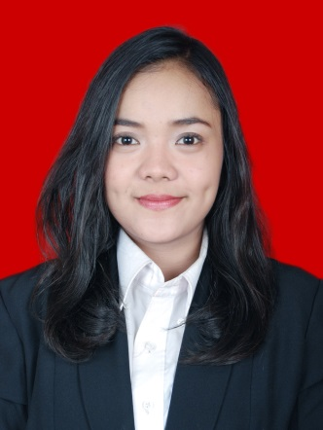
CURRICULUM VITAE

Name : Rahajeng Miranti
Nick Name : Ajeng
Place, Date of Birth : Pontianak, April 10th 1991
Gender : Female
Identification Number : 3174075004910008
Religion : Islam
Nationality : Indonesia
Address : Jl. Senopati no. 26, Kebayoran Baru. Jakarta Selatan
Occupation : Sarjana Teknik Informatika dan Matematika,
Bina Nusantara University
Phone Number : 082111975310
Email : rahajengmiranti@gmail.com

Educational and Professional Qualification
Education Information
Periode
Sekolah / Institusi / Universitas
1996-1997
TK KENARI KARAWANG
1997-2003
SDS ABDI NEGARA BEKASI
2003-2006
SMP Negeri 2 Bekasi
2006-2009
SMA Negeri 9 Bekasi
2009-2014
Bina Nusantara University

Education Non Formal Training / Seminar/ pengalaman pekerjaan

- LIA Cabang Galaxy
- IEC
- New Concept
- Bina Nusantara English Club
- BVoice Radio
- Himpunan Matematika, Bina Nusantara University
- Seminar Broadcasting Knowladge
- Seminar Aplikasi Matematika dan Teknik Informatika dalam kehidupan sehari-hari
- MC PENSI
- MC Seminar, Expo, Ultah, Matic
- Reportase JJF, Java Rockin Land, and many more event
- crew BLITZMEGAPLEX

Language
Language | Reading |  |  | Writing |  |  | Speaking
 | Good | Fair | Bad | Good | Fair | Bad | Good | Fair | Bad
Indonesia | ■ | □ | □ | ■ | □ | □ | ■ | □ | □
English | ■ | □ | □ | ■ | □ | □ | □ | ■ | □

Activities and Organization
Bvoice Radio | Reporter | 2009
Bvoice Radio | Produser | 2010
Bvoice Radio | HRD (Skill and Development) | 2011
Expo HIMMAT (HimpunanMatematika) | MC  (6 days) | 2009
MATIC (Mathematic and Statistik Competition) | MC | 2009
Expo MATIC | MC  (5 days) | 2010
Seminar Bvoice Radio “Broadcastknowledge VIII” | Attendant | 2010
MATIC | Staff Acaradan Reporter | 2010
Pro-Art (profilartis) Bvoice Radio | Reporter | 2010
Seminar MatematikadanPenerapan | MC | 2010
Ultah HIMMAT | Staff Acara | 2010
Seminar Bvoice Radio “Broadcastknowledge IX” | KonsumsidanPerlengkapan | 2010
BAKSOS | Acara | 2010
Studi Banding ke Global Radio | Attendant | 2010
Training Camp Bvoice Radio | Konsumsidanperlengkapan | 2010
MATIC | Acara | 2011
Ultah HIMMAT | Acaradan MC | 2011, 2012
BLITZMEGAPLEX | Crew | 2011
Abang None Jakbar | Semifinalis | 2012
Risolle | Ceo | 2012
Pusakamerahputihfundbike 17845 | Koordocumentasidan booth | 2012
Studi Tour kePrambors Radio | PenanggungJawab | 2012
Menpora sport festival with traxfm | Produser | 2012
Hackton Windows 8 | Peserta | 2012
Blessing from Universe | Publikasidankoor fashion show | 2012
Java Jazz Festival | Scanner ID | 2013
Java Festival Production | Internship proyek mobile application for iphone | 2012
Job Expo BINUS University | Laison officer Bank Mandiri | 2012
FIF Astra | Internship marketing analisis | 2013
Jakarta Fashion Week | Crew | 2013
T.E.E.W.O | Crew | 2014
PT. Huarui Logamindo Pacific | Bisnis and development | 2014

Warm regards,

(Rahajeng Miranti)

