Nuranto Hadyansah
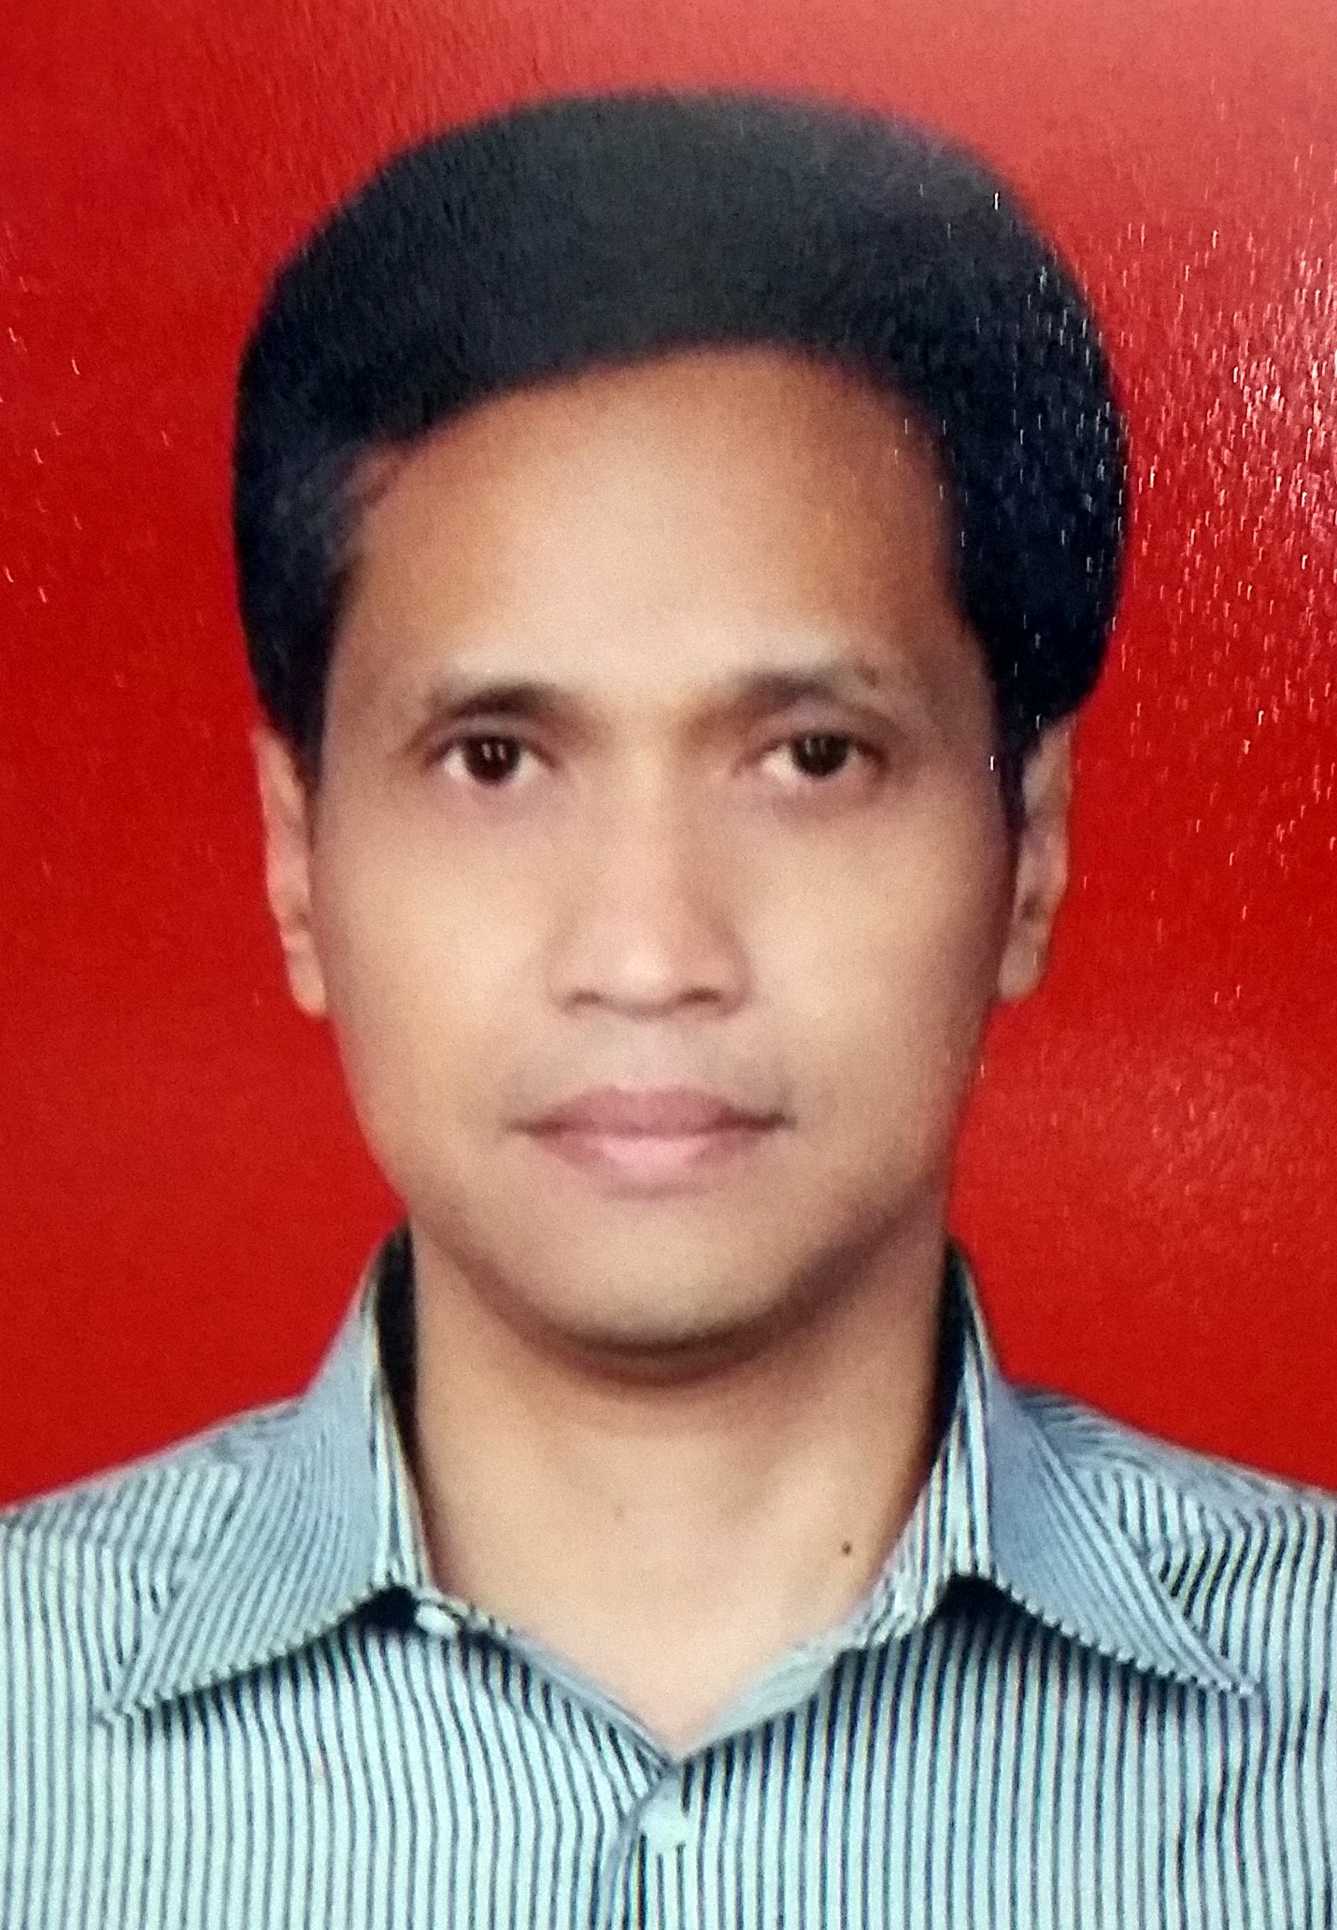
Jl. Mangga No. 7E, Jakarta Selatan
HP. 081905000120
nuranto.hadyansah@gmail.com

Experience:

HR Business Partner Head; PT Bank CIMB Niaga
2008 – Present, Jakarta
- Aligns business objectives with employees and management in designated business units. Serves as a consultant to management on Human Resource related issues.

Organization Development Head; PT Lippo Bank
2006 – 2008, Karawaci
- Coordinates, monitors & ensures Organization Development to ensure organization structure accommodate company needs and provide professional analysis in job design, analysis and evaluation.

Training Head; PT. Lippo Bank
2005 – 2006, Karawaci
- Manage Training & Development in order to ensure that Bank’s internal and external training are in line & support the company’s policies and strategy

HR Relation Manager & Career Development Head; PT. Lippo Bank
2003 – 2005, Karawaci
- Ensures & monitors delivery of all HR services executed by HR representatives in area/branches

Resourcing & Assessment Head; PT Lippo Bank
2000 – 2003, Karawaci
- Managed assessment center to support employee development and individual career movement.

Human Resource Head; PT. Olympindo Multi Finance
1999 – August 2000, Jakarta
- Manage recruitment, selection and placement processes
- Manage Performance Management System, Payroll System & GA matters

Human Resources Manager; PT. Sigma Cipta Caraka
- – 1999, Jakarta
- Manage Training & Development in order to support the company’s strategy & business, Payroll System & GA matters

Personnel Officer; PT. Astra International - Honda Sales Operation
September 1991 – April 1996, Jakarta
- Management recruitment operation & conduct/provide assessment acitivity.
- Coordinates performance appraisal activity .

Education:

- S1, Psychology, Universitas Indonesia
- S2, Manajemen, Universitas Indonesia

Interest & Achievement

- Writing
 | Novel Ranggamorfosa |  | Novel  Kondominium Lantai 9

- Blog https://btarasurya.wordpress.com/category/cerpen/
- Photography https://www.flickr.com/photos/nuranto/

I am HR Business Partner of a large bank in Indonesia with 24 year experience in recruitment,assesment, organization developement, performance management, industrial relation & reward management. I have strong interest in writing & photography.

