CURRICULUM VITAE
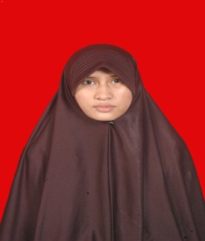
PERSONAL DETAILS
Names : Rufaidah
Place and Date of Birth : Jakarta, 31th October 1997
Sex : Female
Address : Jalan Kuningan H-12, Yogyakarta
Marital Status : Single
Telephone Number : 0895337708933
Email : rufaidah310@gmail.com
EDUCATION
- September 2016 Indonesian Language and Literatur Education at Yogyakarta State Universty
- 2016 Finished Senior High School (MAS ANNAJAH)
- 2012 Finished Junior High School (SMPIT DAQTA)
- 2009 Finished Primary School (SDN MALAKA JAYA 08 PG)

OTHER SKILLS

- Memorize Al – Qur’an
- Karate
WORKING EXPERIENCE
- 2014 -2015 Teachers Mufrodat
- 2015 Companion Halaqah
- October 2015 Teaching Practice
- Januari 2016 Practice of Propaganda Society

ORGANISATIONAL EXPERIENCE
- 2014 – 2015 Secretary of OSHAN
- 2015 Seminar Organaizes
- 2016 Turn Caretaker Committee
- 2016 Active in Karate Student Activity Unit

