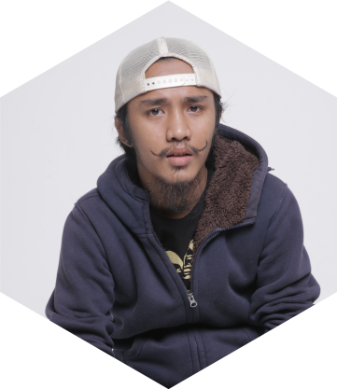
M. KHAIRUL ROZZI
MENTENG JAYA RT 7/10 NO.8
MENTENG, JAKARTA PUSAT 0888 1902 4 22
rozzirock1013@gmail.com
Adobe Premiere
Video & Photography
MS. Oflce Content Write

I am a fun person, able to adapt quickly to the new working environment,
has an attitude that is easy going and simple person, appropriate work processes and likes new challenges, high creativity and assess problems into opportunities Had the ambition and able to refrain from pressure

2010 - 2013
VOCATIONAL HIGH SCHOOL 16 JAKARTA (BUSINESS MANAGEMENT)

2015 - PRESENT
STTI – STIENI JAKARTA ( TECH INFORMATH )

Retail Assistant And Fashion Advisior Armani Exchange, PT.Club21 Retail Indonesia,Jakarta – Senayan City Mall (October 2013- October 2015)

Achievements and responsibilities:
- Assist customers in the purchase of goods
- Perform Service Excellence in Sales
- Achieve targets individual salles
- Make planing sale items every month
- Administration of daily and monthly reports
- Changing the appearance of Customer according to customer

Creative StaV Production Mataharimall.com (October 2015 - Present)

Responsibilities :
- Monitor the development of all products submitted by a seller to dipublished in web views MatahariMall.com
- Creating a theme for the company's advertising campaign
- take photo product or fashion and create a video campaign to socmed
- Help the totality of what is needed production team
- writing content and control the quality of the product that will be sold on the web

