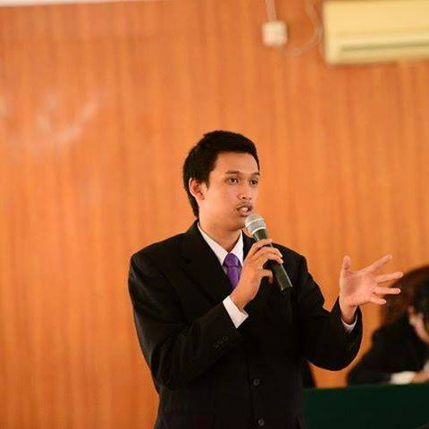

Personal Information :
Name : Adeant Alfa Parici
Date of Birth : 26th July 1995
Place of Birth : Palembang, South Sumatera, Indonesia
Educational Background :
- Elementary School : SDN 192 Palembang (2000-2006)
- Junior High School : SMPN 4 Palembang (2006-2009)
- Senior High School : SMAN 6 Palembang (2009-2012)
- College : Sriwijaya University (2012- Present)
- Faculty / Major / Specializations : Law Faculty / International Law

Experiences :
Organization Background
- Vice Chief of Class Assembly in Senior High School 6 Palembang (2010)
- Chief of Politics Organization and Leadership Division in School Council in Senior High School No. 6 Palembang (2011)
- Member of Purna Paskibraka Indonesia (2011)
- Staff of Alumnus Division in ALSA LC UNSRI (2013)
- Manager of Moot Court Division in ALSA LC UNSRI (2014-2015)
National Event in ALSA
- Delegates of National Seminar and Workshop ALSA INDONESIA, Manado (2013)
- Delegates of ALSA Indonesia Legal Course and Visit (KPK, SSEK LAW FIRM) , Jakarta (2015)
- Delegates of ALSA National Moot Court Competition, Banda Aceh (2015)
- Achievements
    - Best Judges
    - Best Procecute
    - Best Attorney.

- National Seminar and workshop ALSA INDONESIA, Palembang 2015 as a chief of workshop in comittee (2015)
Other achievement
- Best “Students Orientation” Project Officer in Palembang (2010)
- 2nd winner Paskibra competition (2012)
- 1st winner Paskibra Competition (2012)
- 1st winner of constitution tribunal moot court competition internal dean cup, faculty of law, sriwijaya university (2015)
- Best Player in Moot Court Competition Internal Dean Cup (2015)

Committee In ALSA LC UNSRI

Friendly Night  Name of Event | Vice of Project Officer  Role | 2012  Period
OLMA  Name of Event | Chief of Equipment  Role | 2013  Period
ALSA Parents Socialization and Inauguration  Name of Event | Vice of Project Officer  Role | 2013  Period
Seminar Lokal ALSA LC Unsri  Name of Event | Chief of Public Relation  Role | 2014  Period
Annual Ability 1st  Name of Event | Staff of Event  Role | 2013  Period
ALSA English Competition 2013  Name of Event | Chief of Equipment  Role | 2013  Period
Anniversary ALSA LC Unsri  Name of Event | Awards Coordinator  Role | 2014  Period
National Seminar and Workshop ALSA INDONESIA | Chief of Workshop  Role | 2015  Period

Committee In Other event
 | SEA GAMES 2011  Name of Event | Volunteer  Role | 2011  Period
 | Islamic Solidarity Games  Name Of Event | Volunteer  Role | 2013  Period
 | International Seminar “
 | Students Orientation Law Faculty of Sriwijaya University  Name of Event | Vice Project Officer  Role | 2015  Period

