Curriculum Vitae |  | 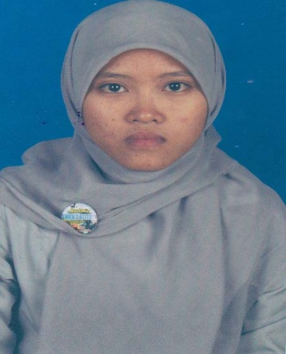
Personal information
First name(s) / Surname(s) |  | Nurchalimah/ Nurchalimah
Address(es) |  | Dsn. Ngandengan Ds. Tegalrejo, Kec. Selopuro, Blitar 66185, East java (Jatim),Indonesia
Facebook/Twitter/Instagram |  | Nurchalim99/@nuriyajinki/@nuriyajinki
E-mail/skype |  | nurchalimah51@yahoo.co.id ; facebook:nurchalim99
Nationality |  | Indonesia
Place/Date of birth |  | Blitar/26 July 1992
Gender |  | Female
Education  1997-1998 |  | “Al-Hidayah” Kindergarten
1998-2004 |  | State Elementary School 03 Tangkil, Wlingi
2004-2007  2007-2010  2011-2015  (August) |  | State Islamic Junior High School Jambewangi, Selopuro  Public Vocational High School 02 Blitar  Sekolah Tinggi Ilmu Ekonomi “Indonesia” Pontianak
Computer skills and competences |  | Theoritical and Pratical = Satisfactory
English Skills |  | Writing = Intermediate  Listening = Intermediate  Speaking = Intermediate
Thesis |  | Analysis of The Factors that Influence Brand Loyalty to The Product Telkomsel in Pontianak (a Case Study on Management Students of STIE “Indonesia” Pontianak)
Grants and Fellowships |  | Fund from DIKTI of Scholarships Achievement (2013), Rp. 5.400.000
Work Experience
2011-2015 (August) |  | PT. Sukma Karya Sejati Branch Office of Pontianak as Administrative Staff
2014 (December) – now  Portfolio Writing |  | Freelance writer  - www.behijab.com/blog  - www.dailymuslimah.com  - www.carajadikaya.com  - www.mediakalbar.com  - www.tokopipabesi.com  - www.designkainprinting.com

