Curriculum Vitae

Personal Information
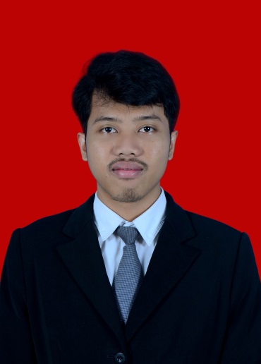

4 x 6

Name : Yudhi Kristanto
Current Address : Jl. Kenanga Raya Blok D1/1
RT 05/008 Taman Cibodas,
Tangerang, Banten. 15138
Contact Number : 0856 1874 786 / (021) – 55 33 226
E-mail Address : yudhikatoo@gmail.com
Place & Date of Birth : Tangerang, December 5th, 1994
Gender : Male
Marital Status : Single
Nationally : Indonesia
Height / Weight : 168 / 65

Education

University: Mercu Buana (2012 - 2016) | GPA: 3.3
Faculty: Computer Science
Major: Information System | Focus Major: Maintenance
Estimate of Graduated: June 2016
(2009-2012) SMA Negeri 4 Tangerang
(2006-2009) SMP Islamic Centre Tangerang
(2000-2006) SD Negeri Taman Cibodas Tangerang

Work Experiences

2014 : Chief Executive of “Pameran Akbar” Information Systems Events.
Chief Executive Seminar for Students University.
2015 : Participated in the Event Tangerang Cisadane Festival 2015
IT Support & Maintenace Service in Metrodata
2016 : Team Leader of BigBadWolf’s Crew 2016
Organizational Experiences

2015 : Member of BEM (Badan Eksekutif Mahasiswa) in Mercu Buana
University
2013-2015 : Member of HIMSISFO (Himpunan Mahasiswa Sistem Informasi) in Mercu
Buana University
Member of GTRWPALA Communities

Professional Skills

- Software:
  - Ms. Office : Ms. Word, Ms. Excel, Ms. PowerPoint,
  - Program : Visual Studio 2010, Android Studio
  - Adobe : Photoshop, Premier
  - Others
- English (passive)
- Good Attitude, Communicative, Diligent, Tolerant, Target Oriented, Discipline, Honest, and Responsible.
Seminars

Year | Detail | Institution
2016 | Seminar Nasional “Supersemar dan Implikasinya Bagi Peradaban Bangsa Indonesia” | Mercu Buana University
2015 | Certificate of Accomplishment “ SAP Course “ | PT. Harfian Tri Megah (EDUGATE)
2015 | Entrepreneur Seminar “YoungPreneurship” | Mercu Buana University
2015 | “Seminar of Motivation for Life to be An Entrepreneur” | Mercu Buana University
2014 | “ Aplikasi Berbasis Web Menggunakan Framework Yii PHP ” | Mercu Buana University
2013 | “Personal Confidence to Global Competition” with Koran Sindo | Mercu Buana University
2013 | “Karakter Sukses” Untuk Membentuk Kompetensi Personal & Etik Organisasi di Masa Depan | Mercu Buana University
2012 | Seminar Menteri Negara Lingkungan Hidup RI “Ketahanan & Keutuhan Bangsa Melalui Pelestarian Lingkungan Hidup di Kalangan Generasi Muda” | Mercu Buana University
2012 | “Membangun Kota Berbasis Kearifan Lokal” with Ir. H. Joko Widodo | Mercu Buana University

