Ana Rahayu October 13 , 2014
Perum Malau Permai Blok D/3
Jl. Suka Karya Kel Tuah Karya Panam
081378925912
Anarahayu11@gmail.com

To
Director of Personnel
Sribulancer.com

Dear Mr/Ms Director of Personnel:
I am pleased to submit my application for the position of Translator Pekanbaru. I am 33 years old, Married, Graduated from Communication Major, UNSOED Purwokerto Central Java. Having experience in teaching English for years in some English courses in Purwokerto and in Pekanbaru.
I would gladly welcome an opportunity to have an interview with you at your convenience. I hope my skills can be one of your company's assets. I am looking forward to hearing from you in the near future. Thank you for your consideration and attention.

Sincerely,
Ana Rahayu

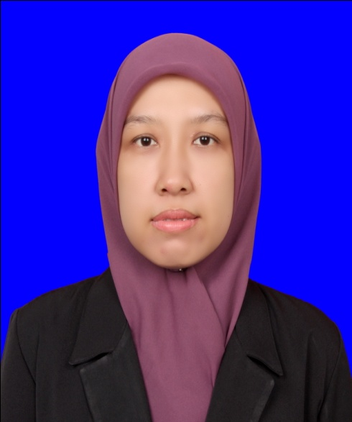

ANA RAHAYU

PERSONAL INFORMATION
Place of birth: Banyumas, Central Java
Date of birth : November, 27th .1980
Sex : Female
Marital Stat : Married
Citizenship : Indonesian
Ethnicity : Javanesse

ADDRESS
Perumahan Malau Permai Blok D/3
Kel. Tuah Karya, Kec Tampan
Kotamadya Pekanbaru. RIAU

CONTACT PERSON
Mobile : +6281378925912
Email : anabai_27@yahoo.com

PERSONAL DATA

Education
High School (SMU) SMU Negeri 1 Banyumas Jawa Tengah.
Bachelor Degree (S1) Majoring Communication Science, Faculty of Social Science,General Soedirman University (UNSOED) Central Java.

Work Experience
May 2005 – May 2009. Lecturer
Wijayakusuma University, Faculty of Social Science. Purwokerto Central Java
Job Responsibilities
Preparing material for teaching, delivering material in teaching and give evaluation after teaching process. I taught several lesson such as: English, Political Communication, Sosiology of Indonesia. Handled a monthly journal in Social dan Political Faculty.

November 2006 – August 2008. English Trainer
International College (IEC), Education Department
Job Responsibilities
Preparing material for teaching, delivering material in teaching and give evaluation after teaching process.

March 2010 – Dec 2011. English Tutor
Easy Speak Branch Pekanbaru. Education & Program Department.
Job Responsibilities
Preparing material for teaching, delivering material in teaching and give evaluation after teaching process.

Training/Courses
2006 National Seminar English Teaching Methodology Provided by International College. Purwokerto. Central Java
2007. Training of Methodology of Research Provided by Wijayakusuma University Purwokerto. Central Java
2008 Multimedia Training Proveided by Wijayakusuma University Purwokerto Central Java
2008. Training of Methodology of Research Provided by Wijayakusuma University Purwokerto. Central Java
2009. Training of Research Methodology of Women Investigation Provided by Muhammadiyah University Purwokerto. Central Java

Related Skills
Indonesian (Native) and English (Good) both speaking and written; computer literacy (word,excell,powerpoint,etc); good teamwork; coaching, facilitating and good interpersonal skill.

