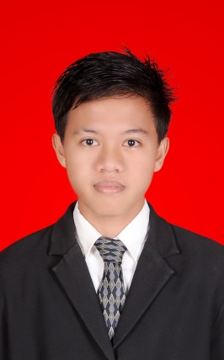

CURRICULUM VITAE

Complete Name | Kiki Usman
NIK | 1602 0501 0194 0017
University | State Polytechnic of Sriwijaya

CURRICULUM VITAE

- SELF IDENTITY
Name : Kiki Usman
NIK : 1602 0501 0194 0017
Place and Date of Birth : Kayuagung, 01 January, 1994
Gender : Male
Marital Status : Single
Religion : Islam
Address : Jl. Lunjuk Jaya Lrg.Tembesu No.2266
Bukit Besar Palembang.
Telp/ Fax : 0857-88742088
E-mail : Kikiusman111@gmail.com

- EDUCATIONAL BACKGROUND
Year of Graduation | Educational Program | School / Collage | Study Program
2006 | Elementary School | SD Negeri 3 Kayuagung
2009 | Junior High School | SMP Negeri 1 Kayuagung
2012 | Vocational High School | SMA Negeri 1 Kayuagung | Social Science
2015 | University Level | State Polytechnic of Sriwijaya | Informatics Management

III NON FORMAL EDUCATION

Year of Graduation | Educational Program | School/Collage/Uni | Study Program
2012 | Pascal | Bina Insan Profesional | Pascal

IV PROFFESIONAL TRAININGS
Year | Training Program | Hosts | Duration
2012 | Diksarlin Polsri | State Polytechnic of Sriwijaya | 6 days
2014 | Movie coaching clinic - Menuju Gemilang FFI 2014 Sumatera Selatan | Swarna Dwipa’s Hotel | 1 day
2014 | Work Shop Make Up Movie Effect - Menuju Gemilang FFI 2014 Sumatera Selatan | Swarna Dwipa’s Hotel | 1 day
2014 | Work Shop Berita Ringan – Anniversary 7th Sriwijaya TV | The Jayakarta Daira’s Hotel | 1 day

V WORKING EXPERIENCES
Company | Position | Departments | Duration
PT. PLN (PERSERO) WS2JB RAYON KENTEN PALEMBANG | Trainee | Teknologi Informasi (TI) | 1 Month

VI SCIENTIFIC MEETINGS
Year | Activities | Hosts | Duty
2013 | Menuju Indonesia 2020 | State Polytechnic of Sriwijaya | Participants
2014 | Limitless Breaktrough with Technopreneurship | State Polytechnic of Sriwijaya | Participants

