Name : Steffani
Place, Date of Birth : Jakarta, 25 September 1995
Address : Cluster San Fransisco
Q4/46, Kota Wisata,Cibubur
Phone : 08568842987
Email : fanisteffani07@gmail.com

Curriculum
Vitae
2016
Personal Details
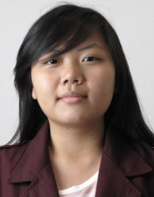

Organizational Experience

2013 - 2014 | Staff of Social Division  Binus Square Student Committee 4th Presidency  From this organization, we participate in making many events in our dormitory and that is Binus Square. I’m one of the social division that making many charity events like goint to one of orphanage house in Jakarta. And I also participate in “Japanese Culture Week” event as Sponsorship Staff and “Maestro” music event as a Secretary. From this Organization I learned how to work in team and how to move others to work too.
March 2015-  July 2016 | Mentor Scholarship  Student Advisory Centre Binus University  As a Mentor, I’m responsible in helping other Binusian that need help in their study, the staff of SAC will decided the pairing, and we are responsible of their study in one semester and I’ve been a mentor for 3 semesters and from this experience I learned how to communicate with different kind of people and how to persuade others to study.

Education
2010 | Major in Science  Bunda Hati Kudus Senior High School
2013 | Management - eBusiness  Bina Nusantara University | GPA: 3.87

Interests
Skills

Microsoft Office  Managerial  Punctuality and Time Keeping  Quick Learner  English | Learning Foreign Language (Currently Studying Korean Language)  Cooking  Planning

