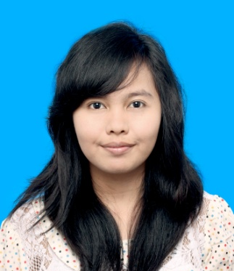
CURRICULUM VITAE

Personal Information
Name : Fransiska Dwiningsih Renwarin
Date of Birth : 21 May 1992
Nationality : Indonesia
Home Address : Jl. Nuri Dalam No. 21 Wagom, Fakfak, Papua Barat
Current Address : Puri Nugraha Boarding House
Jl. Ampel No. 27, Papringan, Sleman
Mobile Phone : 085292621113
E-mail : fr.drenwarin@gmail.com

Education
1998-2004 : SDN 01 Fakfak Papua Barat
2004-2007 : SMP YPPK Don Bosco Fakfak Papua Barat
2007-2010 : SMA Pangudi Luhur Sedayu
2010-2014 : English Language Education Study Program,
Sanata Dharma University
Language Proficiency
No. | Language | Competence
 |  | Reading | Writing | Listening | Speaking
1. | Indonesia | Very good | Very good | Very good | Very good
2. | English | Good | Good | Good | Good

Achievement
Presenter of Linguistic Paper in Universitas Ahmad Dahlan TEFL International Conference (2012)
Experience
- LO in Closing Ceremony of Darmasiswa Scholarship (2013)
- Interpreter in HAN University Sharing Knowledge Event with students of PGSD Sanata Dharma University (2014)
- Interpreter in ROTA- QATAR Volunteering Trip Indonesia. Bayat, Klaten 12-17 April 2014
Working experience
- Tutor of English language Extracurricular SMP Pangudi Luhur 1 Yogyakarta (2011 - now)
- Tutor of English Course in Seminari Anging Mamiri batch 2012 (June-July 2014)
- Translator of Abstracts and papers in education

Interests: New cultures, language, communication and public relations

