Curriculum Vitae
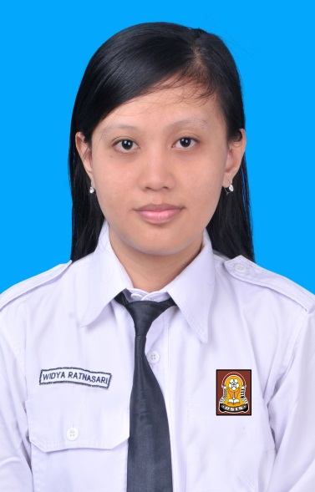
Name : Widya Ratnasari
Place, date of birth : Tuban, June 2nd 1995
Age : 18 years old
Sex :Female
Religion : Moeslem
Nationality : Indonesia
Address : Jl. Patimura GG. Pandansari 609 Tuban
Phone Number : +6289688907888
Email :widwidyaratnasari@gmail.com
Father’s Name : Andi Widiatnoko
Parent’s Address : Jl. Patimura GG. Pandansari 609 Tuban

EDUCATION
- FORMAL
2011 – now :Vocational High School Telkom Sandhy Putra Malang
2008 – 2011 : Junior High School 1 Tuban
2002 – 2008 : Elementary School Kutorejo 2 Tuban
2000 – 2002 : Pertiwi Kindergarten Tuban
- NON FORMAL
2000 – 2006 : SEMPOA SmartOne Tuban
2007 – 2008 : MADANI English Course Tuban
2011 : LP3i English For Teenager
ORGANIZATION
- Sie Ibadah Badan Dakwah Islam SMK TELKOM Sandhy Putra Malang 2011-now
- Purna Pasuka Pengibar Bendera 17 Agustus SMK TELKOM Sandhy Putra Malang 2011
- Sandhy Putra Informatic and Technology (SPITEC)
SKILLS
- LANGUAGE
- Indonesia
- Javanese
- English
- Operating System
- Windows XP, 7.
- Linux Debian 5

- Programming Language
- HTML
- Javascript
- PHP
- CSS
- ASP.NET (C#)
- DELPHI
- C++
- Web Design
- Dreamweaver
- Graphic Design
- Corel Draw
- Photoshop
- Flash
- 3ds Max
- Adobe Premier
- After Effect
- Office Tools
- Microsoft Office
- Database
- MySQL
- Microsoft Access
- Able to makes static web and dinamic web
- Able to troubleshooting computer.
SEMINAR AND WORKSHOP
  - Seminar Wikusama Festival 2 (2013) and 3 (2014)
  - Discipline Training at LANAL Malang (2012)
  - Work Training at PT. Gamatechno Yogyakarta (2013)
  - Training Speedy at TELKOM kacab. Tuban (2012)
WORK EXPERIENCE
Name of corporate : PT. Gamatechno Yogyakarta
Info jobs : Service
Activity :
- Make wiki of division
- Make tutorial video for user
- Input data
- Study gtfw (gt framework)

PORTOFOLIO
    - Web Application Reserving Online for a Regency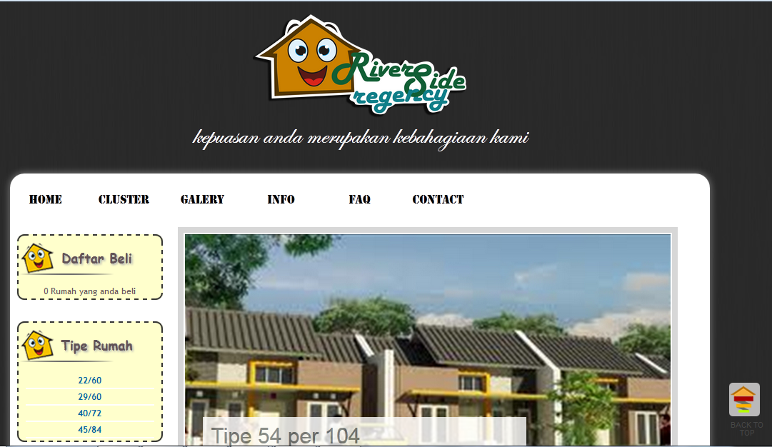

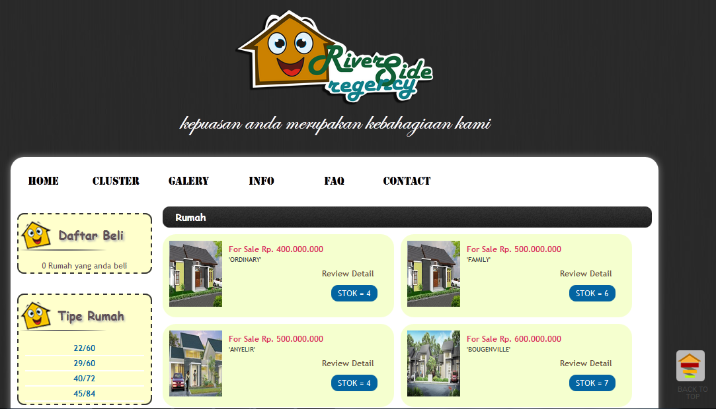

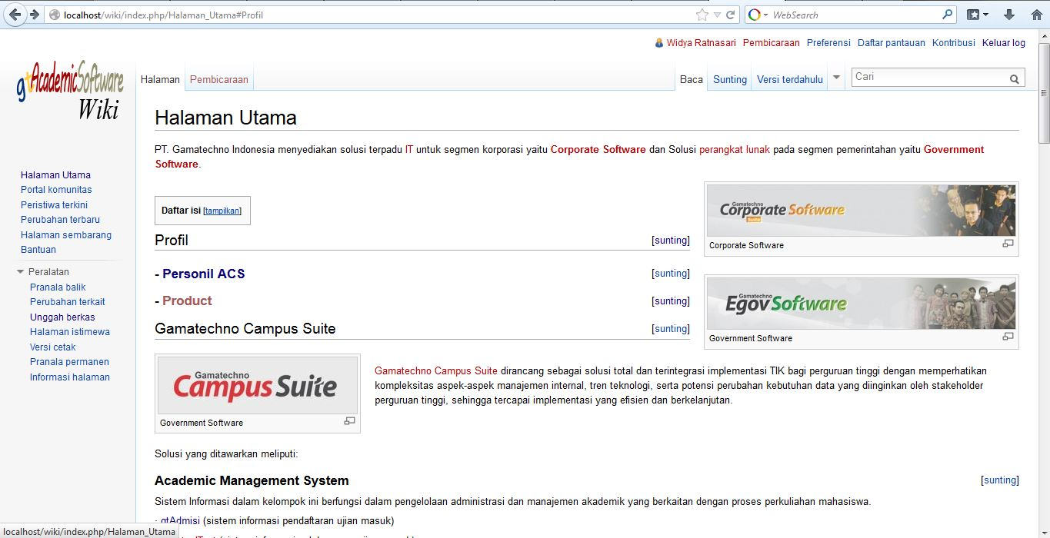
    - Wiki for GT Academic Software

Malang, Februari 18th
Sincerely,

Widya Ratnasari

