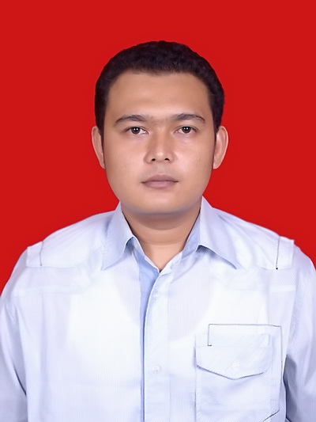
Curriculum Vitae

Personal Details

Full Name | Putrama Fajri S.EI
Place, Date of Birt | Maur 29 April 1985
Sex | Male
Nationality | Indonesia
Education | Bachelor Degree
Marital Status | Married
Height, Weight | 170 cm, 75 Kg
Religion | Moslem
Address | Jln. Ir Soetami No 096. Jr. Sei Padi, Kel. Lubuk Gadang, Kec. Sangir, Kab Solok Selatan, Sumatera Barat
Mobile Phone | 082390108579
Email | fajriputrama01@gmail.com

Educational Background

- Perguruan Tinggi Swasta Sekolah Tinggi Ekonomi Islam (STEI) Yogyakarta Tahun 2003-2006

Course & Education

- English Course at Excelent Course Centre Padang Panjang
- Computer Course at LPK PB Padang Panjang
- Training about Bank Perkreditan Rakyat Syariah di STEI Yogyakarta
- Training about Syariah Banking Operation Programe (SBOP) di UMY Yogyakarta
Qualifications
- Accounting & Administration Skills (Journal Printing & Calculation, Petty Cash Payroll & Calculation, Inventory Controls, Project Data Updating, Teller, Salary Calculation)
- Computer Literate (MS Word, MS Excel, MS Power Point, MS Access, MS Outlook).
- Internet Literate

Working Experience

- Working at PNPM Perkotaan Pariaman
Periode : Sept 2014 – Now
Position : Economic Consultants

- Working at PT. HARTA AMAN PRATAMA General Insurance
Periode : Oktober January 2014 – August 2014
Position : Surveyor

- Working at PT. Bredero Shaw Indonesia
Periode : Jan 2013 – October 2013
Purpose : Contract
Position : QC/ Tally
Job Description:
- Record Number and Inspect bare pipe to coating production
- Organized and record stacking pipe
- Quality Control just good pipe can to be Load out to client
- Working at PT. Asuransi Astra (an Astra International Group)
Periode : Feb 2007 – March 2012
Purpose : Permanent
Position : Surveyor
Job Description:
- Serve Customer who Claim Insurance
- Make decision about claim (approve/ reject) and how to replacement
- Inventory Part and Salvage
- Cost Claim Control
- Complaint Handling
- Filling File
- Reporting
- Administration buying to Workshop

Sangir, 29 Januari 2015
Putrama Fajri

