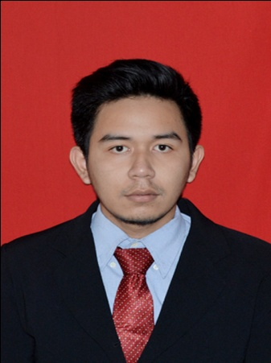
RIFQI FAUZAN

Fresh Graduate and Seeking a Professional Career

0857-7117-4440 | r_fauzan2612@yahoo.com | 22 years old | Cilandak, South Jakarta
Born  Address  Previous | December 26,1992, Jakarta  Jl.KH.Muhasyim 4 No.7f Rt.012/06,West Cilandak,South Jakarta  Internship Student (2014)  Bilateral and Regional Division  Foreign Cooperation Center, Ministry of Forestry, Republic of Indonesia
Education | Syarif Hidayatullah, Islamic State University (UIN) of Jakarta  Bachelor Degree on International Relations (at August 2015)
GPA | 3.17 (4.00 scale)
Nationality  Religion | Indonesia  Islam
Expected Salary | IDR. 4.000.000 (Negotiable)
I consider myself as a very open minded person with a strong communication skill both in working environment and daily life. I am also known as an energetic and friendly individual who has excellent time management. In working environment, I am accustomed to work independently and as a flexible, supportive team member or leader.

Education History

- Formal

1998 – 2004 SDI Raudlatul Ilmiyah, Islamic School of Jakarta

2004 – 2007 MtsN 3 Pondok Pinang, Islamic Junior High School of Jakarta

2007 – 2010 SMAN 46 Jakarta (Social Science Student)

2010 – 2015 UIN Syarif Hidayatullah, Jakarta (Bachelor Degree on
International Relations)

- Non Formal

2007 – 2010 Arabic and English Language Basic Course in LBI
(Lembaga Bahasa Internasional)

2008 – 2009 English Language Conversation Course in LIFRA

2008 – 2009 Studying Cinematography in X-KUL TV

2009 – 2011 English Language for Adults Course in LIA (Elementary,
Intermediate, and High Intermediate Levels)

Skill and Profile Gained
Advance | Analytical on Domestic, Regional and Global Politics, Economic, Security and Social Issues;
 | Good English both Spoken and Written;
 | Basic France and Arabic Spoken;
 | Presentation Skill; (Ms.Office, Prezi, Movie Maker)
 | Telephoning Courtesy; Survey and Marketing
 | Conduct Qualitative Research; Structure, Analysis, Data Input,
 | Translating, and Editing

Work Experience
Jan 2014 – Feb 2014 | Internship student
1 month | Ministry of Forestry Republic of Indonesia| Jakarta Raya  (Bilateral and Regional Division)
 | Responsibilities
 | Search some articles about international organization who has relation with Ministry of Forestry Republic of Indonesia and attend some meeting and socialization about new program which held by the Ministry
Organization Experience
Aug 2015 – Present | Member at International Relation Alumni Community in my Collage
Aug 2014 – Sep 2014 | Event Division of Community Service Program (KKN)
Feb 2014 – Present | Member of WALHI (Wahana Lingkungan Hidup)/Sahabat WALHI

