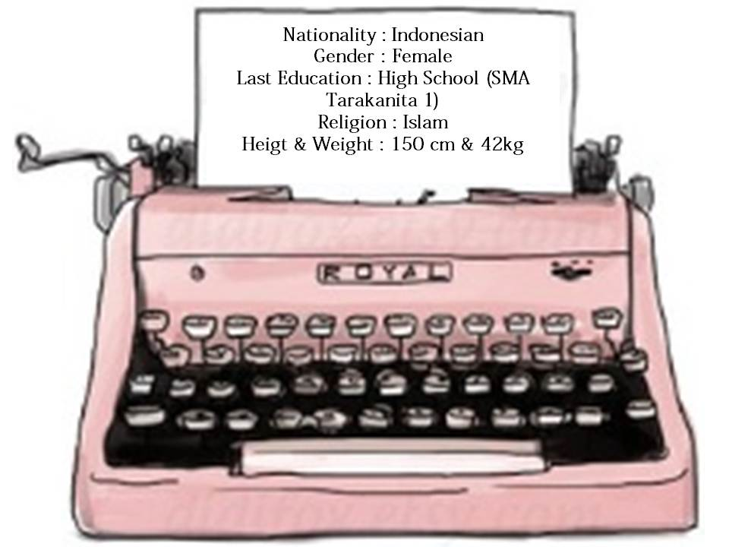
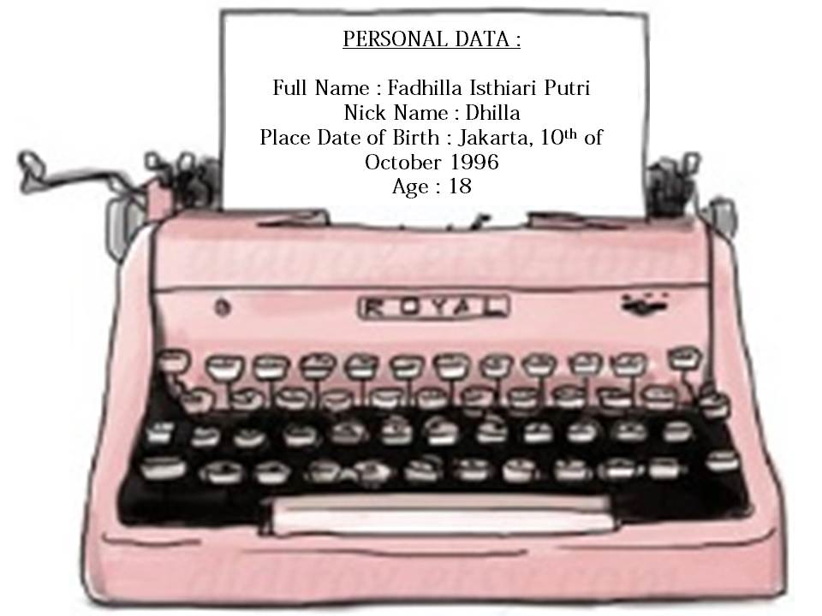
FADHILLA .
●●●
CURICULUM VITAE OF..
●●●

f

FORMAL EDUCATION :
- 2003 - 2008 : SD Al - Fath
- 2009 - 2011 : SMP Pangudi Luhur
- 2012 - 2014 : SMA Tarakanita 1
- 2014 – Now : Binus University, Major in Accounting & Finance

INFORMAL EDUCATION :
- 2001 : GLOVI (Global Vision Education)
- 2007 – 2008 : COMPUTERKID Learning Center
- 2012 – 2014 : Ultimate Learning Institute (English Course)
- 2012 – 2014 : FUTUREPRO held by SMA Tarakanita 1 collaborated with BSW GRAMEDIA

ACHIEVEMENTS :
- 2010 : Certificate Of Mural Art Competition held by Electro Green City representing
SMP Pangudi Luhur, 3rd Place
- 2012 : Certificate Of Completion of English Course by Ultimate Learning Institute,
with a final grade: “A”
- 2013 : Certificate Of Completion of English Course by Ultimate Learning Institute,
with a final grade: “A”
- 2014 : Certificate Of Completion of English Course by Ultimate Learning Institute,
with a final grade: “A”
- 2014 : Certificate Of Completion of Computer Course by FUTUREPRO in associates
with BSW GRAMEDIA, with a final grade: “ISTIMEWA”

THE EXPERIENCES :
SKILLS & PERSONALITY
.Fine editing pictures and making crafts on Coral Draw software.
.own a website: www.fadhillaisthiari.wix.com/creatingspaces
.Able to work in group or individual.
.Well-socialized person.
.Great Responsibility.
.Fluent in english.
.Ambitious person.
- 2009 – 2010 : Member of “Densus 89” (responsible to trains scouts of 1st grade of Junior High School)
- 2010 : Member of “PLCS” or Pangudi Luhur Cheers Squad (responsible to finding a coach from Indonesian Cheerleading Community, and manage the team to join some competitions)
- 2011 : Fund Committee of “TARQ CUP XV”, A Competition Cup of Sports, art,
and education held by SMA Tarakanita 1
- 2014 : Fund Committee of “TARLEXANDRIA” (“Pentas Seni” that held by SMA
Tarakanita 1)
- 2014 – Now : Activist of “HIMA” (Himpunan Mahasiswa Akuntansi) In Binus University

Similarly, the resume I created with truth and truth can be accounted for.
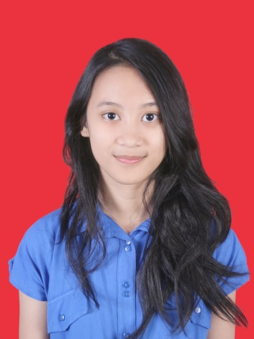

Jakarta, 26th Of October 2014

Fadhilla Isthiari Putri

