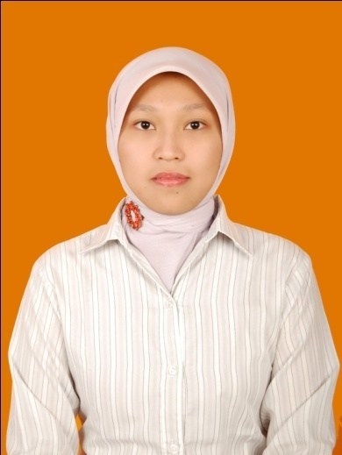
CURRICULUM VITAE
Novita Rahma Ekasari, S. ST
Jln. Merdeka No. 5B Gondek,
Mojowarno, Jombang 61475
Phone : 085746052740
Email : fie86_cute@yahoo.com

PERSONAL DETAIL
Gender : Female
Marital status : Married
Birth Date : Trenggalek, 12 November 1986
Religion : Muslim
Nationality : Indonesian
FORMAL EDUCATION
1992 – 1998 : MI Sullamuddiniyah Jombang
1998 – 2001 : SLTP A. Wahid Hasyim Tebuireng Jombang
2001 – 2004 : SMU Negeri Ngoro Jombang
2004 – 2008 : Telecommunication Engineering Department
Electronic Engineering Polytechnic Institute of Surabaya (EEPIS)
Institut Teknologi Sepuluh Nopember (ITS) Surabaya
GPA : 3.21 ( scale 4)
PRACTICAL SKILL
Microsoft Office : Ms.Word,Ms.Power Point,Ms.Excel
Language : English

NON FORMAL EDUCATION
SINCE | SUBJECT | ORGANIZER | CITY
2003 | English Course (Elementary One) | LEC | Jombang
 | English Course (Elementary Two)
2006 | English Course (Mastering Intensive English) | HARVARD | Kediri
 | English Course (Focus Grammar 2) | UNIVERSE
 | CISCO Training – CCNA1 | PENS - ITS | Surabaya
2009 | External Training  ”Achieving Service Excellence by Effective Selling at Contact Center” | PT. Mitracomm - Telkomsel | Surabaya
2010 | External Training  ”Motivation and Communication Skill” | PT. Mitracomm - Telkomsel | Surabaya

RESEARCH STUDY
NAME | SUBJECT | SINCE
PT. Telekomunikasi Indonesia, Tbk  Kandatel Malang | Operation System & Component to Arrange Central System of NEAX61E and EWSD in Malang Area Network | 2007
Signal Processing Laboratory – Research Study of Speech Signal Processing Team | Word Segmentation Processing to make data based corpus in Indonesian Language | 2008
“EEPIS I-Studio” PENS - ITS  (SMS Gateway) | Final Project Team (SMS Application for Election Song in Radio Brodcast System) | 2008

CAREER HISTORY
SINCE | POSITION | CITY | COMPANY
2007 | Maintenance Staff | Malang | PT. Telekomunikasi Indonesia
2011 | Lecturer | Jombang | Universitas Darul Ulum
2009 - 2011 | Caroline Officer | Surabaya | PT. Telkomsel – Mitracomm Ekasarana

Sincerely Yours,

Novita Rahma Ekasari, S. ST

