Contoh Portofolio Marketbiz.net

www.sriabiratuvilla.com

www.thegrandbali.com
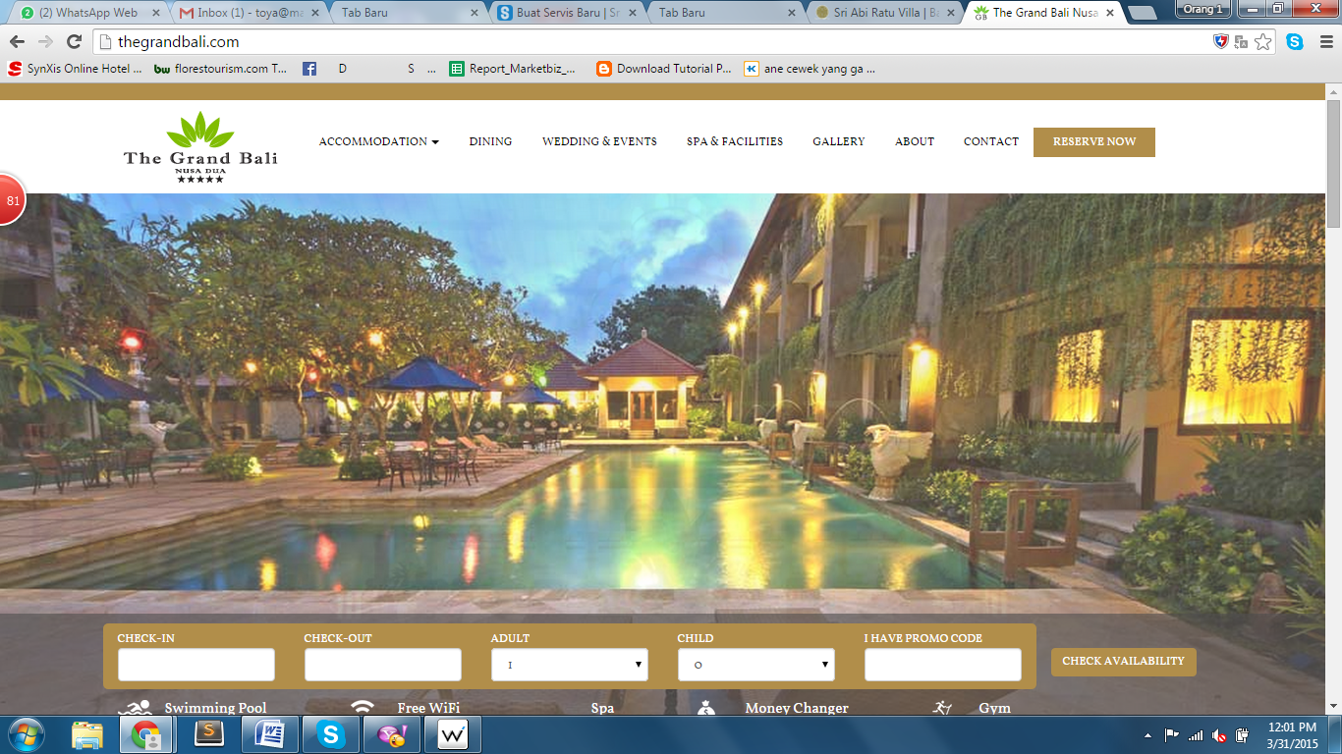

www.febrishotelspabali.com
