CURRICULLUM VITAE
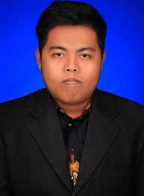
Name : Muhammad Rozi, S.Pd
Place/Date of Birth : Baturaja, 01/01/92
Address : Bumi Dipasena, Blok 12 Jl 4 No 3, Rawajitu Timur, Lampung
Contact Information : +6285769971368
rozi010192@gmail.com
http://Facebook.com/Rozimohawk
Educational Background : Formal Education
SD Negeri 01 Bumi Dipasena Sejahtera, Lampung, Indonesia (Elementary School)
SMP Negeri 02 Baturaja, Sumatera Selatan, Indonesia (Junior High School)
SMA Negeri 01 Baturaja, Sumatera Selatan Indonesia (High School)
Universitas Lampung (Bachelor Degree in Language Teaching)
Universitas Sebelas Maret (Master Degree in Language Teaching) – In Progress
Informal Education
Small England English Course, Baturaja, Sumatera Selatan, Indonesia
Work Experiences : English Private Teacher (2009-2012)
English Teacher at Ganesha Operation (2013-Now)
Skills : Teaching Language
Research in Language Teaching and Education
Speak and Write in Indonesian and English Fluently

