CURICULUM VITAE

PERSONAL DATA
Name:  ARDI NOOR QAEDI | ID num.  331902021093008 | 
Permanent address:  Jl. Kartini 115 RT. 3 RW. 3 Burikan Kudus | Place & Date of birth:  Kudus, October 2 1993
Religion:  Islam | Email:  ardinoorqaedi@rocketmail.com
Sex:  Male | Mobile Phone:  085291412786
Marital status :  Single | Blood type  O

PARENTS
Name | Sex | Age | Education level | Occupancy
Noor Cholies | Male | 60 | S1 Economy | Occupational Pension
Ida Mahmudah | Female | 54 | D3 Accounting | Businesswoman

BROTHERS & SISTERS
Name | Sex | Age | Education level | Occupancy
Alfian Noor | Male | 27 | S1 Accounting | Tax Consultant
Listya Aina Firda | Female | 25 | S1 Midwife | Student

EDUCATIONAL BACKGROUND
Education Level | Periode |  | Name of Institution | Major | GPA
Education Level | From | To | Name of Institution | Major | GPA
Elementary School | 1999 | 2005 | SD Nganguk Kudus | - | 59.37
Junior High School | 2005 | 2008 | SMP 2 Kudus | - | 31.00
Senior High School | 2008 | 2011 | SMA 1 Bae Kudus | Sains | 53.5
University | 2011 | 2014 | Diponegoro University | D3 Architecture | 3.06

OTHER COURSE/SEMINAR
Subject | Period |  | Promoter | City | Date of Certificate
Subject | From | To | Promoter | City | Date of Certificate
Green Architecture Seminar | 2012 | 2012 | Architecture Enginering  Diponegoro University | Semarang | November 9 2012
Talkshow Dies Natalis HMDA SHADATA | 2012 | 2012 | HMDA SHADATA  Diponegoro University | Semarang | September 23 2012

ORGANIZATIONAL MEMBERSHIP (SCHOOL/ SOCIAL/ PROFESSIONAL)
Name of organization | Period |  | City | Position
Name of organization | From | To | City | Position
OSIS SMA 1 Bae Kudus | 2009 | 2010 | Kudus | Sie Personality And Character
Scout SMA 1 Bae Kudus | 2009 | 2010 | Kudus | Sie Techniques Scout
HMDA SHADATA Arsitektur Design | 2011 | 2014 | Semarang | Staff economy And Business

TECHNICAL SKILL
Computer  Skill | AutoCad
Computer  Skill | SketchUp
Computer  Skill | Adobe Photoshop
Computer  Skill | Ms. Office
Computer  Skill | Corel Draw

REWARD
Year | Name
2004 | 2nd Place Men's Doubles Tennis age of 10 years National Level "Pemalang Open Tennis Tournament TOP 1"
2004 | 3rd Place Men's Doubles Tennis age of 10 years National Level "Purbalingga Open Junior Tennis Championships"
2006 | 3rd Place Men's Singles Tennis age of 12 years National Level "Tennis Championships Persami Pillars of the Holy Cup"
2009 | 3 rd Place Procedure Ceremony and Linear Line Forces Saka Bhayangkara Holy District Level in 2009

WORKING EXPERIENCE
 | Month | Year | Name of company | Position
From | Juli | 2013 | CV. Daya Cipta Mandiri | Drafter
To | Agustus | 2013 | CV. Daya Cipta Mandiri | Drafter

I understand that any omission or misrepresentation with respect to this information may be cause for denial or immediate termination of employment.
Jakarta , Maret 2015

( Ardi Noor Qaedi )

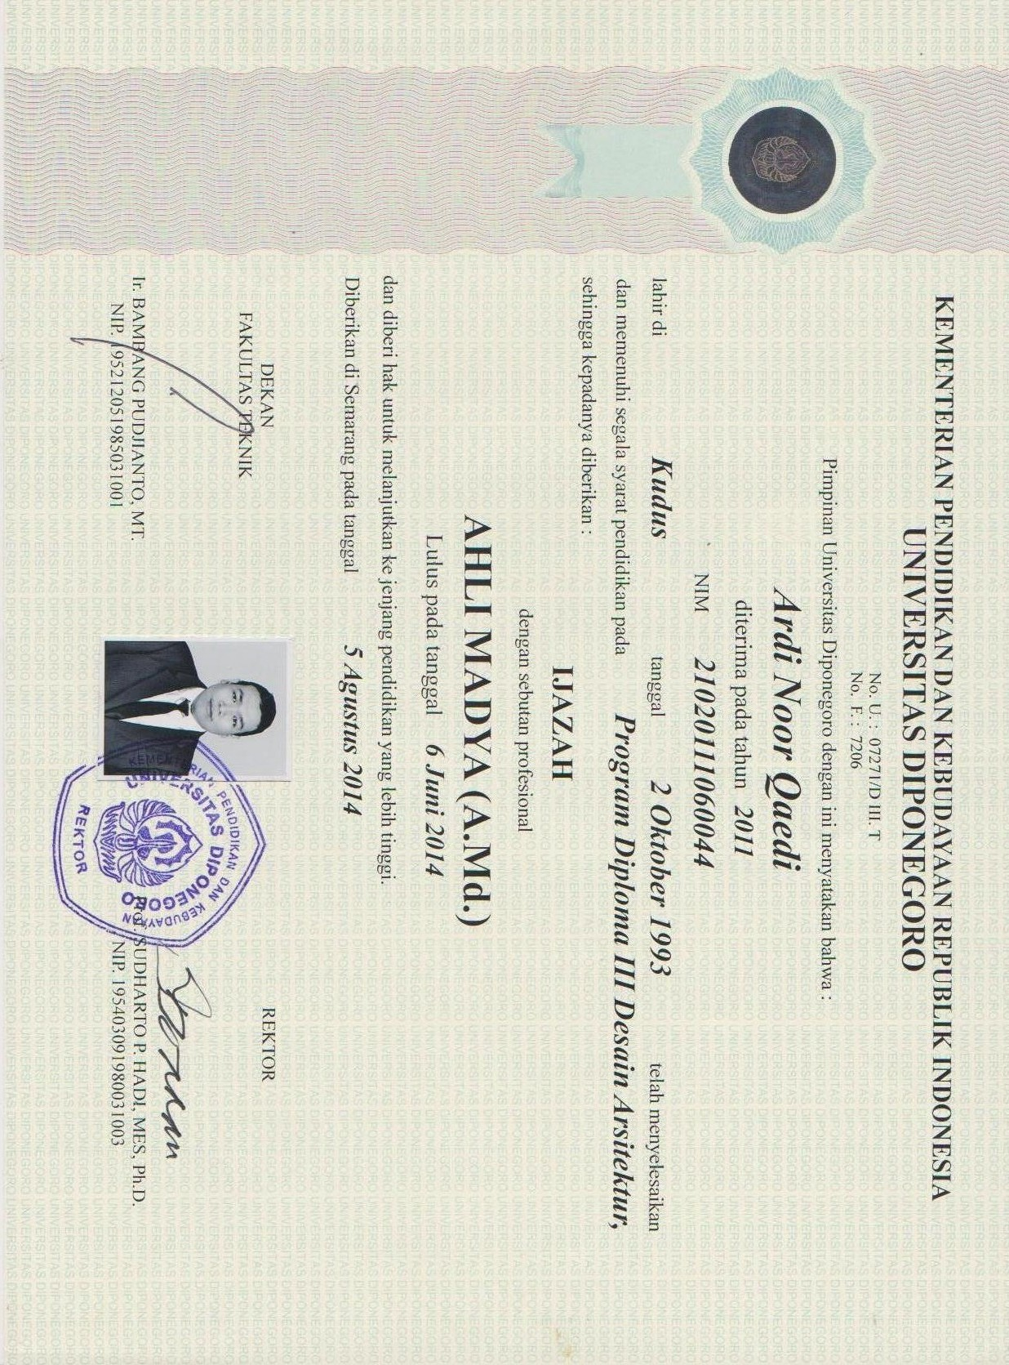

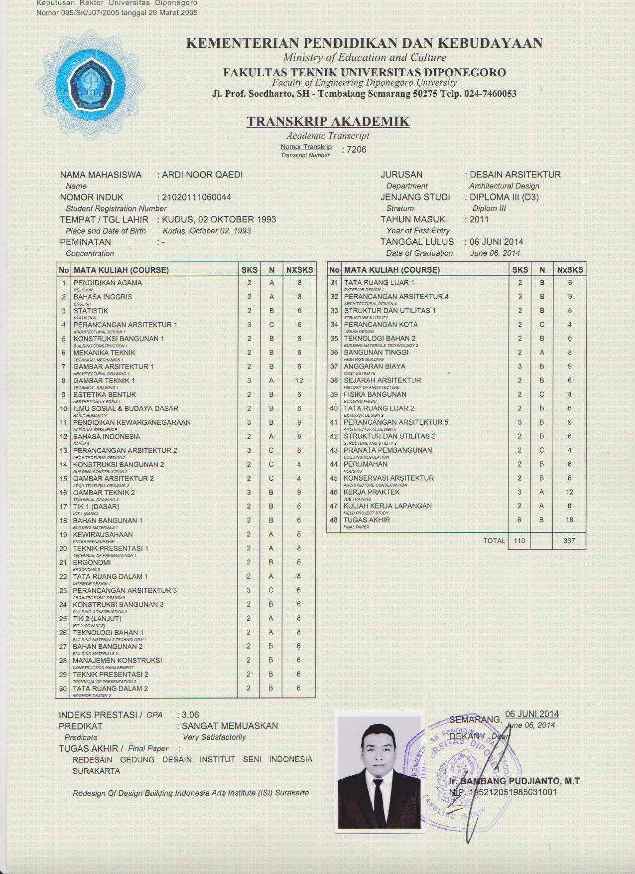

Final Paper “ Redesign of Design Building Indonesian Art Institute Surakarta”
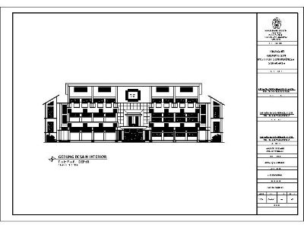
Front View
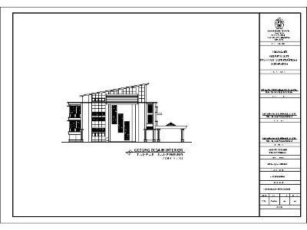
Side View

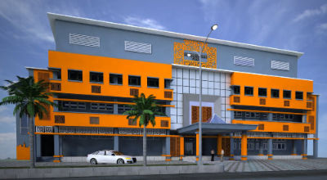
Perspective 1

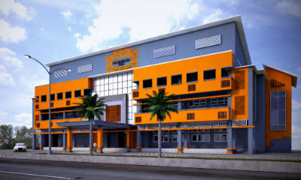
Perspective 2



