My Portofolio :
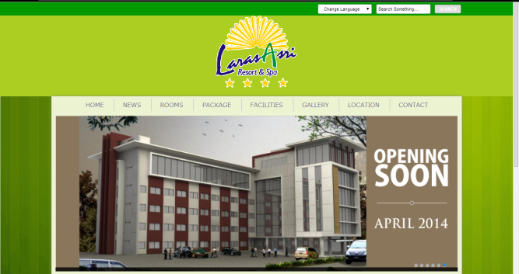
Larasasri resort hotel: in http://larasasriresort.com/
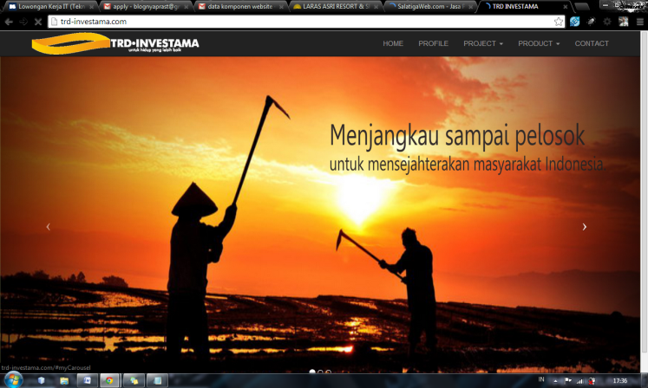
TRDINVESTAMA profile company : in http://trd-investama.com/
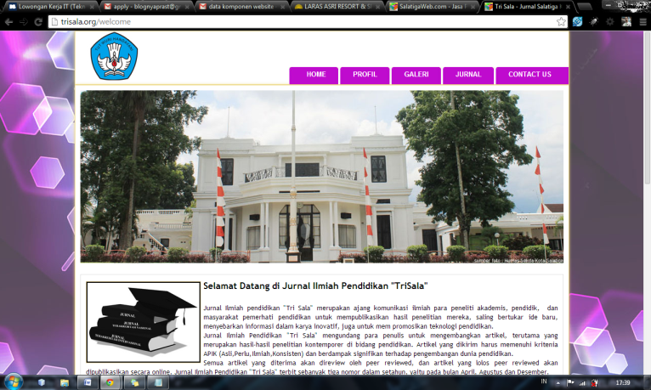
Trisala Salatiga : E Jurnal Salatiga.. in http://trisala.org/welcome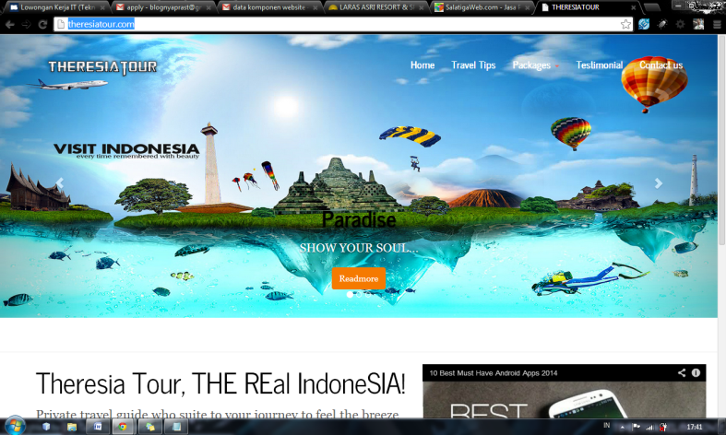
Theresia Tour : Web Tour n Travel in http://theresiatour.com/
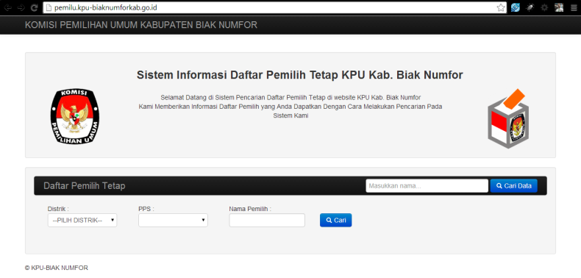
KPU BIAK Numfor : Data Pemilih tetap kpu di biak : http://pemilu.kpu-biaknumforkab.go.id/
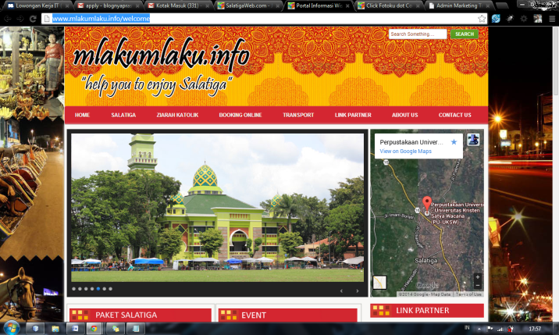
Web Portal Salatiga : Seputar Salatiga. In http://www.mlakumlaku.info/welcome
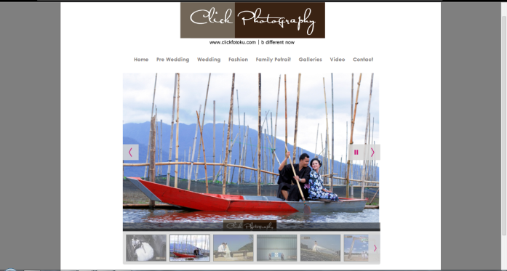
Web Photography : in http://www.clickfotoku.com/index
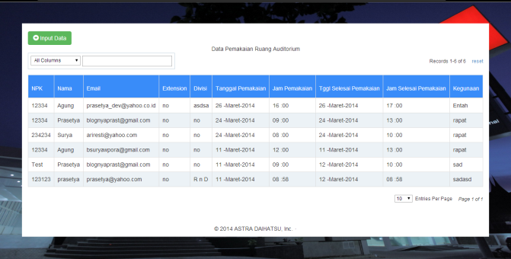
Web Internal ADM : Data Penggunaan Ruang di PT Astra Daihatsu Motor
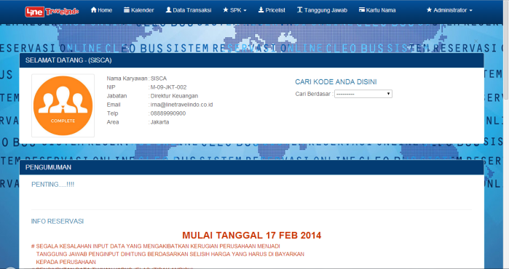
Web Internal Application Linetravelindo.co.id aplikasi marketing penyewaan bus agen bus CLEO..
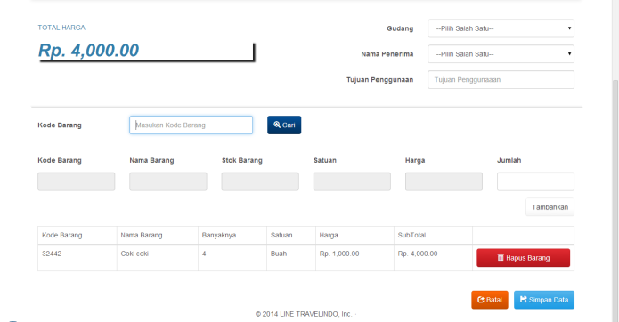
Sistem Inventory Application Linetravelindo.co.id

