CURRICULUM VITAE

Personal Information
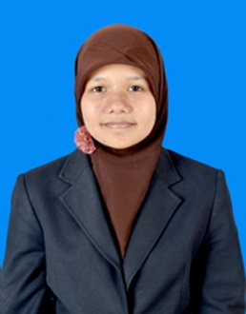
Name : Puspita Wulandari Harahap
Place of Birth : Ciamis, Indonesia
Date of Birth : 9 Febuary 1994
Religion : Islam
Nationality : Indonesian
Address : Dusun Pajaten, RT 002 / RW 005, Dawuan
Tengah Village, Cikampek, Karawang, West
Java, Indonesia
Temporary Address : Jalan Sukasenang No. 22A, Bandung, West
Java, Indonesia
Mobile : +62-878-2587-6546
E-mail : pwulandarih@gmail.com
Skills : Indonesian-English Translation, English- Indonesian Translation and Logo Creations
Personal Profile
A qualified student who has skills in translation and logo design. Presently looking for job as a freelancer.
Education
2001 – 2004 SDN Kalisari 02 Pagi
2004 – 2006 SDN Dawuan Tengah VIII
2006 – 2009 SMPN 1 CIKAMPEK
2009 – 2012 SMAN 1 CIKAMPEK
2013 - Present STIE EKUITAS
Achievements
23 October 2014 English Speech Contest as Participant in STIE EKUITAS
22 Feb – 8 Mar 2015 Student Exchange Program as Participant in Selangor International Islamic University College, Malaysia

