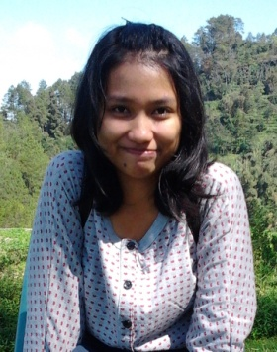
Fransiska Retno Ambar Sari

Kampung Rapet Banyubiru, Central Java 50664
085741406768
fransiska.retno.ambar@gmail.com

Education | Satya Wacana Christian University Salatiga (SWCU)  English Department – Faculty of Language and Literature (FLL)  English for Education with GPA 3,66  Writing and Speaking Courses – FLL SWCU Salatiga  - Interpersonal Speaking GPA : B  - Guided writing GPA : AB  - Transactional Speaking GPA : AB  - Narrative and Descriptive Writing GPA : AB  - Public Speaking GPA : AB  - Expository and Argumentative Writing GPA : AB  - Academic Writing GPA : B |  | Expected graduation:  July 2015  2011-2012/1  2011-2012/2  2011-2012/2  2012-2013/1  2012-2013/1  2012-2013/2  2013-2014/1
Experience Summary | • Columnist • Secretary •Part Time English Teacher • Ketua Angkatan 2011-ers •Public Relations•
Experiences | Columnist – Access Magazine of FLL SWCU Salatiga  - Conduct interviews  - Analyze the information  - Write and revise articles for Access magazine, the English Department’s magazine which is published per semester | 2014 – present
 | Secretary – Orang Muda Katolik Banyubiru  - Work with the chairperson to organize the meetings and events of the organization  - Write minutes, proposals, letters, and the reports of events held by Orang Muda Katolik (OMK) Banyubiru, a religious organization  - Document the proposals, letters, reports, and photos  - Contact the members of the organization | 2013 – present
 | Part Time English Teacher – Kotabahasa, Salatiga  - Prepare and develop the materials  - Teach English courses of General English for beginner and elementary level, English Conversation 1&2, English for Specific Purposes to students whom varied from elementary, high school, and university students, workers, and the like.  - Write journals of the teaching activities  - Report students’ grades at the end of the program  - Translate articles from the clients  Ketua Angkatan 2011-ers – FLL SWCU Salatiga  - Hold a coordination between students batch 2011 to compete with other batch in the annual faculty’s events, e.g.: LOading Via English Days (LOVED) and English Department Olympic (EDO)  - Pass on the related information from the Head of the Program to students and the other way around  Public Relations – Access Magazine of FLL SWCU Salatiga  - Contact the editors  - Arrange the Access’ booth in the faculty open house  - Arrange the distribution of the magazine to the student | 2013 – present
2011 – present

2014-present

Computer Skills | • Microsoft Word • Microsoft Power Point • Microsoft Excel •

Hobbies Reading novels, news, articles, and magazines
Travelling
Writing poems
Drawing

Personal Data Born on March 16, 1993
Age 22
Excellent health

References will be available on request

