andi
rocadi
photographer
DATA PRIBADI  Nama : Andi Rochadi  Tgl LAhir : 19-03-1992  Tmp Lahir : Jakarta  Jenis Kelamin : Laki- laki  Agama : Islam  Status : Belum Menikah  Jl. Pirus no 22 Rt 013  Kel. Bidaracina  Kec. Jatinegara  the.concreat@gmail.com  089606970748 | Pengalaman Kerja  2010-2012  NISSAN MOTOR INDONESIA  Jabatan tool kipper  2014 – Sekarang  Freelance Photographer and Videographer  - Videographer cinematic aevent Mods My Day  - Photo prewedding and wedding  - Photo produk  - Photo and disign book year  “2013 Juara 1 program talkshow seminar di Karnos film  2014 juara 3 film terbaik di BSI AWARD”  PENDIDIKAN  1998–2004  SDN 04 Ptg  2004–2007  SMPN 265  2007–2010  SMK BERLIAN (Teknik Mesin)  2012–2014  BSI (Broadcasting)  Photoshop Illustrator lightroom premiere pro videography photography  KETERAMPILAN

SERTIFIKAT
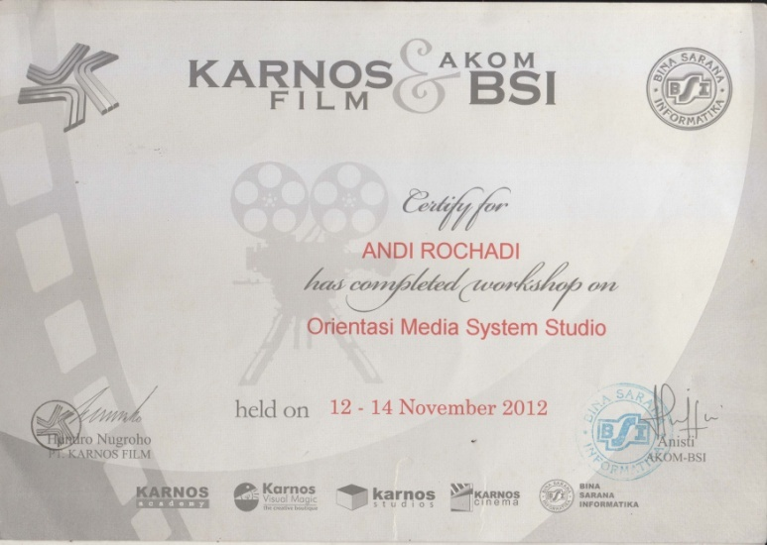
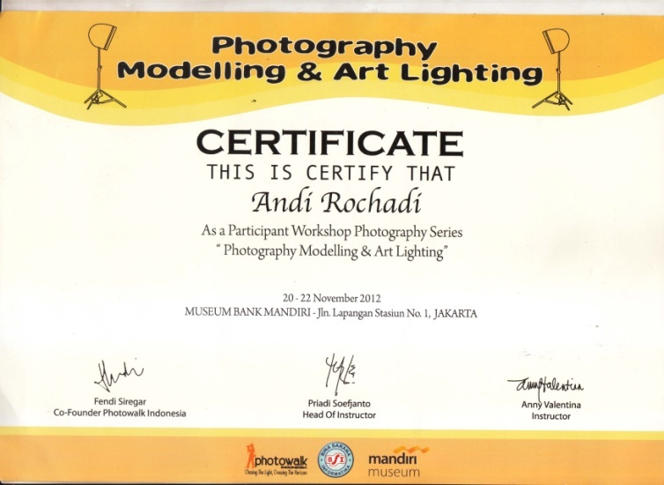

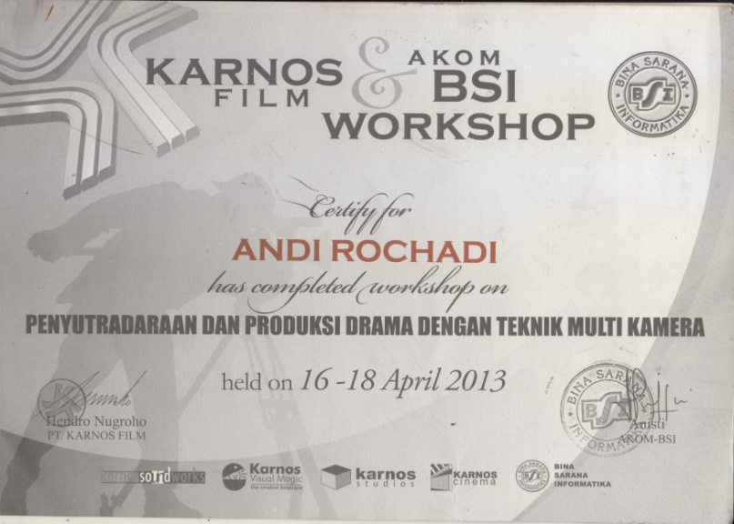

PORTOFOLIO
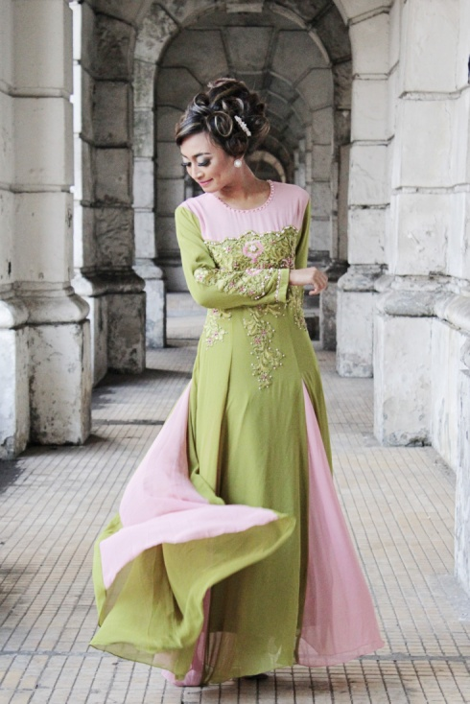
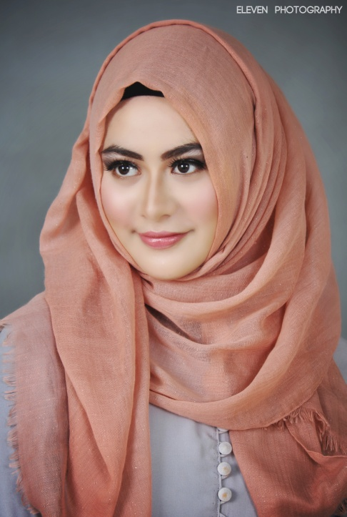
PHOTO PRODUCT

