CURRICULUM VITAE
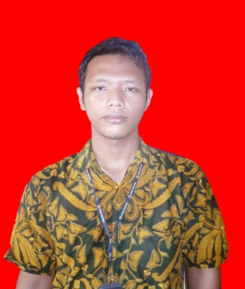
Proposed Position : Business Consultant (BC)
Name : Rizky Ryan Hermawan
Place,Date of Bith : Sorong, July 12, 1995
Marital Status : Single
Religion : Islam
Nationality : Indonesia
Address : Jl. Kilang Km. 9,5 Sawagumu, Sorong Utara
Mobile Phone : 085319172034

Formal Education :

School Place Province
Victory University Sorong Papua Barat
Senior High School SMK Negeri 1 Sorong, Papua Barat
Junior High School Mts. Tsanawiyah Negeri Sorong, Papua Barat
Elementary School SD Negeri 109 Sorong, Papua Barat

Completed Courses by PT. Putra Satria Persada :
- Permit To Work, 12 Agustus 2013
- Basic Fire Awareness – Modul A, 13 Juny 2014
- Confined Space Entry, 10 October 2013
- Skilled Induction
- Malaria & HIV Awareness
- Eye Safety
- Commissioning Transitional
- Environmental Awareness
- Integrated Safe System of Work Awareness

Certificate :

- CV. Saga Retailindo Performing Authority & Sales

Qualification

3 years experienced as private employees and 1 years as Leader WHS.

Work Experiences :
Place
Oct 2013–Dec2013 :
PA/CIVIL : PT. Tirta Kedaton
Job Description : Inventory Management, Perpetual Stock Taking officer, Leader WHS, Part Distribution Centre Service Support.

Work Experiences :
Place
Jan 2014–Dec 2015 :
PA/CIVIL : PT. Putra Satria Persada
Job Description : PST Officer, PDCSS Officer, Incoming Job, and Outgoing process, Leader WHS.

Your Truly

Rizky Ryan Hermawan

