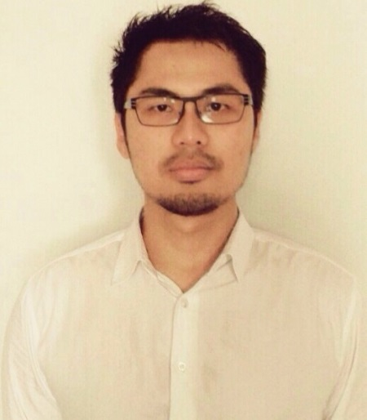

Curriculum Vitae
Yuri Tofani
I’m passionate at economic, finance, accounting and love to do everything that related those. commonly i work under clear vision, mission and plan. With the good plan, we can reach the goal effectively heading to vision and mission.
Contact Details

Home : Seasonscity, A Tower, 18Ath Floor, AC
Prof.Dr Latumenten street No.33, West Jakarta
Tel. : 081311091518
E-mail : banyu.iman810@gmail.com
yuri@accountant.com

Personal Data

- Name : Yuri Tofani
- Gender : Male
- Place of birth / date : Tulungagung, June 28, 1984
- Religion : Moslem
- Marital : Married
- Citizenship : Indonesia
- Height & Weight : 173 cm / 77 kg
Formal Education

2002 – 2006,
STIE IBEK Tomang Jakarta,
Faculty of Economic,
Major Accounting
GPA 3.46

2005,
University of TRISAKTI Jakarta,
Faculty of Ecomonic,
Brevet A and B tax Education
Foreign Language

English
Software Operating

Microsoft office - Advance
MYOB - Advance
Banana Accouting - Advance
SAP - Intermediate (FICO Module)
Zahir Accounting - Basic
Non Formal Education/Training

2014,
PT ITHACA RESOURCES
Internal Audit Risk Management sharing knowledge as a Trainer

2014,
OZMINE
Mining innovation for productivity, optimization and efficiency

Non Formal Education/ Training
2014,
PT ITHACA RESOURCES
SAP FICO Module

2014,
Inquest Consultant
Overview and implementation ISO 9001, 14001 and OHSAS 18001

2013,
Coaltrans Conference

2013,
Australia and ASEAN Partnering
Australian Mining Conference

2012,
The Indonesian Institute of Accountant
Application and review local GAAP No 33, 64

2011,
BDO (KAP Tanubrata Sutanto Fahmi & Rekan)
Application and review local GAAP No 50, 55

2011,
Yayasan Pendidikan Internal Audit
Enterprise Risk Management

2011,
The Indonesian Institute of Accountant
Local GAAP to IFRS convergence and its application

2010,
DFK International (KAP Anwar & rekan)
Updating the current local GAAP

2009,
DFK International (KAP Anwar & rekan)
Tax regulation review

Working Experience

March 2010 – current, (Assistant Manager)

PT Ithaca Resources
Full-time employee at Internal Auditor and Risk Management Department.

Assignments:
- As team leader with 4 members to direct each different task runs in internal department and multi department well. Prepare a consolidate report to Internal Audit Chief that describe of comprehensive issue with priority level.
- Doing multi department Communication and discussion regarding audit finding or improvement program.
- Identify, quantify, manage the risk and monitor the mitigation that have been done as complete procedure cycle.
- Review and evaluate the activities and operation of a particular function, activity, department or unit under review. Measure all those activities comply with company policies and procedures, ISO, OHSAS as well as applicable laws and regulation.
- Validate the accuracy and completeness of records and accounts financial report balance. Review conformity the Financial statement accordance with GAAP/IFRS
- Evaluate the contracting process, the compliance with the provision of contract and performance.

Working Experience
February 2014 – Current, (Manager)

KAP S MANNAN, ARDIANSYAH & REKAN (Integra Affiliation)
Part-time employee as Auditor.

Assignments:
- Actively engage in the planning of the audit, as well as the fieldwork at interim and final, statutory audit and completion work.
- Work as part of an audit team or run an audit, reporting directly to the audit partner.
- Prepare audit report for partner approval.
- Ensuring the firm comply with risk management procedures.
- Analyze problems, identify core issues, investigate, evaluate and integrate information.
- Providing leadership and direction to designated team.
- Supervising and coaching junior members of staff to help them realize their full potential.

January 2014 – Current,
Project as Personal Consultant (Accounting Service).

Assignments:
- Maintain accounting records and prepare management information.
- Preparing financial statements, both monthly and annual.
- Offer an advice in relation to tax issues.
- Prepare cost accounting reports.

October 2007 – March 2010, (Senior Auditor)

KAP Anwar & Rekan (DFK International Affiliation)
Full-time employee as Auditor.

Assignments:
- Lead operational audits and took responsibility for staff preparation and development.
- Participate in special review and investigation client business.
- Monitor client’s operations and each financial system and evaluates their efficiency, effectiveness, and compliance with internal corporate policies and procedures and external laws and government regulations.
- Measure and evaluate the effectiveness and efficiency of business practices and operations, the reliability of financial reporting, the process for deterring and
- investigating fraud, and the safeguarding of company assets.
- Examine and evaluate the organization’s financial and information systems, management procedures, and managerial and internal controls to ensure records and controls are accurate.
- Write audit programs, reports and presented results to upper management.

The companies that have been audited:
- Asuransi Jiwa Sinarmas
- Dana Pensiun dan Lembaga Keuangan Sinarmas
- PT Bumi Merak Terminalindo
- SDS Sibalec
- PT Inamco Multi Services
- Badan Arbitrase Pasar Modal Indonesia
- JFE Engineering Corporation
- PT Bangun Gita Nusa Sarana
- PT Claris Lifesciences Indonesia
- PT Equator Development Sejahtera
- PT Pundi Uniwood Industry
- PT Guiding Star Indonesia
- Padang Golf Modernland
- PT Karya Makmur Abadi

Working Experience
March 2007 – September 2006, (Accounting Officer)

KOPERASI SASI MAKMUR SIDOARJO JAWA TIMUR
Full-time employee as Accounting.

Assignments:
- Maintain accounting records and prepare management information.
- Preparing financial statements, both monthly and annual.
- Offer an advice in relation to tax issues.

Remuneration & Benefit

Rp 15.000.000,- Excluding business trip allowance (PT Ithaca Resources).

