TIARA MAHARDIKA  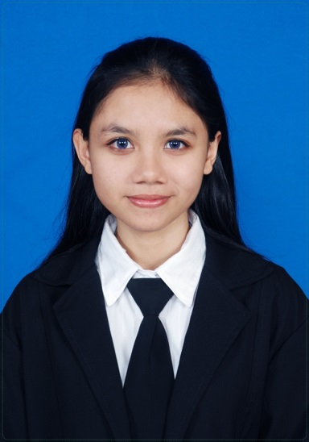  tiaratirr@gmail.com |  | Profile  Name : Tiara Mahardika, S.S  Address : Jl. Pulau Indah, Teuku Umar Barat, Denpasar, Bali  Work Experiences  August 2014 – now / Editor in PT. Mega Iklan - iNFOPEDAS Magazine, Bali (Full Time)  - Creating concepts of a monthly lifestyle magazine  - Writing article for some sections in the magazine (feature, profil, destination, beauty, advertorial for clients, etc.)  - Holding an interview with some public figure  - Supervising some staffs to handle social media (fb, twitter, instagram of the magazine or clients)  - Following up and getting in touch with the contributors to make sure they send the article on time  July 2013 – January 2014 / Educator Tour in Ullen Sentalu Museum Yogyakarta (Full Time)  - Guiding the guest both local or foreigners to look around the museum  - Checking the museum collections once a week  November 2012 – January 2013 / English Instructor for Hotel Employees in Puri Artha Hotel Yogyakarta  I worked as an instuctor to teach English for employees (from many departments like F&B, House Keeping, Security, F&B Product ) in Puri Artha Hotel, once a week and two hours per meeting.  May 2011 & August 2011 / Assistant Auction Officer in PT. iBid Balai Lelang Serasi  I worked as a freelance auction officer for PT iBid Balai Lelang Serasi’s event (cars auction).  December 2010 – June 2012 / Freelance English Tutor in Widyatama Foundation  Education  September 2011 – April 2013, Yogyakarta University of Technology, English Literature study (S1/Bachelor of Arts) with GPA 3.48  July 2008 - September 2011, Yogyakarta University of Technology, English study (D3/Diploma) with GPA 3.33  2005 – 2008, 6 Senior High School of Yogyakarta  Internship  February 2011 – May 2011 (3 months) as English Teacher in Keputran I Elementary School, Yogyakarta  June 2012 – September 2012 (3 months) as Intern Front Desk Agent / Front Officer in Puri Artha Hotel Yogyakarta  Course  Dutch Language basic level in Indonesich – Netherlands Cultureel Centrum, Yogyakarta, June – August 2013  Achievement  Second Prize Winner of Asian Job Express Business Writing Competition from Indonesia in Ryohin Keikaku Department  Member of Team with Best Business Plan in Final Business Writing Competition by Ryohin Keikaku Department held in Japan, December 2012  Qualification  I have a good qualification in using Bahasa Indonesia and English, both written or spoken. I have internet literate, able to use computer (MS Office), writing creative or technical articles, and know editorial aspects.

