Curriculum Vitae
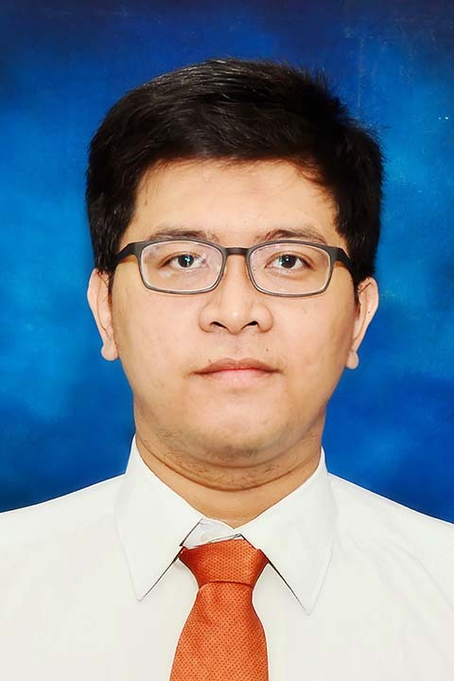
Personal Information
Name : M Faizar Rahman H.N.
Date/Place of Birth : Bandung, 26 Januari 1988
GPA : 3,27 out of 4
Nationality : INDONESIA
Address : Jl. H Saiman No.66 RT 01/02 Desa Gandasari,Andini
Cibitung Bekasi
Contact Number : 0821 2682 4087
Email : Faizar.rahman88@gmail.com
Website : http://id.linkedin.com/pub/faizar-rahman
http://www.kreavi.com/faizarrahman

Resume
I was graduate from Business Administration, Padjadjaran University in 2010 with GPA 3,27 out of 4. Now i am working at PT Bank Negara Indonesia (persero) Tbk. as Credit Analyst from 2010 till now. I can process 1 billion up to 15 billion and have a responsibility to analyze debtor company to see the eligibility of credit, think about credit and business mitigation and create credit proposal to be presented in front of credit commitee for approval. expertice using microsoft excel to perform calculation and forecasting for quality of credit. I always challenge myself to grow and love to learn a new thing.

Work Experience
December 2010 – December 2011 | OFFICER DEVELOPMENT PROGRAM  PT Bank Negara Indonesia (Persero) Tbk. Indonesia
Responsibility
- Learn about general banking process
- Learn about Treasury process
- Learn about Credit Analyze and mitigation the risk

December 2011 – Present | CREDIT ANALYST  PT Bank Negara Indonesia (Persero) Tbk. Indonesia
Responsibility
- capability to proccess from 1 billion up to 15 billion credit proposal.
- Experienced to analyze company financial statement, business condition, creating financial forecast, analyze company legal and perform verification in order to create a credit proposal, mitigate credit risk and to be presented in credit committee.
- Generate and identify client company information with regards the eligibility of credit to enhance decision approval from the credit committee
and maintain customer quality of credit .
- Expertise using excel to perform calculation and forecasting for quality of credit.

Development and Training
12 December 2010 - 2011 | Officer Development Program | PT Bank Negara Indonesia
16 Juli 2013 | Small Credit Enhacement Program | PT Bank Negara Indonesia
21 Juli 2013 | Cashflow Projection Analysis | PT Bank Negara Indonesia
05 April 2014 | Personal Groming | PT Bank Negara Indonesia
08 Juli 2014 | Pelatihan Sistem Alat Bantu Analisa Kredit | PT Bank Negara Indonesia
06 September 2014 – Present | Academic Writing, | LBI – Universitas Indonesia
22 November 2014 | Busines Acument | PT Bank Negara Indonesia

Educational Background
1994 – 2000 | SD Al-Muslim, Tambun
2000 – 2003 | SMP Al-Muslim, Tambun
2003 – 2006 | SMA Negeri 1 Bekasi
- I get in social class at second grade.
- Founder of Movie and Radio community in school and role as a Music Manager and Movie Editor in the community
- Member of GITA PATRIOT, Official Bekasi Marching Band.
2006 – 2010 | Business Administration, Padjadjaran University
- I graduate from college with GPI 3,27 out of 4
- Member of HIMABIS (himpunan Mahasiswa Bisnis) UNPAD Since 2007 and active as Staff of Business Development until 2008
- Become a staff of Design and Documentary in BUSINESS CYBER GAME 2006 and role as coordinator of Design and Documentary in same event next year.
- Become staff of Design and Documentary in campus orientation session (POSTMO and PROFIT) in 2008 and create a logo for that event.

Languages
Proficiency Level : 0 – Poor, 10 – Excellent
Languages | Spoken | Written | Certificate
Bahasa Indonesia | 9 | 9 | -
English | 8 | 8 | -
Japanese | 2 | 2 | -

Soft Skills
Advance | : | Microsoft Word, Microsoft Excell
Intermediate | : | Microsoft Power Point  Photography  Adobe Illustrator  Adobe Photoshop  Adobe In-Design  Adobe Flash  Digital Painting and drawing  Computer Hardware,
Basic | : | HTML Coding

Referees

Name | Relationship | Contact Number
Nadya Ratna  (Small Credit Analyst Supervisor PWK) | Supervisor | 0813 1643 9434
Azie Mega Poetra  (Small Relationship Manager Subang) | Colleague | 0852 9498 8733

