- PERSONAL INFORMATION
Name  Place, date of birth  Nationality  Sex  Marital Status  Contact | :  :  :  :  :  : | Thomas SatriaDwiputra  Jakarta, 24 March 1988  Indonesia  Male  Single  085311792288 (primary)  Thomas.satria.d@gmail (email) | 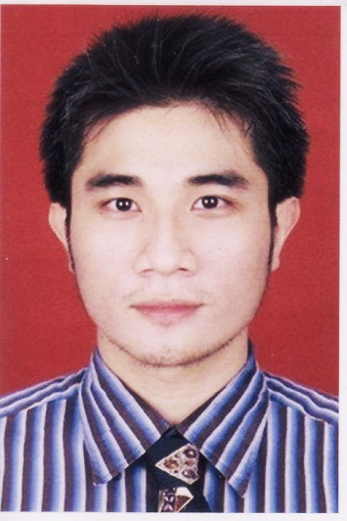

- SUMMARY

- Professionalism. Always ready to support company’s vision and policy
- Service oriented. Do the best to satisfy client’s needs and make sure their needs provided
- Adventures. Ready for new environment and challenges

- EDUCATION BACKGROUND
2006-2011 iBii (InstitutBisnisdanInformatika Indonesia), now KSB (Kwik Kian Gie School of Business). Bachelor of economy, focused in Accounting
2003-2006 St. Theresia, highschool
2000-2003 St. Maria, junior highschool
1996-2000 St. Cicilia, elementary school

- WORKING EXPERIENCES

2015 – now Ray White Sunter
Property agent, based in Sunter. North Jakarta
Latest salary: by commission
Job Description:
- Accommodate seller to letting or selling their property, buyer to renting or buying their desired property
- Giving after sales/rent services
2013 - 2015 PT SDS International Indonesia
Japanese B2B automotive engine parts trading company, as Marketing executive.
Latest Salary: IDR 6.000.000/Month
Job Description:
- Make stock forecast, based on customer’s demand
- Issue PO to maker, either local or import
- New project acquisition
- Make monthly sales report to higher management
- Provide fast assistance for product’s issue
- Providing information for higher management, for future marketing strategy planning. Ex: Competitor information, delivery system, government’s policies, rumors, & any confidential information
- Propose further business development, based on client’s feedback
- Maintain good relationship with clients
2010 - 2013 PT Powerindo Diesel
Heavy equipment parts distributor, as sales staff.
Latest salary: IDR 3.500.000/month+ commision
Job Description:
- Do selling activity for retail customer
- Maintaining good relationship with client
- Provide assistance on product’s issue
Achievement:
- Promoted to sales general trading

- OTHER INFORMATION

- Language proficiency
  - Bahasa Indonesia
primary language
  - English
Actively written and oral (TOEFL-PBT: 550)
- Microsoft office
Word, excel, outlook & Powerpoint

I hope I can meet your expectation, and hope I can be your valuable asset for your company. Thank you for your concern.
Best regards

Thomas Satria D.

