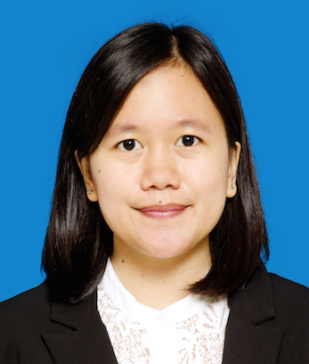
BELLA THESISKA APRILIANTY

Jalan Sudirman, Gang Asia No.21, Pekanbaru 28115
(+62) 812 1463 2022
thesiskabella@gmail.com
Prabumulih, 02 April 1992

Formal Education
INSTITUT TEKNOLOGI BANDUNG
Geodesy and Geomatics Engineering
2010 – 2015

UNIVERSITÄT KASSEL
International Summer University
2014
Working Experiences
PT BANK MANDIRI (PERSERO) TBK
Commercial Banking Relationship Manager (2015 – now)

FRESH GROW INTERNATIONAL
Project Coordinator of Land Surveying – DKI Jakarta (2015)

SKHOLE INSTITUT TEKNOLOGI BANDUNG
Teacher (2013 – 2014)

BADAN PERTANAHAN NASIONAL BALI PROVINCE
Internship (2013)
Organization Experiences
IKATAN MAHASISWA GEODESI INDONESIA
Delegation of Ikatan Mahasiswa Geodesi Institut Teknologi Bandung at National Congress
(2013 and 2014)

IKATAN MAHASISWA GEODESI – INSTITUT TEKNOLOGI BANDUNG
- Vice Head Back-up of Student Orientation and Initiation (2013)
- Editor of Geosphere (2013)
- Head of Graduation Liaison Officer (2012)

PERKUMPULAN SENI TARI DAN KARAWITAN JAWA – INSTITUT TEKNOLOGI BANDUNG
- Head of Research and Development Division (2012 – 2013)
- Producer on 41st Tanggap Warsa Event (2012)
- Assistant Director on 40th Tanggap Warsa Event (2011)
- Head of Documentary Division at Open House Units (2011)
- Director of Student Orientation and Initiation Event (2010)
Skills
LANGUAGE
- Bahasa Indonesia
- English (Advance)
- Germany (A1, Beginner)
- French (A1.1 & A1.2, Beginner)

