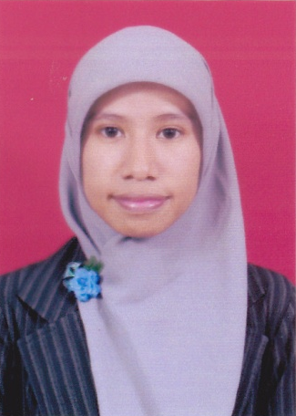
CANNIA HERDINA PUTRI, S. Kom
JL.Z JATI PULO RT 006/08 No. 20
SUBDISTRICT PALMERAH
WEST JAKARTA 11430
PHONE 085697734025 / 08989262725
cannia.motoka@gmail.com

PERSONAL DATA

Place / date of Birth : Jakarta, 25th June 1991
Sex : Female
Religion : Moslem
Nationality : Indonesia
Marital Status : Single
Health : Good
Height / Weight : 38 Kg / 150 cm
Personality : A young, loyal, friendly, dynamic, hard worker, and love to learn something new. Having ability to work as a team or independent and have a good analytical mind. Willing to work under pressure and do the task with high integrity.

COMPUTER SKILL

- Database : MySQL, SQL Server
- Microsoft Office : Word, Excel, Access, PowerPoint, Visio
- Programming : PHP (using Dreamweaver), VB .NET
- Having basic ability to operate Desktop Publishing program (Corel Draw)

EDUCATIONAL BACKGROUND

- Bachelor Degree Program Study Informatics Engineering
At STMIK Bina Sarana Global Jakarta 2013 – 2014
- Diploma Program Study Informatics Computer
At Polytechnic LP3I College Caringin Tomang Jakarta 2009 – 2012
- 35 Senior High School Jakarta 2006 – 2009

WORKING EXPERIENCE

- IT Staff at PT. Pendekar Bodoh (D’Cost Seafood) 2011 – February 2013
Location: Jakarta
Job Description :
- Transfer codes from old design to new design
- Fix the bugs that comes from the application
- Handle complain about bugs from the user
- Help to install application and database application to User’s computer
- Training User to use the application step by step

- IT Quality Assurance Officer at PT. Switchlab Indonesia 2013 – March 2014
Location: Jakarta
Job Description:
- Gather information and user requirements from stakeholders
- Analyze and communicate scripts, plans and procedures
- Test the application based on user requirements
- Create test case gather information whether the application is free from bugs or not
- Report to the developer about bugs that comes when application is tested
- Report the final result to stakeholders

- Business Analyst at PT. Skyworx Indonesia March – September 2014
Location: Jakarta
Job Description:
- Gather information and user requirements from stakeholders
- Analyze and communicate scripts, plans and procedures
- Test the application based on user requirements
- Create test case gather information whether the application is free from bugs or not
- Report to the developer about bugs that comes when application is tested
- Report the final result to stakeholders

TRAINING & SEMINAR EXPERIENCE

- SAP Seminar, Binus Center Jakarta 2012
- Seminar IT Series 8 (Cloud Computing & Yii Framework),
LP3T Nurul Fikri 2011
- Seminar of Achievement Motivation Training (AMT), LP3I 2011
- Seminar “Shining with Entrepreneurship”, LP3I 2010

ORGANIZATION EXPERIENCE

- Committee of Student Outbound Training (SOT), LP3I Caringin 2011
- Committee of 22nd LP3I’s Anniversary, LP3I Caringin Tomang 2011
- Committee of LP3I Futsal League II, LP3I Caringin Tomang 2011
- Person in Charge of UKM Dance, LP3I Caringin Tomang 2010 – 2011
- Commitee of PSPL (Pengenalan Sistem Pendidikan & Lingkungan),
LP3I Caringin Tomang 2010
- LCC (LP3I Computer Club), LP3I Caringin Tomang 2009 – 2010
- Islamic mentoring, LP3I Caringin Tomang 2009 – 2010

