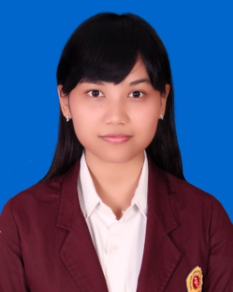
CURRICULUM VITAE

Personal Detail :

Name : Dewi Mutiani, Amd
Date of birth : Argopeni, 18 Oktober 1994
Gender : Female
Religion : Islam
Nationality : Indonesia
Address : Jl. Arif Rahman Hakim No. 52
Kel. Keniten Kec. Ponorogo Kab. Ponorogo
Telephone : 081332718453/ 081335776555
Email : dewimutiani@gmail.com

Education Background :

Formal
- 2011 – 2014 : Diploma III ABA DCC Lampung
IPK : 3,58
- 2008 – 2011 : Senior High School (SMA) N1 Talangpadang, Tanggamus, Lampung
- 2005 – 2008 : Junior High Schoool (SMP) N1 Talangpadang, Tanggamus, Lampung
- 1999 – 2005 : Elementary School (SD) N2 Sumberejo

Personal Skill :

- Organizational and planning skill
- Proven leadership skill & ability to motivate
- Strong written and verbal communication skill
- Ability to work independently or as part of team
- Computer literature (Ms. Word, Ms. Excel, Ms. PowerPoint, Internet)

Organization Experiences :
- Themes : “Orientation Study and Dynamic Campus ORDIK”
Position : Committee mate of ORDIK participant
Implementing : Orientation Study and Dynamic Campus (ORDIK 2011/2012)

- Themes : “One drop your Blood helpful each other”
Position : Committee of Consumption
Impementing : Donor blood together with Dian Cipta Cendekia Lampung College

- Themes : “Refresh and Boost your Spirit”
Positon : Committee of consumption
Implementing : Makrab and Outbound

Job Experiences :

- Intership was conducted in SMPN 1 Talangpadang
Period : December 6, 2013 – February 6, 2014
Position : English Teacher
Specification duty : a. teaching English in VII & VIII grades
b. to help staff T.U fill the data for DAPODIK

- Private lesson in SDN 4 Tekad
Period : October 2012 – December 2012
Position : English Teacher
Specification duty : teaching English in III, IV, V, VI grades

This way curriculum vitae is made by me truthfully and can be responsible.

Your truly,

Dewi Mutiani, Amd

