CURRICULUM VITAE

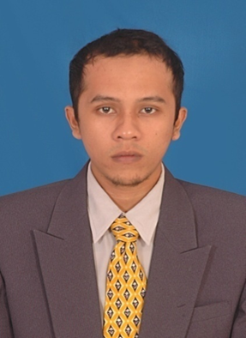
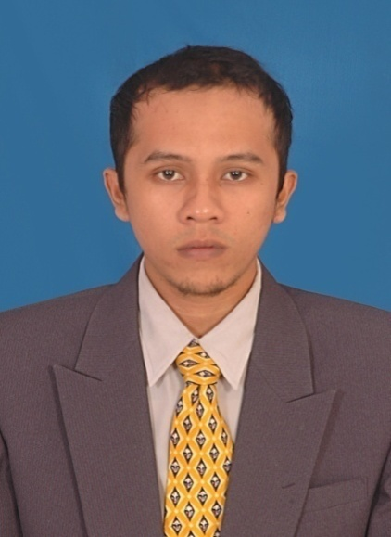
Full Name : Fajri
Place, Date of Birth : Lhokseumawe, November 15, 1998
Address : Jl. Setia Budi Barat no.1 Jaksel
Phone Number : 0852 3323 7562
Last Education : S1 (Islamic Education)
Email : Fajri_achiey@yahoo.co.id
Religion : Islam
Marital Status : Single
Nationality : Indonesian

EDUCATION DETAILS
- 1994-2000State Elementary School 1 Blangkeutumba
- 2000-2003State Junior High School 4 Jeumpa
- 2003-2006State Senior High School I Bireuen
- 2006-2011IAIN Ar-Raniry Banda Aceh

COURSE AND TRAINING EDUCATION
- 2009 Curriculum KTSP Training at Departement of Tarbiyah UIN Ar-Raniry Banda Aceh
- 2010 Computer training at Computer Laboratorium ofUIN Ar-Raniry Banda Aceh
- 2015-2016 English course, Kampoeng Inggris, Pare Kediri

CAREER HISTORY
- 2013-2015 An Islamic Education Teacher (Ponpes Nurul Awal, Tungkop Aceh Besar)
- 2015 An English Tutor (Kresna Institute, Kampoeng Inggris, Pare Kediri )

*Job Descriptions:
- Planning, preparing, and delivering lessons of classes
-Teaching and managing classroom
-Marking all oral and written works of the students
-Preparing and setting tests, examination papers, exercises, etc.

SKILS AND ABILITIES
- Komputer skills (Microsoft Office, Internet, etc)
- Language abilities (Arabic dan English )

HOBBIES
- Travelling, Playing Foot ball, etc

