Teuku Dial Aprilianda

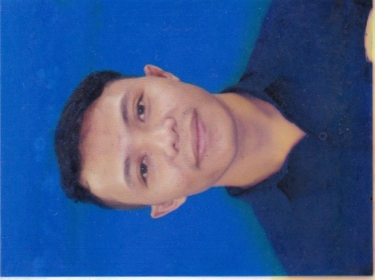

Ph. 0898 5493 927
Mailbox.teukuapril@gmail.com

PERSONAL INFORMATION
Address :
Jln. Lontar Raya, Tanjung Duren, Jakarta Barat
Place and Date of Birth :
Banda Aceh, April 3rd 1990
Marital Status: Single
Nationality: Indonesia

EDUCATIONAL BACKGROUND
Formal Education:
* Trisakti University
Management Departement, Technology and Information (2012-Now)
* Syiah Kuala University
Management Departement, Banking and Finance (2008-2012)
* SMAN 12 Banda Aceh (2005-2008)
* SMPN 6 Banda Aceh (2002-2005)
* SDN 24 Banda Aceh (1996-2002)

INFORMAL EDUCATION
* Computer Course ( Microsoft Office, Network, Social Media )
* LIA English Course

JOB EXPERIENCE
* Social Media Officer at PT Oriel Advertising ( 2008-2009 )
* Social Media Head at Medical Faculty, University of Syiah Kuala (2009-2010)
* Social Media Strategist at PT Mitra Mandiri ( 2010 - 2011)
* Digital Manager at PT Megah Corp (2011-2013)
* Social Media Coordinator at Dr. Zainoel Abidin General Hospital (March, 2013-Dec, 2014)
* Freelance Copywriter at PakarSPG.com and SekolahTalent.com (Dec, 2014 – Now)

ORGANIZATIONAL EXPERIENCES
* BEM Secretary University of Syiah Kuala ( 2009-2010)
* Head of OSIS at SMAN 12 Banda Aceh
* Staff at Indonesian Art Association
* Staff at Youth Leadership & Mentoring Organization
* Staff at Young Indonesian Moeslem Entrepreneur

WORKSHOP AND TRAINING
* Digital Media Marketing Workshop (2009)
* Finance and Banking Workshop (2012)
* Hypnoselling Workshop with Mr Willy Wong (2012)
* Digital Marketing and E-commerce Training with Startup Business ( 2013)
* International Medical Symposium at Hermes Palace Hotel (2012, 2013, 2014)
* Oracle Training with TELKOM (2O14)

ADDITIONAL SKILLS
* Language: Indonesia (Mother Language), English (Medium level)
* Capable to Operate Computer: Windows, Microsoft Office, Network, and All Social Media Tools
* Oracle Social Relationship Management
* Hootsuite
* Able to operate Social Bakers
* Facebook Insight
* Facebook Ads
* Google Analytics

HOBBIES, INTERESTS, & ACTIVITIES
* Reading and Writing
* Learning language
* Music
* Traveling
* Event Organizing
* Sport

Best Regards,
Teuku Dial Aprilianda

