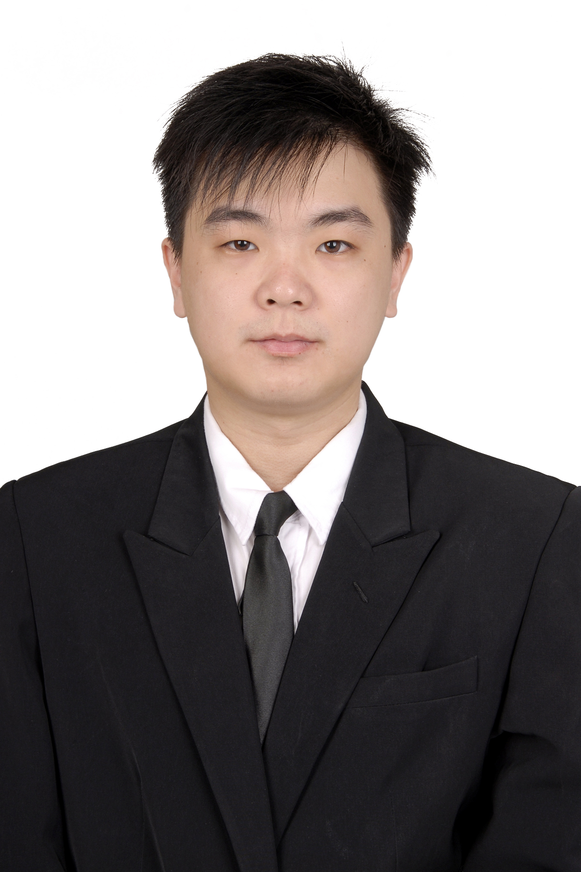

Willy Hadinata
Mobile: 081232131345
Email: willyhadinata22@gmail.com

CAREER OBJECTIVES
A Bachelor of Economic Management and I am now seeking a new professional job experience that allows me to use my skills and experiences, grow in my career and contribute to the goals of the company.

TECHNICAL SKILL SUMMARY
I am a hard worker, creative and discipline person. I can work in a high pressured position, learn fast and easily adapt in various situations.

EDUCATION HISTORY
2012-2016 Universitas Surabaya
Bachelor of Economic Management
2009-2012 Santo Paulus Jember
Higher School Certificate – Indonesia

SEMINAR, WORKSHOP AND TRAINING HISTORY
2014 Internal Committee of Entrepreneurship Class
2015 Eviews-8 Training

INTERNSHIP, RESEARCH PAPER AND THESIS
2012 The Effect of Debt to Profitability on Agriculture Company Listed on BEI 2010-2014
This study aims to examine the effect of short terms debt to total asset, long term debt to total asset , total debt to total asset, debt to equity ratio as a independent variables with sales growth and size as a control agriculture industry sector in Indonesia Stock Exchange (IDX) with the period 2010-2014. The variables tested are the variables that can affect profitability. This study uses a quantitative approach to multiple linear regression analysis model. This study useddata drawn from agriculture companies listedon Indonesia Stock Exchange for the period 2010-2014. The samples used in this study were 15 companies with 75 observation points at first by using classical.

ACHIEVEMENTS
2012 As grantee of Prof. Mr. R. Boedisoesetya scholarship

EXPERIENCES
2016- now Agent of Allianz Life Indonesia
Educating people to understand how important insurance is, and give them the right insurance product based on their needs and ability.

2012- 2013 Casual job as Sains Teacher for Elementary and Junior High School Student
Teaching Sains and Mathematics for elementary and junior high school students privately. I assist them in preparing the exams.

2015- 2015 Crew of Prfction Event Organizer
Assisting in organize and manage various events such as wedding, 17th birthday and etc. I have learnt about teamwork, self control, creative thinking and solving problem as soon as possible (within a limited time)

SKILLS & ABILITIES
Marketing Skills
- I am able to compute and analyze data according to marketing principles
- I am able to think creatively in determining some marketing strategies.
Communication Skills
- I am able to listen sensitively and accurately. I also have good writing skills such as reports writing and essays.

Leadership Skills
- I am able to lead and organize a team that consist of different background
- I get use to work as a team and have good teamwork ability. Moreover, I also have good time management and problem solving skills.
Interpersonal Skills
- I am good in managing any conflicts and I also have awareness in empathizing tutoring, training or teaching.
- I can adapt quickly and built such good relationship with my other partners.

Information Technology Skills
- I have the advances of using Microsoft Office skills that are required for my work field.
- I am good in operating some engineering’s software such as SPSS, and Eviews-8.

HOBBIES & INTERESTS
- Soccer
- Listening music
- Active in Church event and become church committee in GPdI Haleluya

REFEREE LIST
Dr. Werner Ria Murhadi, S.E., M.M.
Head of Finance Lab Management Universitas Surabaya
email: wernermurhadi@gmail.com

Arif Herlambang, S.Si., M.Si.
Lecturer at Universitas Surabaya.

