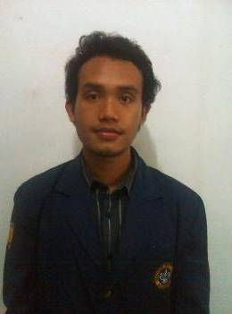Curriculum Vitae

Personal Details
Full Name : Waldemar Bastian Sembiring S.Gz
Age : 25th
Place, Date of Birth : Bogor, March, 20 1989
Height : 165 cm
Weight : 63 kg
Physical Condition : Excellent
Departement : Nutrition Science
Faculty : Human Ecology
Institution : Bogor Agricultural University / Institut Pertanian Bogor (IPB)
GPA : 3.11
Date of Graduate : December, 07 2011
Address : Perum Persada depok blok:A7/04, rt/rw: 02/18, kel Cimpaeun, kec Tapos, kota Depok
Post Code : 16459
Province : West Java
E-mail : wall_bastian@yahoo.co.id
Mobile Number : (0878)88131414

Educational Background
1998 – 2003 : Budi Mulia Elementary School, Bogor
2003 – 2005 : Budi Mulia Junior High School, Bogor
2005 – 2007 : Senior High School No.2, Bogor
2007 up to now : Bogor Agricultural University / Institut Pertanian Bogor (IPB)

Organization Experience
2007 – 2011 : Membership of Komisi Pelayanan Khusus (Kopelkhu) PMK IPB as “Bidang Kepanitiaan”
2008 – 2009 : Commitee of “Masa Perkenalan Departemen Gizi Masyarakat FEMA IPB” as “Bidang Dana dan Usaha”
2008 – 2011 : Membership of HIMAGIZI (Himpunan Mahasiswa Gizi)
2009 – 2010 : Secretary of HRD (Human Research Development) Eco-AgriFarma FEMA IPB
2009 – 2010 : Chairman of Studi Banding Ecoagrifarma FEMA IPB 2010
2009 – 2011 : Organizer of Team PD Permata GBKP Runggun Bogor
2010 - 2011 : Participant of Seminar Gizi Nasional as “Bidang Logistik dan Transportasi”
2011 – 2012 : Chairman of Local Commitee BKSO CUP V Permata GBKP Bogor

Work Experiences
Probation time : July 2012 - October 2012
Placed : PT. HM Sampoerna Tbk as Retail Engagement Executive at Area Sales Officer (ASO) Bogor (Jakarta Outer)

Permanent time : October 2012 - up to now
Placed : PT. HM Sampoerna Tbk as Retail Engagement Executive at Area Sales Officer (ASO) Bogor (Jakarta Outer)

Wellmannered Skill
Language | Writing | Reading | Speaking | Understanding
Indonesian | Excellent | Excellent | Excellent | Excellent
English | Good | Good | Good | Good

General Skill
Microsoft Word | Good
Microsoft Power Point | Good
Microsoft Excel | Good
Internet Explorer | Good
Typing | Good
Interpersonal Communication | Good
Self Skill
- Self confidence
- Full of planning
- Have pay special attention to process on working or getting something
- Can work on pressure situation and looking for to way out
- Curiousity

